目录

一、 实验内容 1

二、 CPU数据通路设计 1

（一） 单条指令的涉及部件和输入输出关系、数据通路和指令流程图 1

（二） 完整数据通路 19

三、 CPU控制部件设计 19

（一） 指令操作时间表 19

（二） 控制信号逻辑表达式 27

（三） 控制部件设计 28

四、 CPU前仿真测试结果 38

（一） 单条指令前仿真波形图及对比结果 38

（二） 网站前仿真测试结果 53

五、 CPU后仿真测试结果 53

（一） 后仿真测试结果及描述 53

（二） 时序分析结果 53

六、 CPU下板结果 55

七、 心得体会及建议 58

# 实验内容

本次实验我们将使用verilog HDL语言实现54条MIPS指令的CPU设计和仿真，可以用单周期完成，也可以用多周期完成。本次实验采用单周期实现，根据实验要求，依次完成：

1. 新建vivado工程，也可以在MIPS31条指令CPU基础上编写各模块
2. 用modelsim前仿真逐条测试所有指令
3. 用modelsim前仿真逐条测试所有指令边界数据
4. 用modelsim前仿真测试指令序列
5. 用modelsim前仿真运行测试程序
6. 用modelsim后仿真测试指令序列
7. 用modelsim后仿真运行测试程序
8. 配置XDC文件，综合下板，并观察实验现象
9. 按照要求书写实验报告

# CPU数据通路设计

## 单条指令的涉及部件和输入输出关系、数据通路和指令流程图

1. ADD

|  |  |  |  |  |  |  |
| --- | --- | --- | --- | --- | --- | --- |
| 指令 | PC | NPC | IMEM | Regfile | ALU | |
| Rd | A | B |
| ADD | NPC | PC | PC | ALU | Rs | Rt |

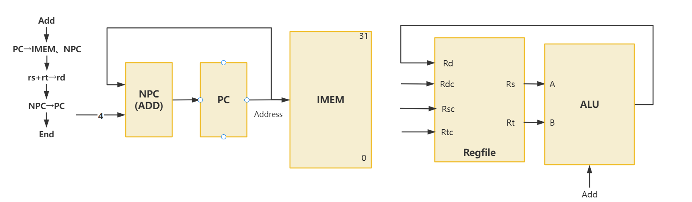

1. ADDU

|  |  |  |  |  |  |  |
| --- | --- | --- | --- | --- | --- | --- |
| 指令 | PC | NPC | IMEM | Regfile | ALU | |
| Rd | A | B |
| ADDU | NPC | PC | PC | ALU | Rs | Rt |

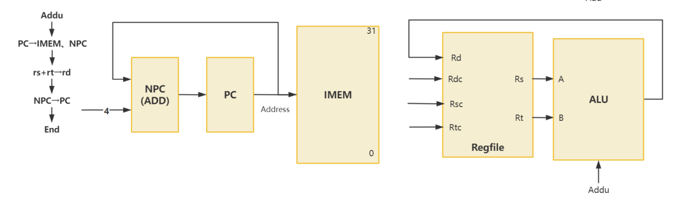

1. SUB

|  |  |  |  |  |  |  |
| --- | --- | --- | --- | --- | --- | --- |
| 指令 | PC | NPC | IMEM | Regfile | ALU | |
| Rd | A | B |
| SUB | NPC | PC | PC | ALU | Rs | Rt |

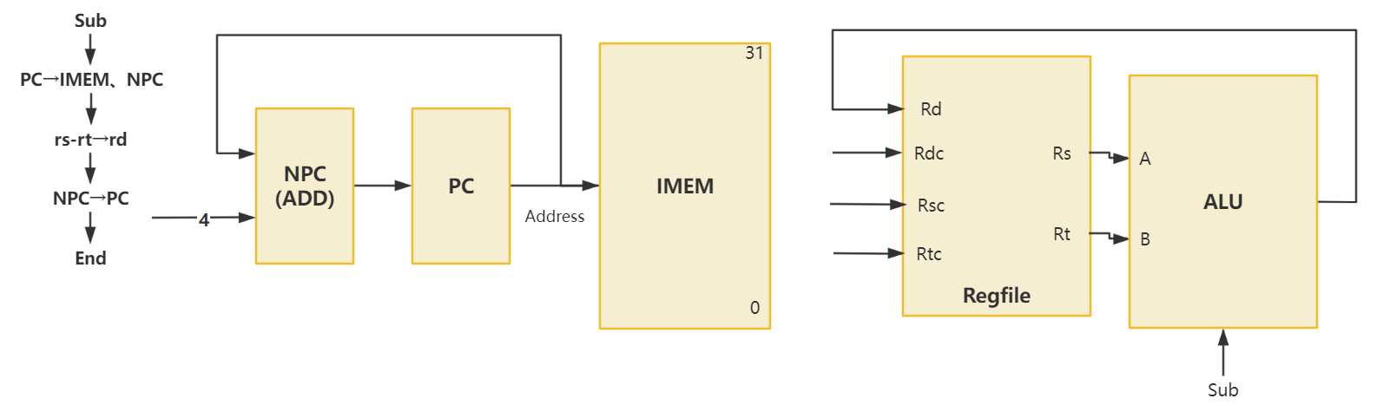

1. SUBU

|  |  |  |  |  |  |  |
| --- | --- | --- | --- | --- | --- | --- |
| 指令 | PC | NPC | IMEM | Regfile | ALU | |
| Rd | A | B |
| SUBU | NPC | PC | PC | ALU | Rs | Rt |

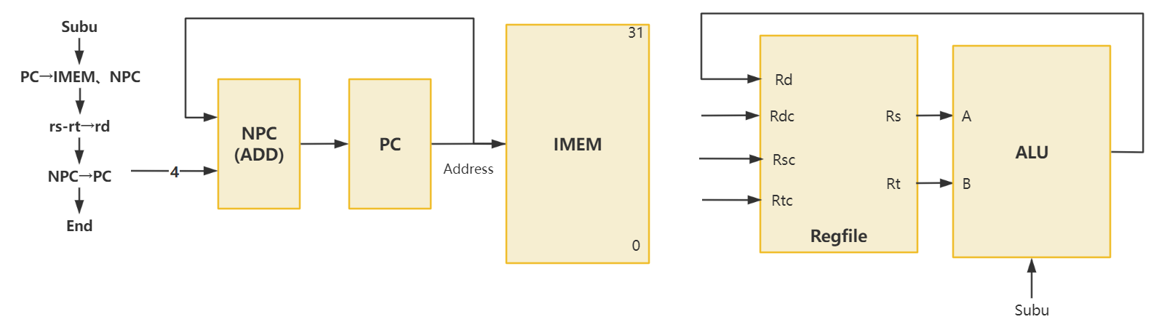

1. AND

|  |  |  |  |  |  |  |
| --- | --- | --- | --- | --- | --- | --- |
| 指令 | PC | NPC | IMEM | Regfile | ALU | |
| Rd | A | B |
| AND | NPC | PC | PC | ALU | Rs | Rt |

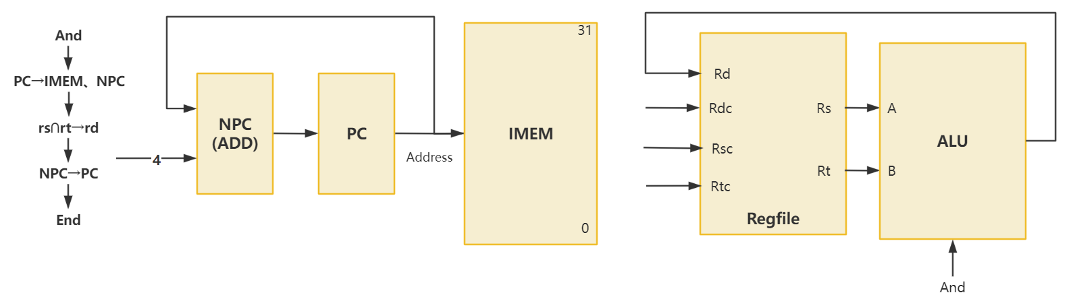

1. OR

|  |  |  |  |  |  |  |
| --- | --- | --- | --- | --- | --- | --- |
| 指令 | PC | NPC | IMEM | Regfile | ALU | |
| Rd | A | B |
| OR | NPC | PC | PC | ALU | Rs | Rt |

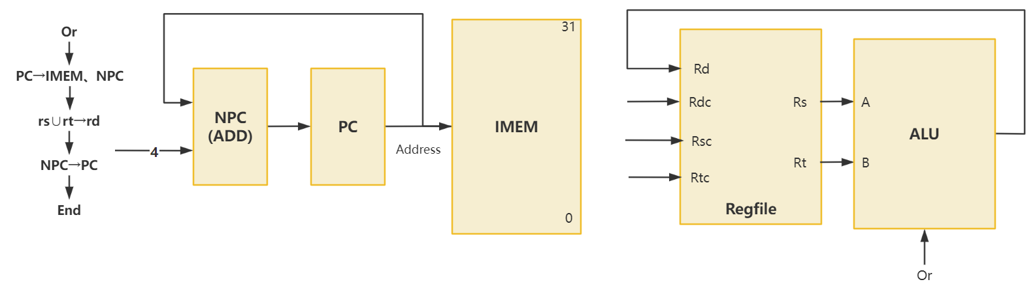

1. XOR

|  |  |  |  |  |  |  |
| --- | --- | --- | --- | --- | --- | --- |
| 指令 | PC | NPC | IMEM | Regfile | ALU | |
| Rd | A | B |
| XOR | NPC | PC | PC | ALU | Rs | Rt |

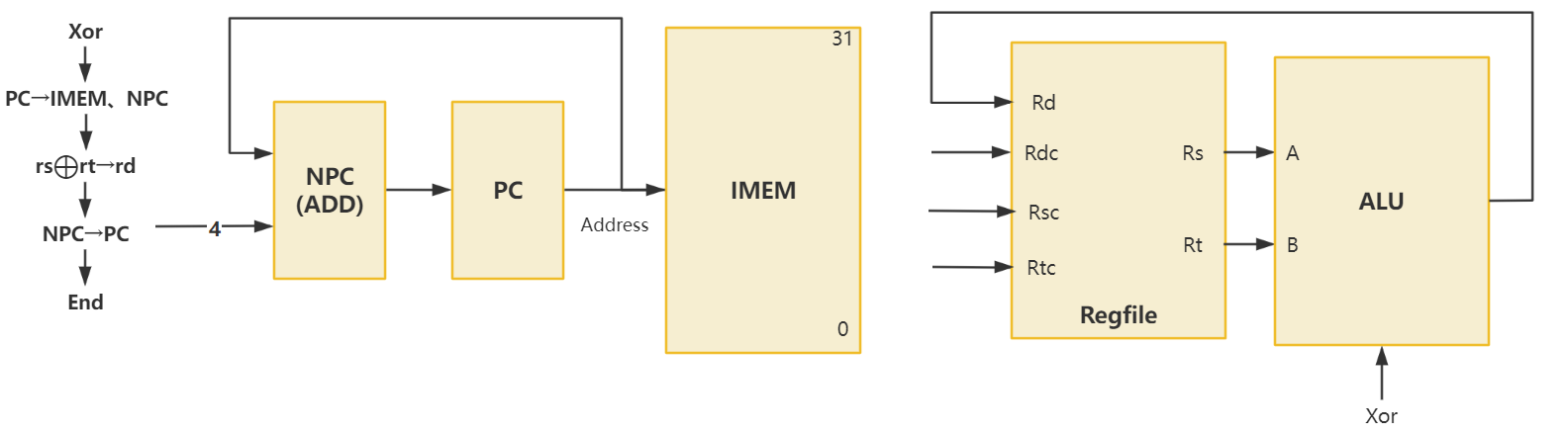

1. NOR

|  |  |  |  |  |  |  |
| --- | --- | --- | --- | --- | --- | --- |
| 指令 | PC | NPC | IMEM | Regfile | ALU | |
| Rd | A | B |
| NOR | NPC | PC | PC | ALU | Rs | Rt |

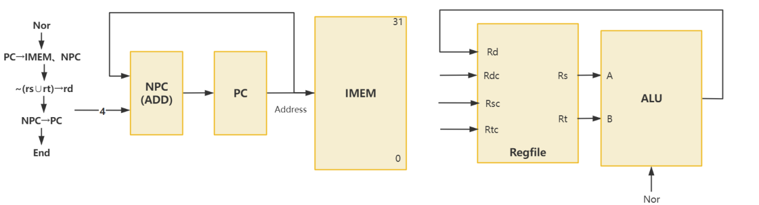

1. SLT

|  |  |  |  |  |  |  |
| --- | --- | --- | --- | --- | --- | --- |
| 指令 | PC | NPC | IMEM | Regfile | ALU | |
| Rd | A | B |
| SLT | NPC | PC | PC | ALU | Rs | Rt |

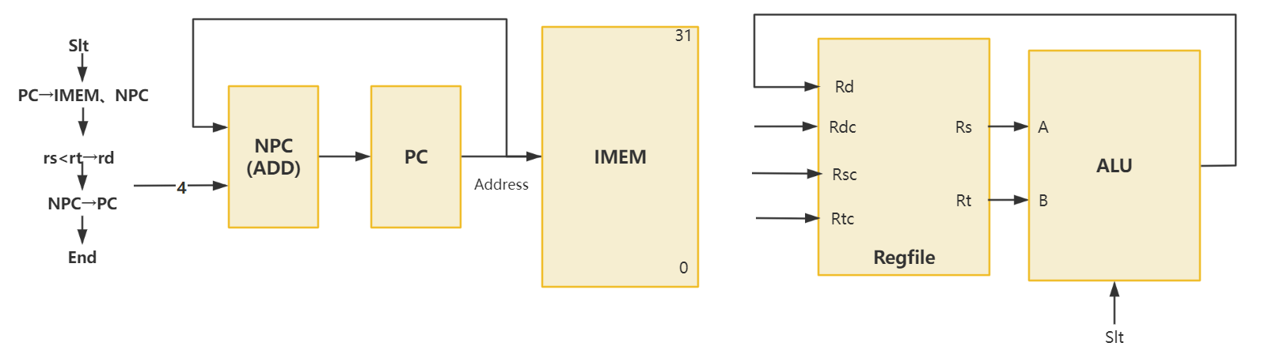

1. SLTU

|  |  |  |  |  |  |  |
| --- | --- | --- | --- | --- | --- | --- |
| 指令 | PC | NPC | IMEM | Regfile | ALU | |
| Rd | A | B |
| SLTU | NPC | PC | PC | ALU | Rs | Rt |

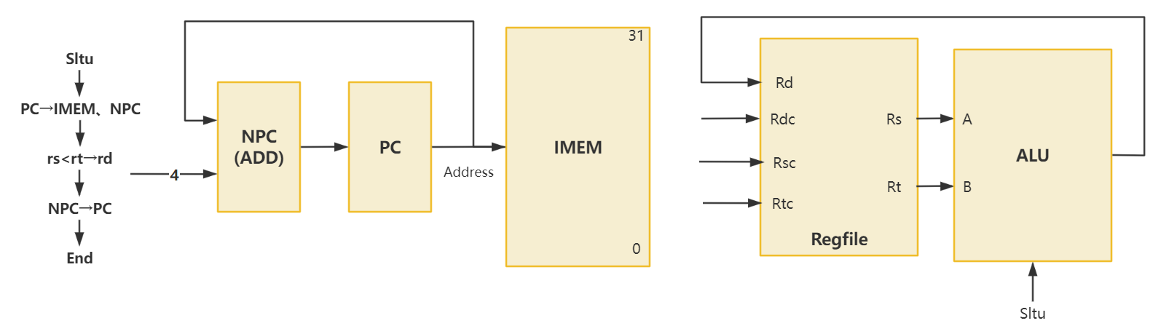

1. SLL

|  |  |  |  |  |  |  |  |
| --- | --- | --- | --- | --- | --- | --- | --- |
| 指令 | PC | NPC | IMEM | Regfile | ALU | | Ext5 |
| Rd | A | B |
| SLL | NPC | PC | PC | ALU | Ext5 | Rt | Sa |

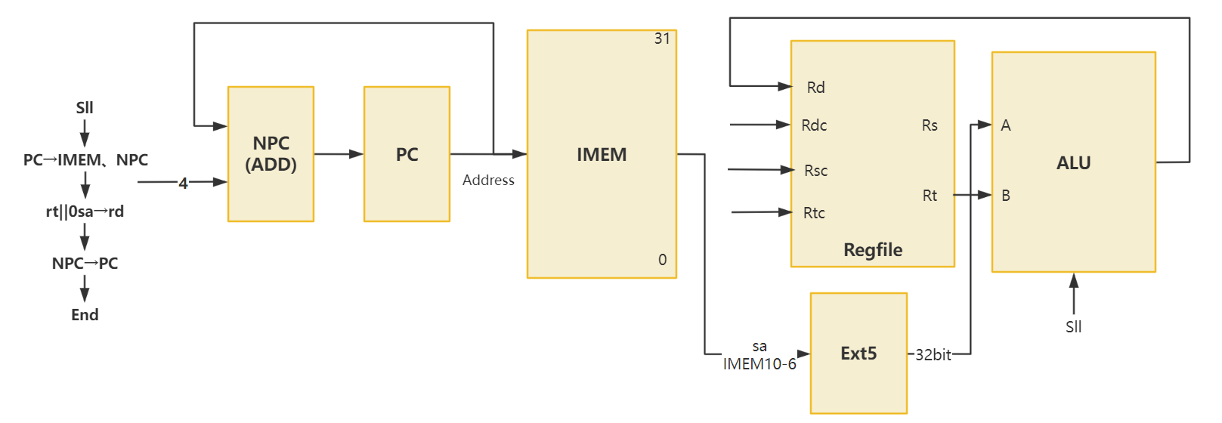

1. SRL

|  |  |  |  |  |  |  |  |
| --- | --- | --- | --- | --- | --- | --- | --- |
| 指令 | PC | NPC | IMEM | Regfile | ALU | | Ext5 |
| Rd | A | B |
| SRL | NPC | PC | PC | ALU | Ext5 | Rt | Sa |

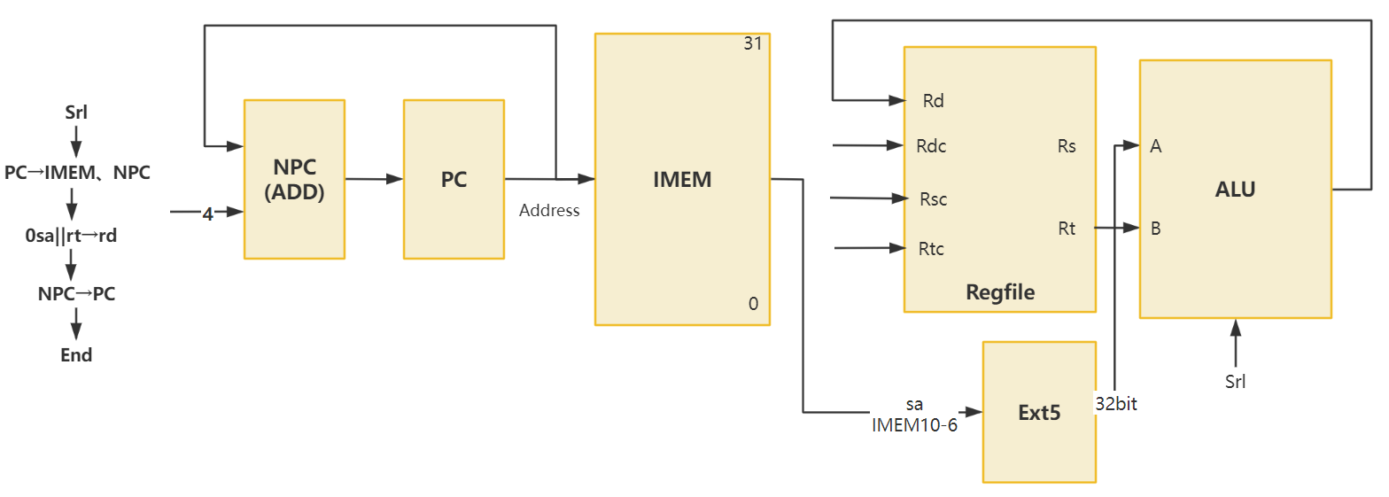

1. SRA

|  |  |  |  |  |  |  |  |
| --- | --- | --- | --- | --- | --- | --- | --- |
| 指令 | PC | NPC | IMEM | Regfile | ALU | | Ext5 |
| Rd | A | B |
| SRA | NPC | PC | PC | ALU | Ext5 | Rt | Sa |

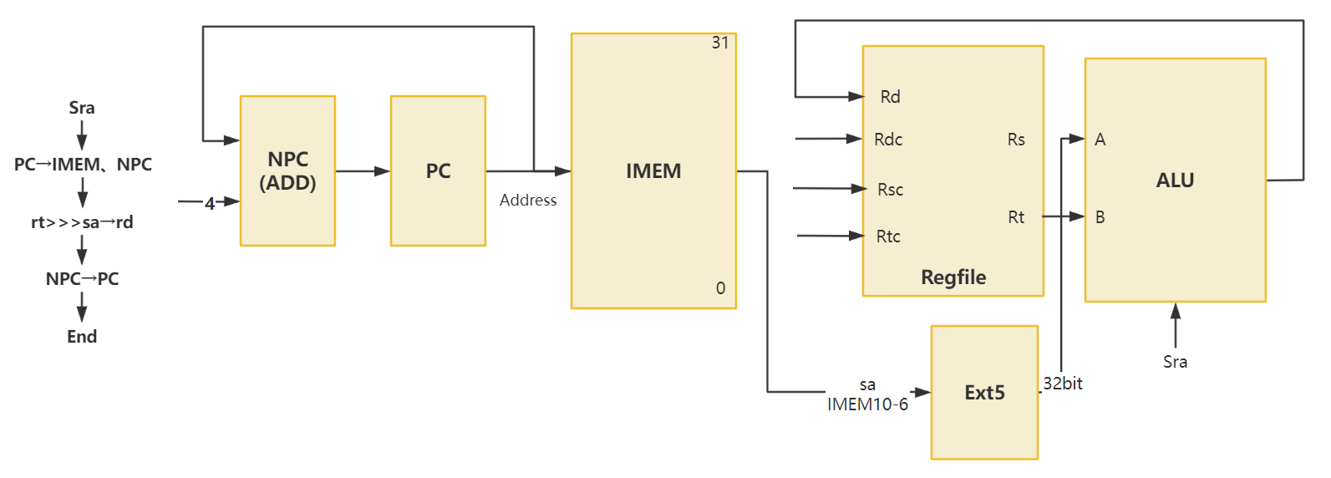

1. SLLV

|  |  |  |  |  |  |  |  |
| --- | --- | --- | --- | --- | --- | --- | --- |
| 指令 | PC | NPC | IMEM | Regfile | ALU | | Ext5 |
| Rd | A | B |
| SLLV | NPC | PC | PC | ALU | Ext5 | Rt | Rs |

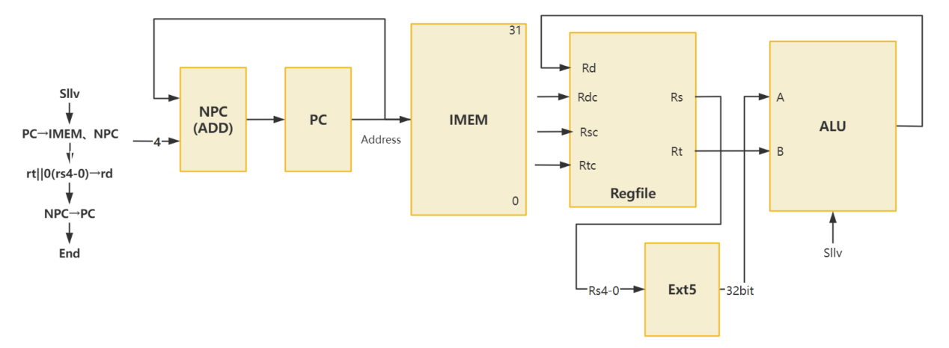

1. SRLV

|  |  |  |  |  |  |  |  |
| --- | --- | --- | --- | --- | --- | --- | --- |
| 指令 | PC | NPC | IMEM | Regfile | ALU | | Ext5 |
| Rd | A | B |
| SRLV | NPC | PC | PC | ALU | Ext5 | Rt | Rs |

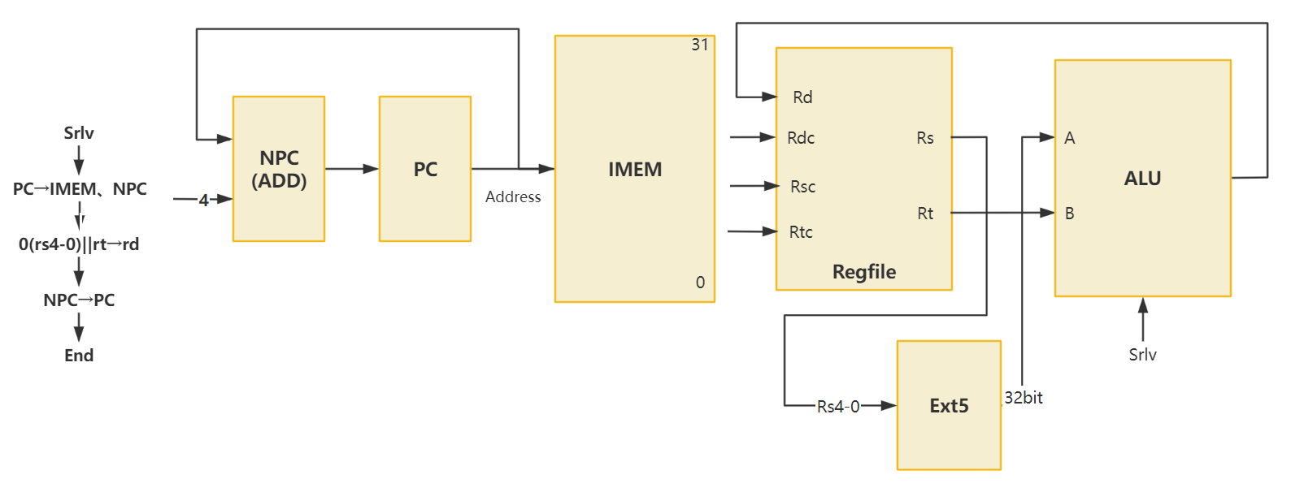

1. SRAV

|  |  |  |  |  |  |  |  |
| --- | --- | --- | --- | --- | --- | --- | --- |
| 指令 | PC | NPC | IMEM | Regfile | ALU | | Ext5 |
| Rd | A | B |
| SRAV | NPC | PC | PC | ALU | Ext5 | Rt | Rs |

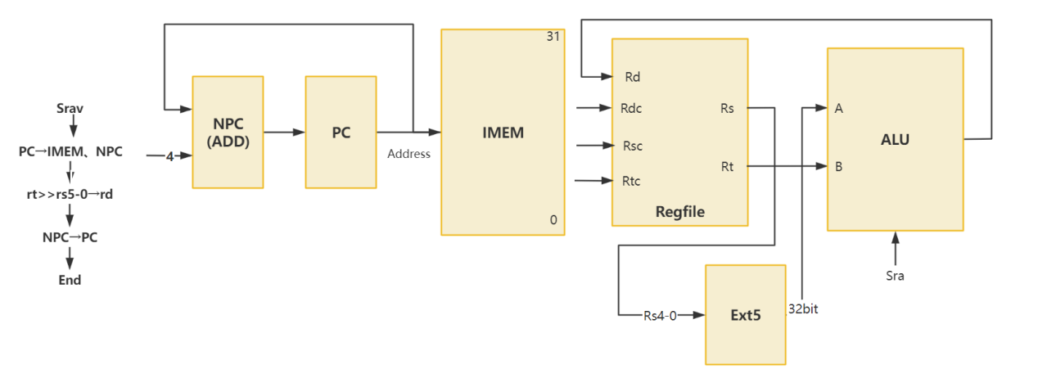

1. JR

|  |  |  |  |  |  |  |  |
| --- | --- | --- | --- | --- | --- | --- | --- |
| 指令 | PC | NPC | IMEM | Regfile | ALU | | Ext5 |
| Rd | A | B |
| JR | Rs | PC | PC |  |  |  |  |

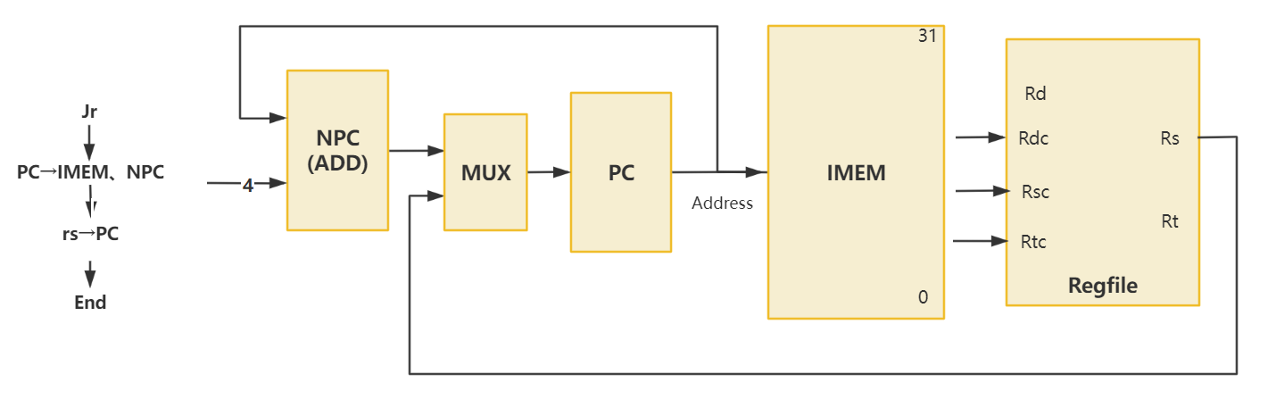

1. ADDI

|  |  |  |  |  |  |  |  |  |
| --- | --- | --- | --- | --- | --- | --- | --- | --- |
| 指令 | PC | NPC | IMEM | Regfile | ALU | | Ext5 | S_Ext16_0 |
| Rd | A | B |
| ADDI | NPC | PC | PC | ALU | Rs | S_Ext16_0 |  | imm16 |

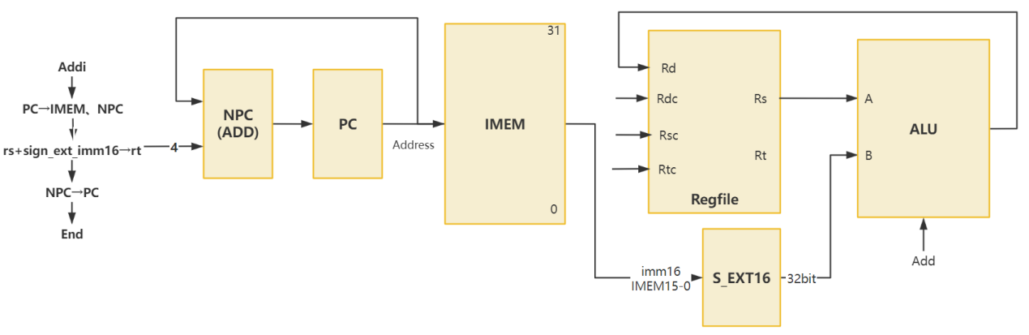

1. ADDIU

|  |  |  |  |  |  |  |  |  |
| --- | --- | --- | --- | --- | --- | --- | --- | --- |
| 指令 | PC | NPC | IMEM | Regfile | ALU | | Ext5 | S_Ext16_0 |
| Rd | A | B |
| ADDIU | NPC | PC | PC | ALU | Rs | S_Ext16_0 |  | imm16 |

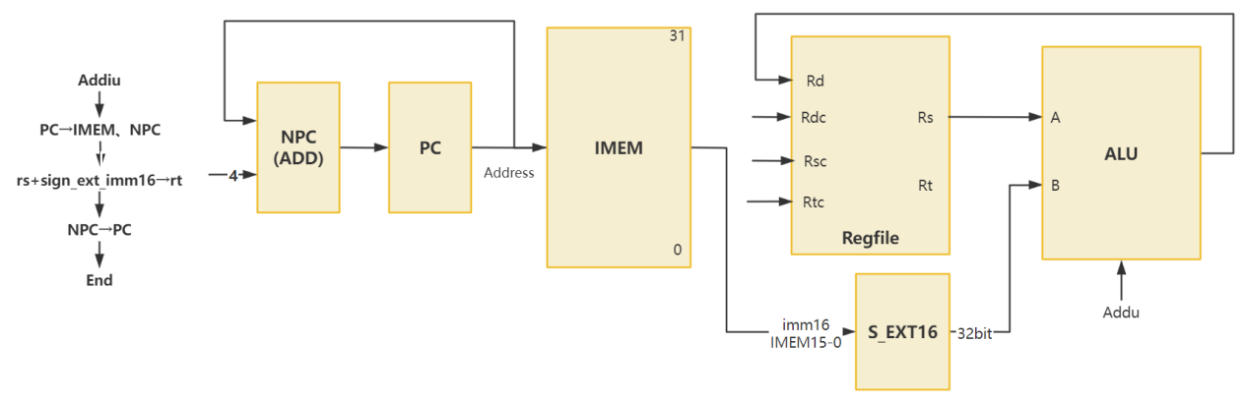

1. ANDI

|  |  |  |  |  |  |  |  |  |
| --- | --- | --- | --- | --- | --- | --- | --- | --- |
| 指令 | PC | NPC | IMEM | Regfile | ALU | | Ext5 | S_Ext16_0 |
| Rd | A | B |
| ADDI | NPC | PC | PC | ALU | Rs | Ext16 |  |  |

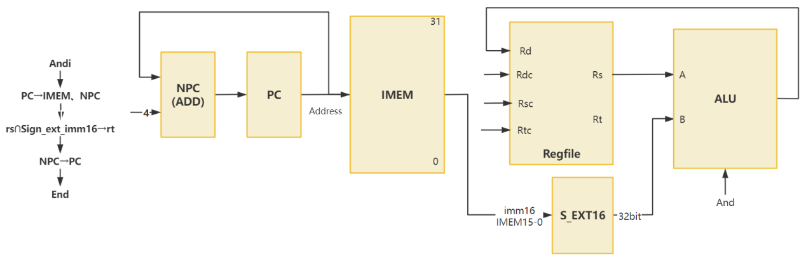

1. ORI

|  |  |  |  |  |  |  |  |  |
| --- | --- | --- | --- | --- | --- | --- | --- | --- |
| 指令 | PC | NPC | IMEM | Regfile | ALU | | Ext5 | S_Ext16_0 |
| Rd | A | B |
| ORI | NPC | PC | PC | ALU | Rs | Ext16 |  |  |

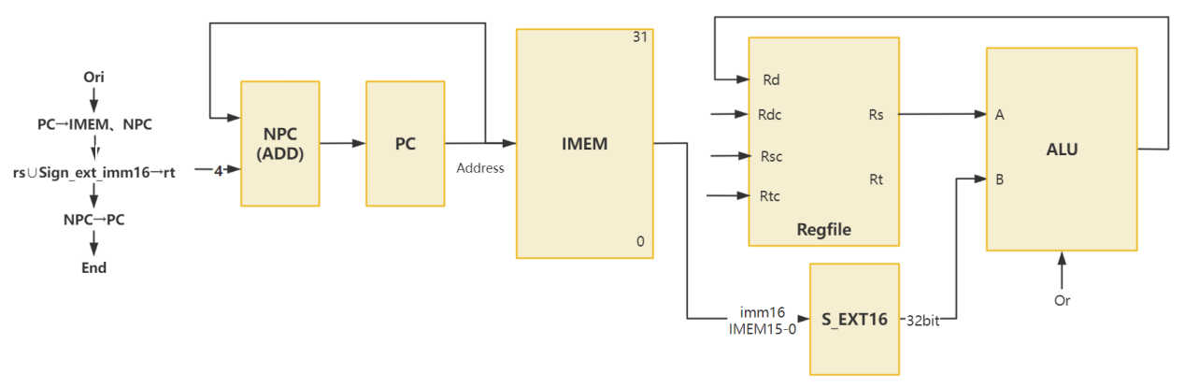

1. XORI

|  |  |  |  |  |  |  |  |  |
| --- | --- | --- | --- | --- | --- | --- | --- | --- |
| 指令 | PC | NPC | IMEM | Regfile | ALU | | Ext5 | S_Ext16_0 |
| Rd | A | B |
| XORI | NPC | PC | PC | ALU | Rs | Ext16 |  |  |

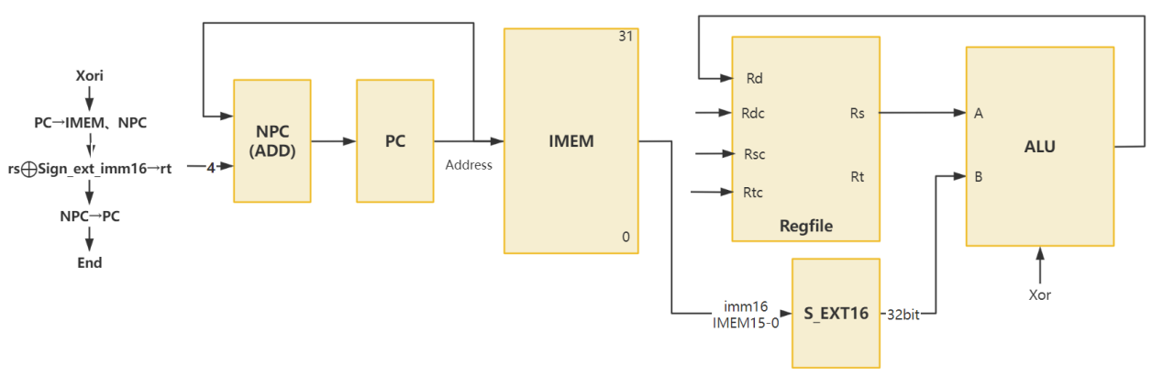

1. LW

|  |  |  |  |  |  |  |  |  |  |  |  |  |
| --- | --- | --- | --- | --- | --- | --- | --- | --- | --- | --- | --- | --- |
| 指令 | PC | NPC | IMEM | Regfile | ALU | | Ext5 | S_Ext16_0 | S_Ext_16_1 | Ext16 | DMEM | |
| Rd | A | B | Addr | Data |
| LW | NPC | PC | PC | Data | Rs | S_Ext16_0 |  | offset |  |  | ALU |  |

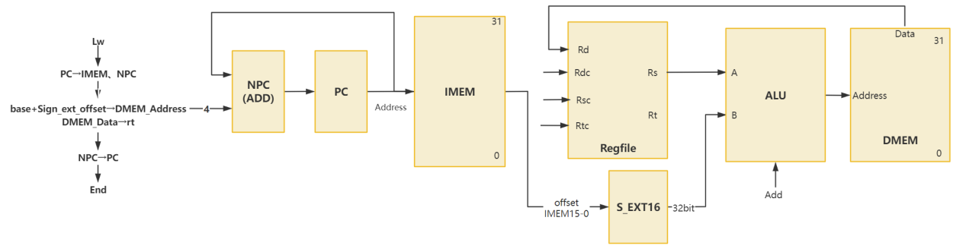

1. SW

|  |  |  |  |  |  |  |  |  |  |  |  |  |
| --- | --- | --- | --- | --- | --- | --- | --- | --- | --- | --- | --- | --- |
| 指令 | PC | NPC | IMEM | Regfile | ALU | | Ext5 | S_Ext16_0 | S_Ext_16_1 | Ext16 | DMEM | |
| Rd | A | B | Addr | Data |
| LW | NPC | PC | PC | Data | Rs | S_Ext16_0 |  | offset |  |  | ALU | Rt |

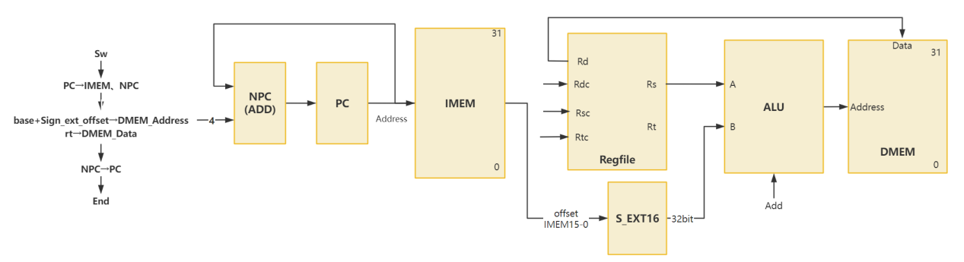

1. BEQ(Z=1)

|  |  |  |  |  |  |  |  |  |  |  |  |
| --- | --- | --- | --- | --- | --- | --- | --- | --- | --- | --- | --- |
| 指令 | PC | | | NPC | | | IMEM | Regfile | | ALU | |
| Rd | | A | B |
| BEQ | NPC | | | PC | | | PC |  | | Rs | Rt |
| S_Ext18 | | S_Ext8 | Ext8 | | ADD | | | |
| A | B | | |
| offset | |  |  | | S_Ext18 | NPC | | |

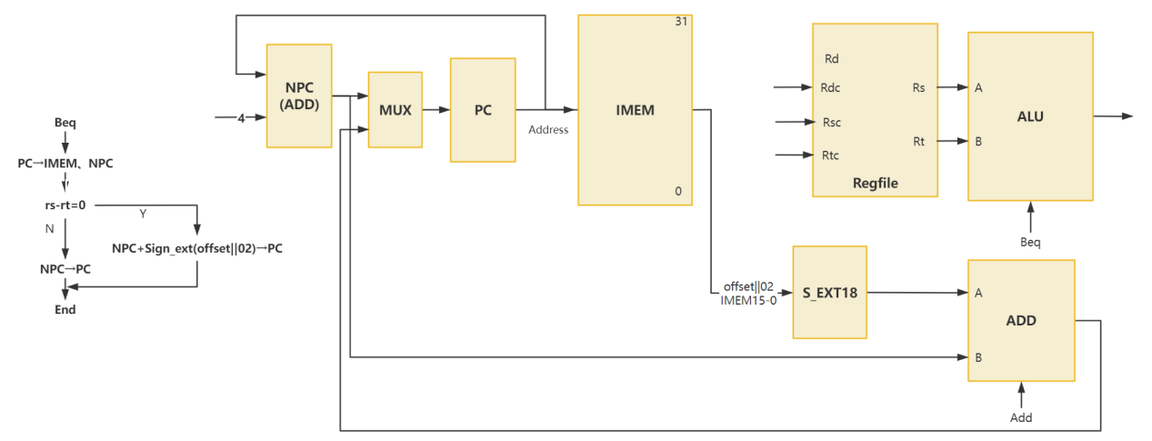

1. BNE(Z=0)

|  |  |  |  |  |  |  |  |  |  |  |  |
| --- | --- | --- | --- | --- | --- | --- | --- | --- | --- | --- | --- |
| 指令 | PC | | | NPC | | | IMEM | Regfile | | ALU | |
| Rd | | A | B |
| BNE | NPC | | | PC | | | PC |  | | Rs | Rt |
| S_Ext18 | | S_Ext8 | Ext8 | | ADD | | | |
| A | B | | |
| offset | |  |  | | S_Ext18 | NPC | | |

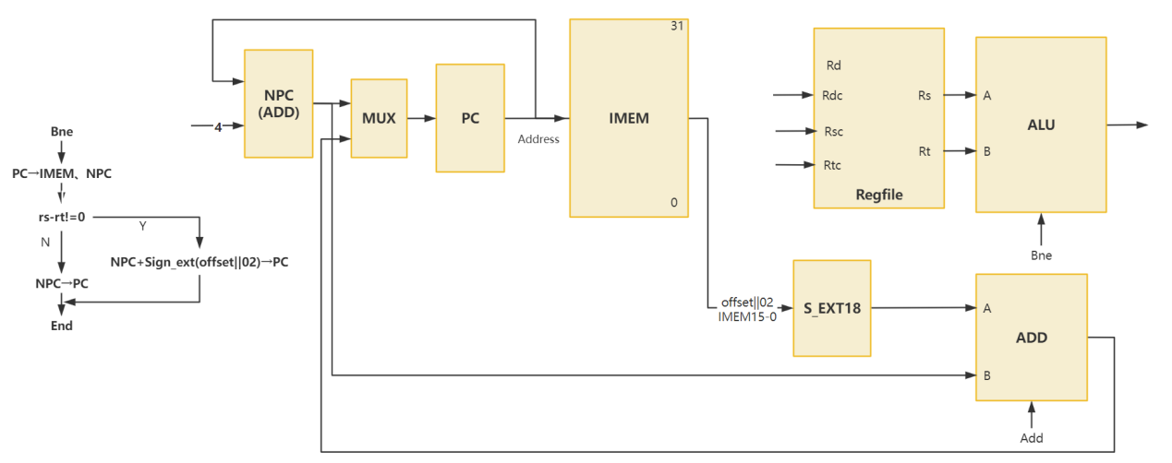

1. SLTI

|  |  |  |  |  |  |  |  |  |
| --- | --- | --- | --- | --- | --- | --- | --- | --- |
| 指令 | PC | NPC | IMEM | Regfile | ALU | | Ext5 | S_Ext16_0 |
| Rd | A | B |
| SLTI | NPC | PC | PC | ALU | Rs | S_Ext16_0 |  | imm16 |

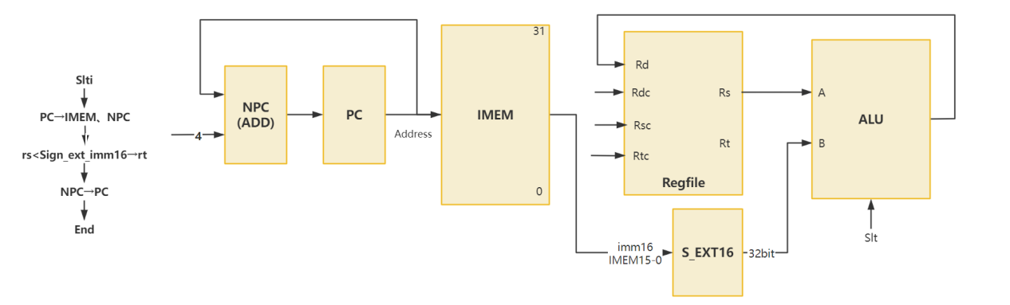

1. SLTIU

|  |  |  |  |  |  |  |  |  |
| --- | --- | --- | --- | --- | --- | --- | --- | --- |
| 指令 | PC | NPC | IMEM | Regfile | ALU | | Ext5 | S_Ext16_0 |
| Rd | A | B |
| SLTI | NPC | PC | PC | ALU | Rs | S_Ext16_0 |  | imm16 |

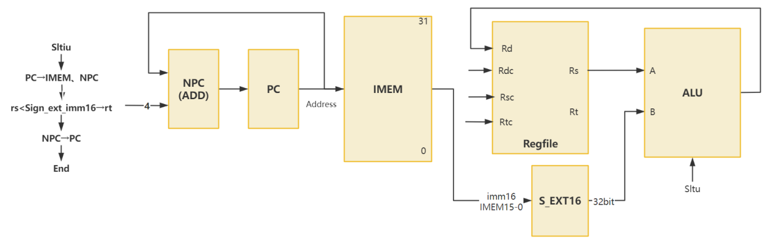

1. LUI

|  |  |  |  |  |  |  |  |
| --- | --- | --- | --- | --- | --- | --- | --- |
| 指令 | PC | NPC | IMEM | Regfile | ALU | | Ext16 |
| Rd | A | B |
| LUI | NPC | PC | PC | ALU |  | Ext16 | imm16 |

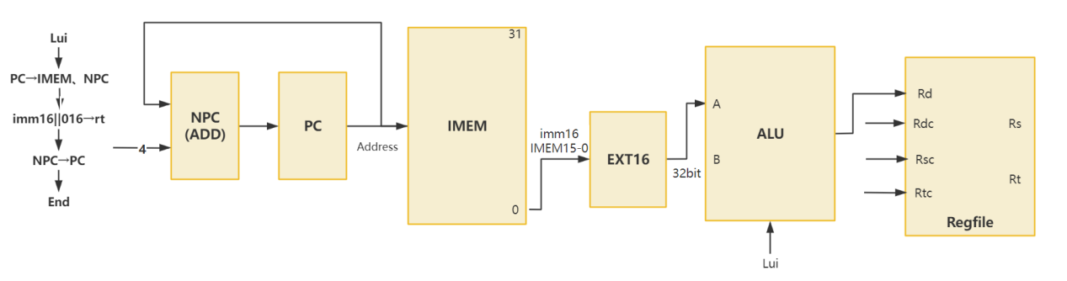

1. J

|  |  |  |  |  |  |  |
| --- | --- | --- | --- | --- | --- | --- |
| 指令 | PC | NPC | IMEM | Regfile | || | |
| Rd | A | B |
| J | || | PC | PC |  | PC31-28 | IMEM25-0 |

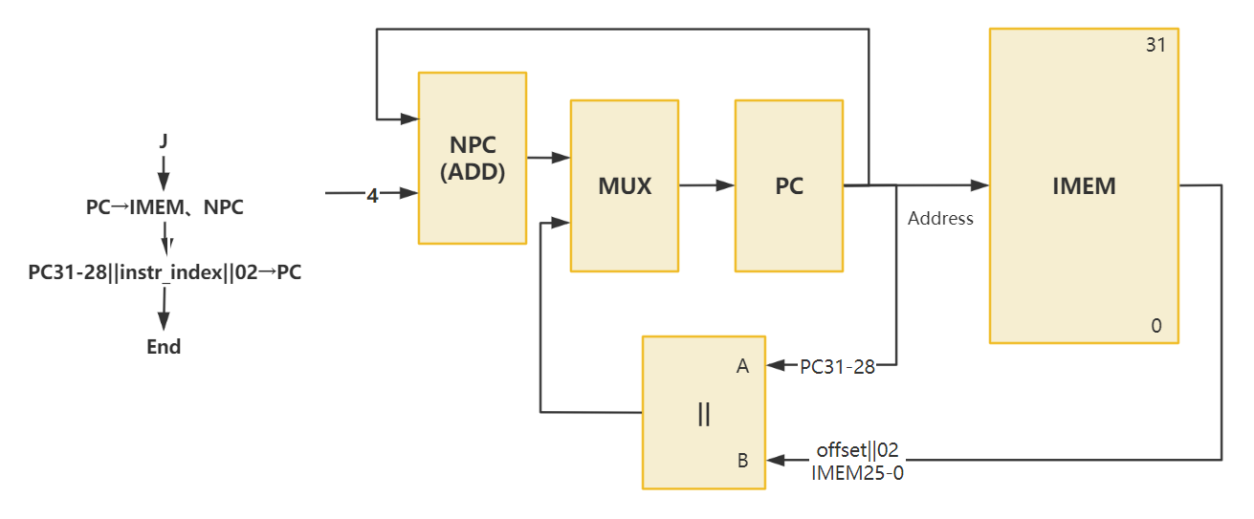

1. JAL

|  |  |  |  |  |  |  |
| --- | --- | --- | --- | --- | --- | --- |
| 指令 | PC | NPC | IMEM | Regfile | || | |
| Rd | A | B |
| JAL | || | PC | PC | ALU | PC31-28 | IMEM25-0 |

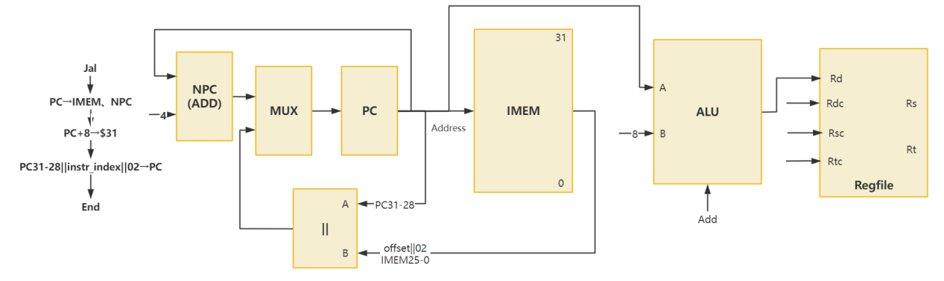

1. DIV

|  |  |  |  |  |  |  |  |
| --- | --- | --- | --- | --- | --- | --- | --- |
| 指令 | PC | NPC | IMEM | DIV | | Hi | Lo |
| Dividend | Divisor |
| DIV | NPC | PC | PC | Rs | Rt | r(DIV) | q(DIV) |

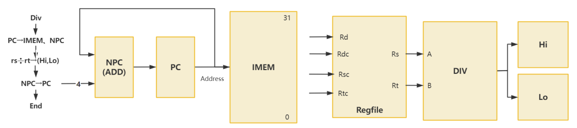

1. DIVU

|  |  |  |  |  |  |  |  |
| --- | --- | --- | --- | --- | --- | --- | --- |
| 指令 | PC | NPC | IMEM | DIVU | | Hi | Lo |
| Dividend | Divisor |
| DIVU | NPC | PC | PC | Rs | Rt | r(DIV) | q(DIV) |

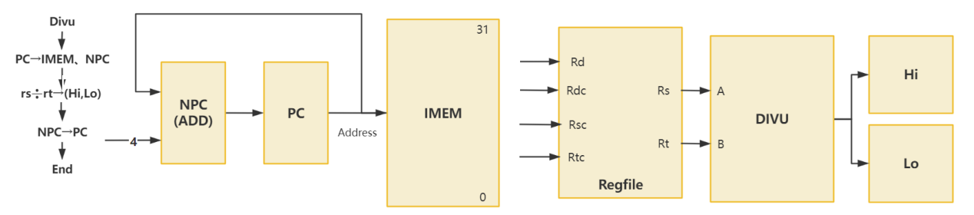

1. MULT

|  |  |  |  |  |  |  |  |
| --- | --- | --- | --- | --- | --- | --- | --- |
| 指令 | PC | NPC | IMEM | MULT | | Hi | Lo |
| A | B |
| MULT | NPC | PC | PC | Rs | Rt | z(MULT)63-32 | z(MULT)31-0 |

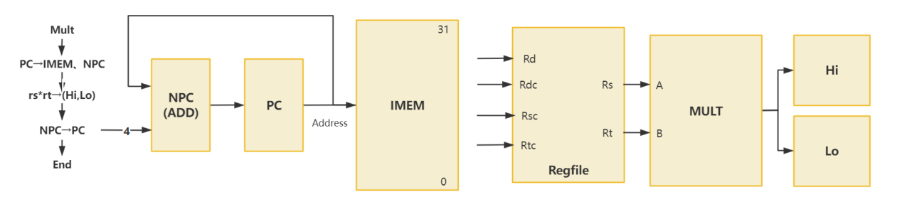

1. MULTU

|  |  |  |  |  |  |  |  |
| --- | --- | --- | --- | --- | --- | --- | --- |
| 指令 | PC | NPC | IMEM | MULTU | | Hi | Lo |
| A | B |
| MULT | NPC | PC | PC | Rs | Rt | z(MULT)63-32 | z(MULT)31-0 |

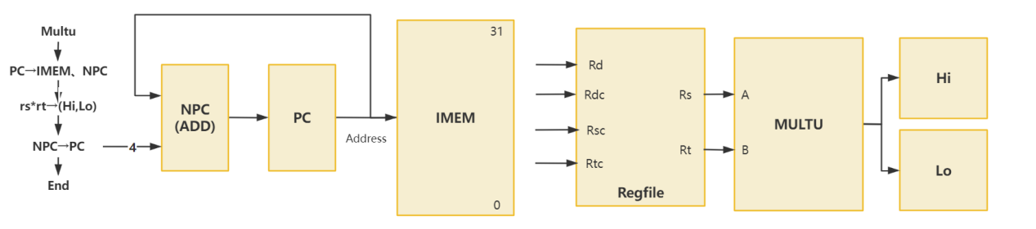

1. MFLO

|  |  |  |  |  |
| --- | --- | --- | --- | --- |
| 指令 | PC | NPC | IMEM | Regfile |
| Rd |
| MFLO | NPC | PC | PC | Lo |

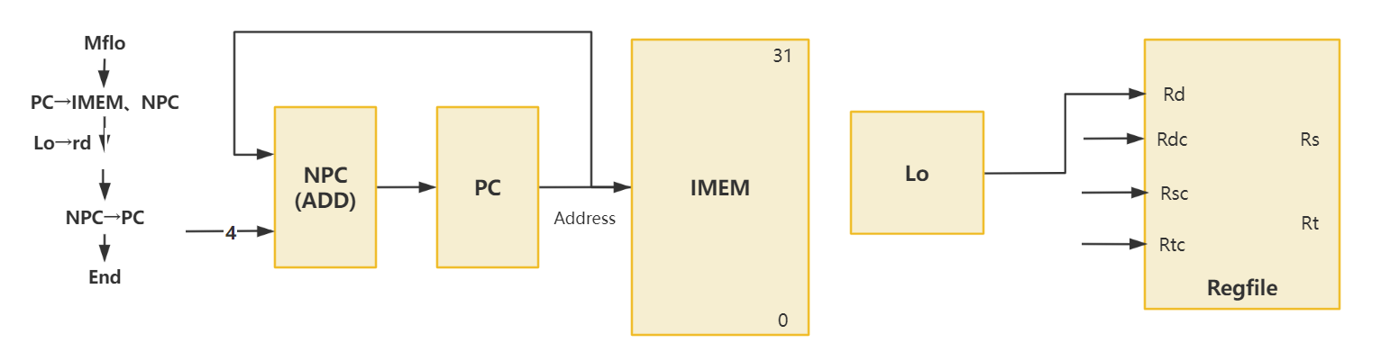

1. MFHI

|  |  |  |  |  |
| --- | --- | --- | --- | --- |
| 指令 | PC | NPC | IMEM | Regfile |
| Rd |
| MFHI | NPC | PC | PC | Hi |

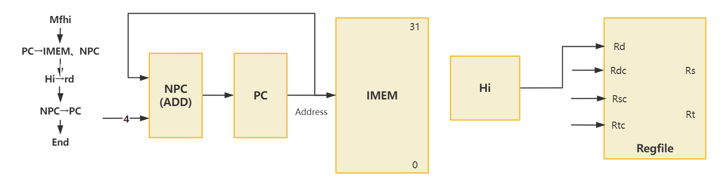

1. MTLO

|  |  |  |  |  |
| --- | --- | --- | --- | --- |
| 指令 | PC | NPC | IMEM | Lo |
|
| MTLO | NPC | PC | PC | Rs |

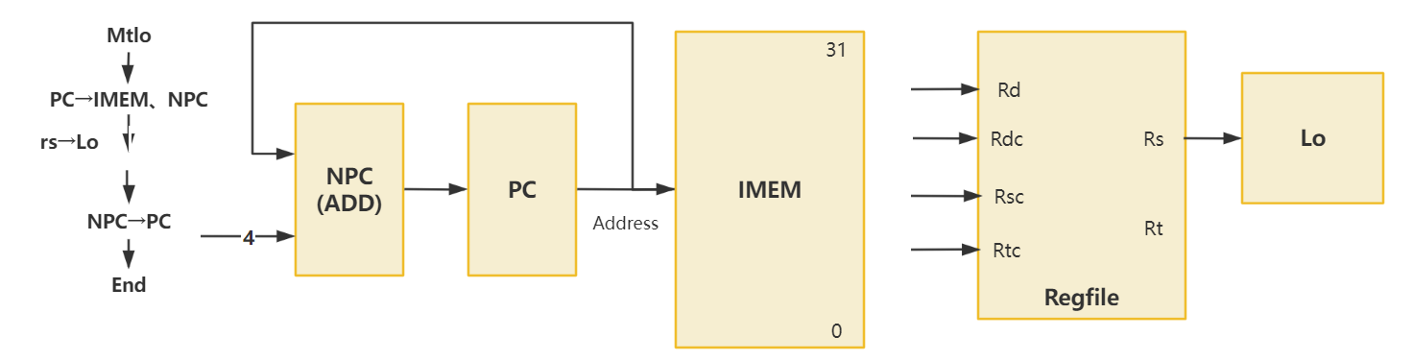

1. MTHI

|  |  |  |  |  |
| --- | --- | --- | --- | --- |
| 指令 | PC | NPC | IMEM | Hi |
|
| MTHI | NPC | PC | PC | Rs |

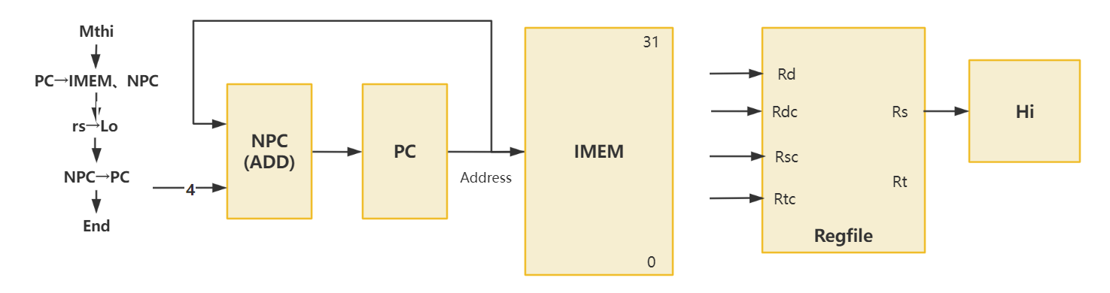

1. LB

|  |  |  |  |  |  |  |  |  |  |
| --- | --- | --- | --- | --- | --- | --- | --- | --- | --- |
| 指令 | PC | NPC | IMEM | Regfile | ALU | | S_Ext16_0 | DMEM | S_Ext8 |
| Rd | A | B | Addr |
| LB | NPC | PC | PC | S_Ext8 | Rs | S_Ext16_0 | offset | ALU | Data |

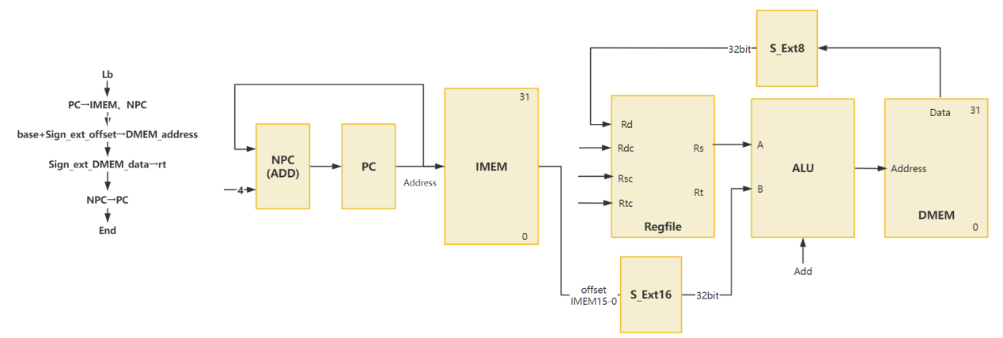

1. LBU

|  |  |  |  |  |  |  |  |  |  |
| --- | --- | --- | --- | --- | --- | --- | --- | --- | --- |
| 指令 | PC | NPC | IMEM | Regfile | ALU | | S_Ext16_0 | DMEM | Ext8 |
| Rd | A | B | Addr |
| LB | NPC | PC | PC | S_Ext8 | Rs | S_Ext16_0 | offset | ALU | Data |

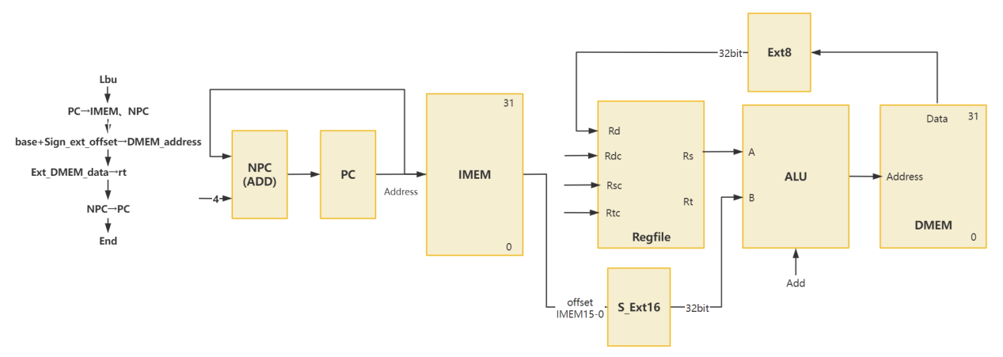

1. LH

|  |  |  |  |  |  |  |  |  |  |
| --- | --- | --- | --- | --- | --- | --- | --- | --- | --- |
| 指令 | PC | NPC | IMEM | Regfile | ALU | | S_Ext16_0 | DMEM | |
| Rd | A | B | Addr | Data |
| LH | NPC | PC | PC | S_Ext16_1 | Rs | S_Ext16_0 | offset | ALU |  |

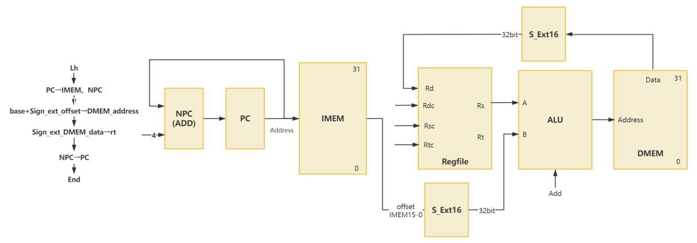

1. LHU

|  |  |  |  |  |  |  |  |  |  |
| --- | --- | --- | --- | --- | --- | --- | --- | --- | --- |
| 指令 | PC | NPC | IMEM | Regfile | ALU | | S_Ext16_0 | DMEM | |
| Rd | A | B | Addr | Data |
| LHU | NPC | PC | PC | S_Ext16_1 | Rs | S_Ext16_0 | offset | ALU |  |

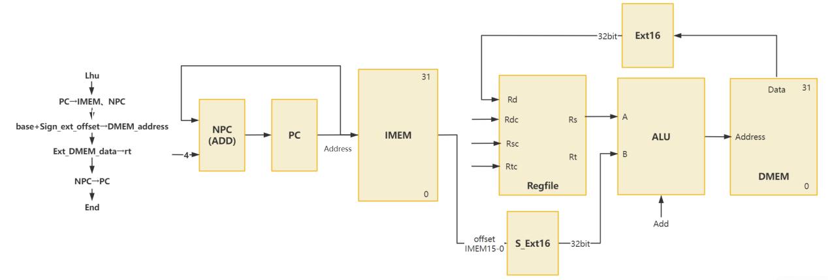

1. SB

|  |  |  |  |  |  |  |  |  |
| --- | --- | --- | --- | --- | --- | --- | --- | --- |
| 指令 | PC | NPC | IMEM | ALU | | S_Ext16_0 | DMEM | |
| A | B | Addr | Data |
| SB | NPC | PC | PC | Rs | S_Ext16_0 | offset | ALU | Rt7-0 |

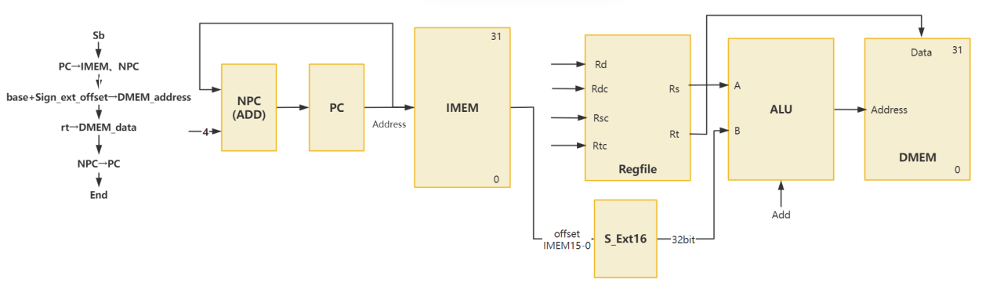

1. SH

|  |  |  |  |  |  |  |  |  |
| --- | --- | --- | --- | --- | --- | --- | --- | --- |
| 指令 | PC | NPC | IMEM | ALU | | S_Ext16_0 | DMEM | |
| A | B | Addr | Data |
| SH | NPC | PC | PC | Rs | S_Ext16_0 | offset | ALU | Rt15-0 |

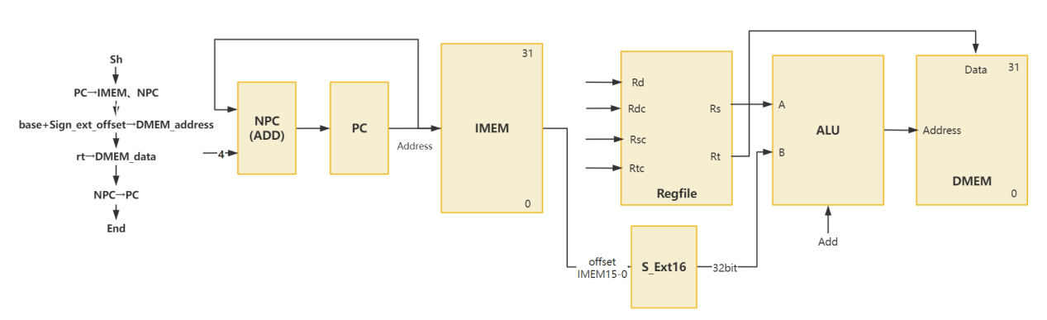

1. BGEZ(N=0)

|  |  |  |  |  |  |  |  |  |
| --- | --- | --- | --- | --- | --- | --- | --- | --- |
| 指令 | PC | NPC | IMEM | ALU | | S_Ext18 | ADD | |
| A | B | A | B |
| BGEZ | ADD | PC | PC | Rs | 0 | offset||02 | S_Ext18 | NPC |

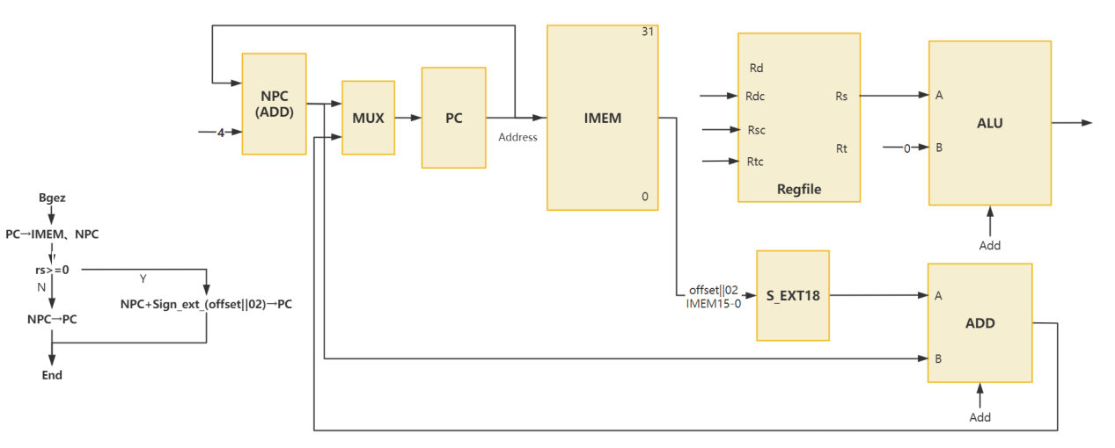

1. JALR

|  |  |  |  |
| --- | --- | --- | --- |
| 指令 | PC | NPC | IMEM |
|
| JALR | Rs | PC | PC |

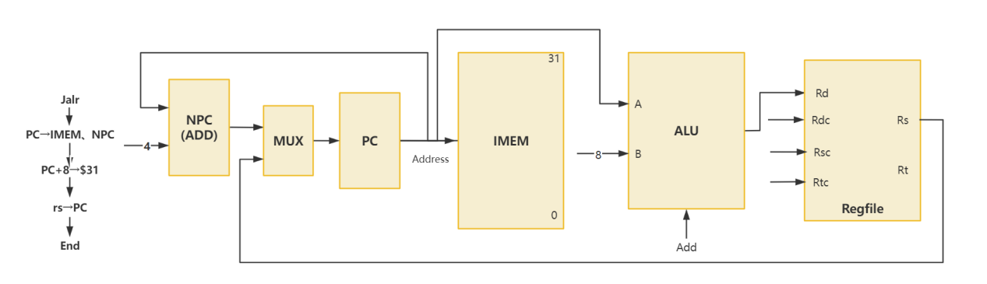

1. BREAK

|  |  |  |  |  |  |  |
| --- | --- | --- | --- | --- | --- | --- |
| 指令 | PC | NPC | IMEM | CP0 | | |
| PC | Rd | wData |
| BREAK | 0x4 | PC | PC | PC |  |  |

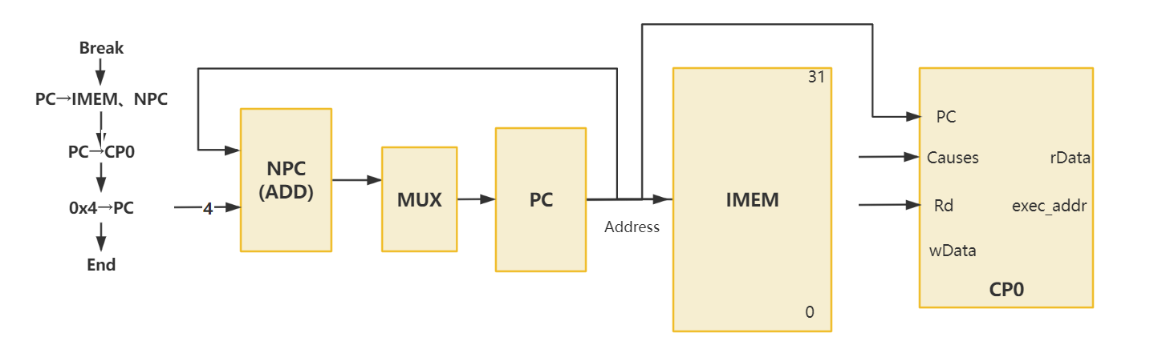

1. SYSCALL

|  |  |  |  |  |  |  |
| --- | --- | --- | --- | --- | --- | --- |
| 指令 | PC | NPC | IMEM | CP0 | | |
| PC | Rd | wData |
| SYSCALL | 0x4 | PC | PC | PC |  |  |

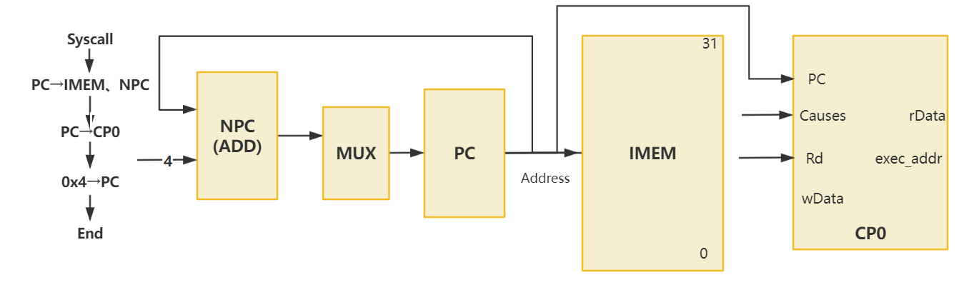

1. TEQ(Z=1)

|  |  |  |  |  |  |  |  |  |
| --- | --- | --- | --- | --- | --- | --- | --- | --- |
| 指令 | PC | NPC | IMEM | ALU | | CP0 | | |
| A | B | PC | Rd | wData |
| TEQ | 0x4 | PC | PC | Rs | Rt | PC |  |  |

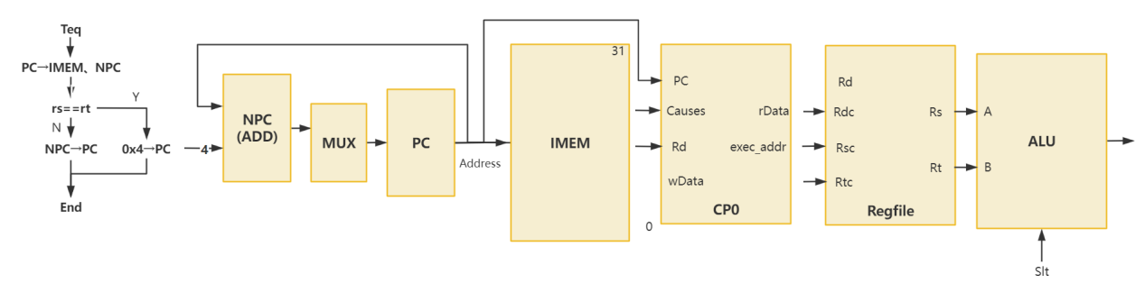

1. MFC0

|  |  |  |  |  |  |  |  |
| --- | --- | --- | --- | --- | --- | --- | --- |
| 指令 | PC | NPC | IMEM | Regfile | CP0 | | |
| Rd | PC | Rd | wData |
| MFC0 | NPC | PC | PC | rData(CP0) |  | Rd |  |

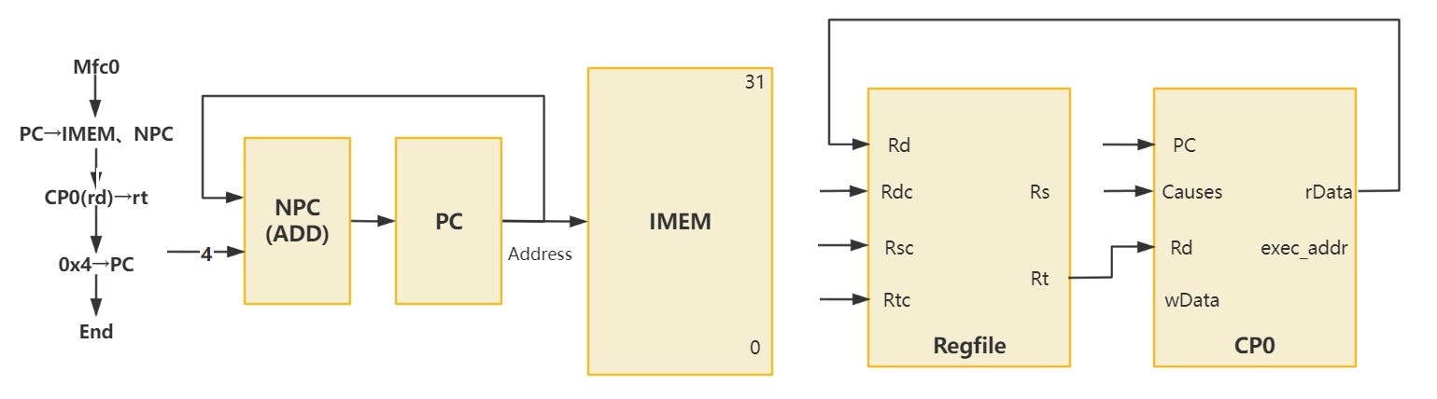

1. MTC0

|  |  |  |  |  |  |  |
| --- | --- | --- | --- | --- | --- | --- |
| 指令 | PC | NPC | IMEM | CP0 | | |
| PC | Rd | wData |
| MTC0 | NPC | PC | PC |  | Rd | Rt |

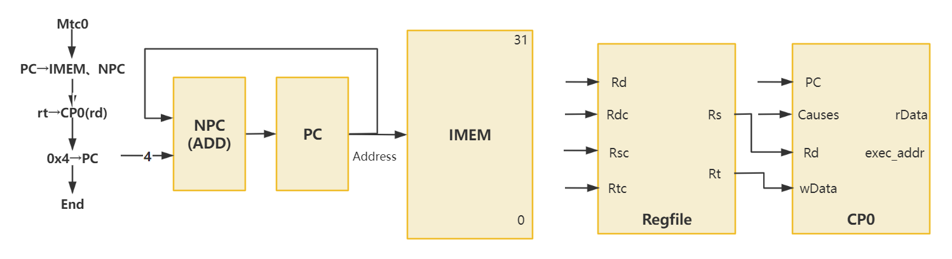

1. ERET

|  |  |  |  |
| --- | --- | --- | --- |
| 指令 | PC | NPC | IMEM |
|
| ERET | exc_addr(CP0) | PC | PC |

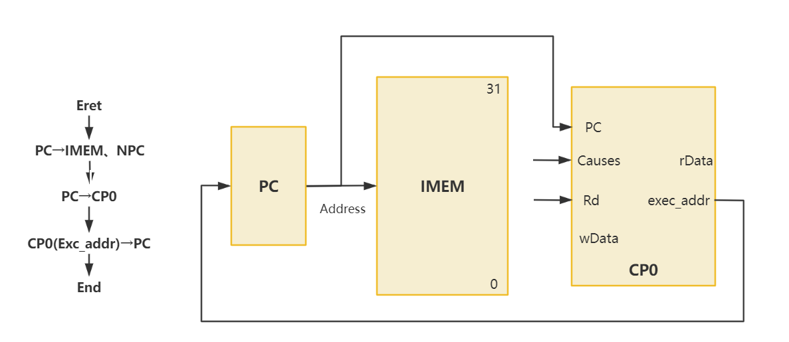

1. CLZ

|  |  |  |  |  |  |
| --- | --- | --- | --- | --- | --- |
| 指令 | PC | NPC | IMEM | Regfile | CAL |
| Rd |
| CLZ | NPC | PC | PC | CAL | Rs |

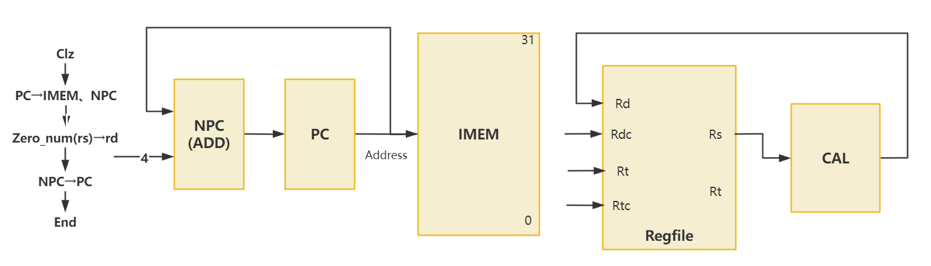

## 完整数据通路

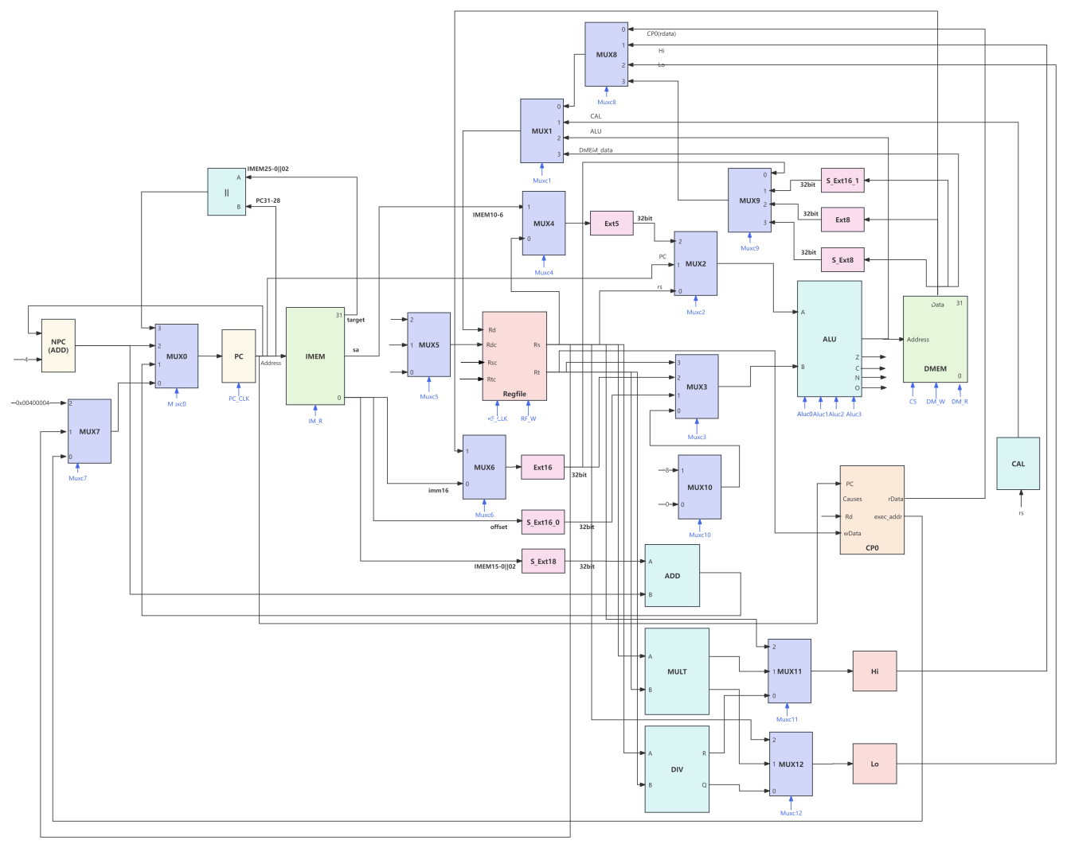

# CPU控制部件设计

## 指令操作时间表

1. **选择器控制信号的指令操作时间表**

|  |  |  |  |  |  |  |  |  |  |  |  |
| --- | --- | --- | --- | --- | --- | --- | --- | --- | --- | --- | --- |
| 控制器信号 | ADD | ADDU | SUB | SUBU | AND | OR | XOR | NOR | SLT | SLTU | SLL |
| mux0 | 2 | 2 | 2 | 2 | 2 | 2 | 2 | 2 | 2 | 2 | 2 |
| mux1 | 2 | 2 | 2 | 2 | 2 | 2 | 2 | 2 | 2 | 2 | 2 |
| mux2 | 0 | 0 | 0 | 0 | 0 | 0 | 0 | 0 | 0 | 0 | 2 |
| mux3 | 3 | 3 | 3 | 3 | 3 | 3 | 3 | 3 | 3 | 3 | 3 |
| mux4 | 0 | 0 | 0 | 0 | 0 | 0 | 0 | 0 | 0 | 0 | 1 |
| mux5 | 2 | 2 | 2 | 2 | 2 | 2 | 2 | 2 | 2 | 2 | 2 |
| mux6 |  |  |  |  |  |  |  |  |  |  |  |
| mux7 |  |  |  |  |  |  |  |  |  |  |  |
| mux8 |  |  |  |  |  |  |  |  |  |  |  |
| mux9 |  |  |  |  |  |  |  |  |  |  |  |
| mux10 |  |  |  |  |  |  |  |  |  |  |  |
| mux11 |  |  |  |  |  |  |  |  |  |  |  |
| mux12 |  |  |  |  |  |  |  |  |  |  |  |

（续表）

|  |  |  |  |  |  |  |  |  |  |  |  |
| --- | --- | --- | --- | --- | --- | --- | --- | --- | --- | --- | --- |
| 控制器信号 | SRL | SRA | SLLV | SRLV | SRAV | JR | ADDI | ADDIU | ANDI | ORI | XORI |
| mux0 | 2 | 2 | 2 | 2 | 2 | 0 | 2 | 2 | 2 | 2 | 2 |
| mux1 | 2 | 2 | 2 | 2 | 2 | 2 | 2 | 2 | 2 | 2 | 2 |
| mux2 | 2 | 2 | 2 | 2 | 2 | 0 | 0 | 0 | 0 | 0 | 0 |
| mux3 | 3 | 3 | 3 | 3 | 3 | 3 | 1 | 1 | 2 | 2 | 2 |
| mux4 | 1 | 1 | 0 | 0 | 0 | 0 | 0 | 0 | 0 | 0 | 0 |
| mux5 | 2 | 2 | 2 | 2 | 2 | 2 | 1 | 1 | 1 | 1 | 1 |
| mux6 |  |  |  |  |  |  |  |  | 0 | 0 | 0 |
| mux7 |  |  |  |  |  | 1 |  |  |  |  |  |
| mux8 |  |  |  |  |  |  |  |  |  |  |  |
| mux9 |  |  |  |  |  |  |  |  |  |  |  |
| mux10 |  |  |  |  |  |  |  |  |  |  |  |
| mux11 |  |  |  |  |  |  |  |  |  |  |  |
| mux12 |  |  |  |  |  |  |  |  |  |  |  |

（续表）

|  |  |  |  |  |  |  |  |  |  |  |  |
| --- | --- | --- | --- | --- | --- | --- | --- | --- | --- | --- | --- |
| 控制器信号 | LW | SW | BEQ (Z=1) | BNE (Z=0) | SLTI | SLTIU | LUI | J | JAL | DIV | DIVU |
| mux0 | 2 | 2 | 1 | 1 | 2 | 2 | 2 | 3 | 3 | 2 | 2 |
| mux1 | 3 | 2 | 2 | 2 | 2 | 2 | 2 | 2 | 2 |  |  |
| mux2 | 0 | 0 | 0 | 0 | 0 | 0 | 0 | 0 | 1 |  |  |
| mux3 | 1 | 1 | 3 | 3 | 1 | 1 | 2 | 3 | 0 |  |  |
| mux4 | 0 | 0 | 0 | 0 | 0 | 0 | 0 | 0 | 0 |  |  |
| mux5 | 1 | 2 | 2 | 2 | 1 | 1 | 1 | 2 | 0 |  |  |
| mux6 |  |  |  |  |  |  | 0 |  |  |  |  |
| mux7 |  |  |  |  |  |  |  |  |  |  |  |
| mux8 |  |  |  |  |  |  |  |  |  |  |  |
| mux9 |  |  |  |  |  |  |  |  |  |  |  |
| mux10 |  |  |  |  |  |  |  |  | 1 |  |  |
| mux11 |  |  |  |  |  |  |  |  |  | 0 | 0 |
| mux12 |  |  |  |  |  |  |  |  |  | 0 | 0 |

（续表）

|  |  |  |  |  |  |  |  |  |  |  |  |
| --- | --- | --- | --- | --- | --- | --- | --- | --- | --- | --- | --- |
| 控制器信号 | MULT | MULTU | MFLO | MFHI | MTLO | MTHI | LB | LBU | LH | LHU | SB |
| mux0 | 2 | 2 | 2 | 2 | 2 | 2 | 2 | 2 | 2 | 2 | 2 |
| mux1 |  |  | 0 | 0 |  |  | 0 | 0 | 0 | 0 |  |
| mux2 |  |  |  |  |  |  | 0 | 0 | 0 | 0 | 0 |
| mux3 |  |  |  |  |  |  | 1 | 1 | 1 | 1 | 1 |
| mux4 |  |  |  |  |  |  |  |  |  |  |  |
| mux5 |  |  | 2 | 2 |  |  | 1 | 1 | 1 | 1 |  |
| mux6 |  |  |  |  |  |  |  |  |  | 1 |  |
| mux7 |  |  |  |  |  |  |  |  |  |  |  |
| mux8 |  |  | 2 | 1 |  |  | 3 | 3 | 3 | 3 |  |
| mux9 |  |  |  |  |  |  | 1 | 2 | 3 | 0 |  |
| mux10 |  |  |  |  |  |  |  |  |  |  |  |
| mux11 | 1 | 1 |  |  |  | 2 |  |  |  |  |  |
| mux12 | 1 | 1 |  |  | 2 |  |  |  |  |  |  |

（续表）

|  |  |  |  |  |  |  |  |  |  |  |
| --- | --- | --- | --- | --- | --- | --- | --- | --- | --- | --- |
| 控制器信号 | SH | BGEZ  (N=0) | JALR | BREAK | SYSCALL | TEQ (Z=1) | MFC0 | MTC0 | ERET | CLZ |
| mux0 | 2 | 1 | 0 | 0 | 0 | 0 | 2 | 2 | 0 | 2 |
| mux1 |  |  | 2 |  |  |  | 0 |  |  | 1 |
| mux2 | 0 | 0 | 1 |  |  | 0 |  |  |  |  |
| mux3 | 1 | 0 | 0 |  |  | 3 |  |  |  |  |
| mux4 |  |  |  |  |  |  |  |  |  |  |
| mux5 |  |  | 2 |  |  |  | 1 |  |  | 2 |
| mux6 |  |  |  |  |  |  |  |  |  |  |
| mux7 |  |  | 1 | 2 | 2 | 2 |  |  | 0 |  |
| mux8 |  |  |  |  |  |  | 0 |  |  |  |
| mux9 |  |  |  |  |  |  |  |  |  |  |
| mux10 |  | 0 | 1 |  |  |  |  |  |  |  |
| mux11 |  |  |  |  |  |  |  |  |  |  |
| mux12 |  |  |  |  |  |  |  |  |  |  |

1. **其余微操作信号的指令操作时间表**

|  |  |  |  |  |  |  |  |
| --- | --- | --- | --- | --- | --- | --- | --- |
| 微操作信号 | ADD | ADDU | SUB | SUBU | AND | OR | XOR |
| PC_CLK | 1 | 1 | 1 | 1 | 1 | 1 | 1 |
| IM_R | 1 | 1 | 1 | 1 | 1 | 1 | 1 |
| Rsc4-0 | IM25-21 | IM25-21 | IM25-21 | IM25-21 | IM25-21 | IM25-21 | IM25-21 |
| Rtc4-0 | IM20-16 | IM20-16 | IM20-16 | IM20-16 | IM20-16 | IM20-16 | IM20-16 |
| ALUC3 | 0 | 0 | 0 | 0 | 0 | 0 | 0 |
| ALUC2 | 0 | 0 | 0 | 0 | 1 | 1 | 1 |
| ALUC1 | 1 | 0 | 1 | 0 | 0 | 0 | 1 |
| ALUC0 | 0 | 0 | 1 | 1 | 0 | 1 | 0 |
| Rdc4-0 | IM15-11 | IM15-11 | IM15-11 | IM15-11 | IM15-11 | IM15-11 | IM15-11 |
| RF_W | 1 | 1 | 1 | 1 | 1 | 1 | 1 |
| RF_CLK | 1 | 1 | 1 | 1 | 1 | 1 | 1 |
| DM_ena | 0 | 0 | 0 | 0 | 0 | 0 | 0 |
| DM_R | 0 | 0 | 0 | 0 | 0 | 0 | 0 |
| DM_W | 0 | 0 | 0 | 0 | 0 | 0 | 0 |
| Signed_mult |  |  |  |  |  |  |  |
| Signed_div |  |  |  |  |  |  |  |
| exception |  |  |  |  |  |  |  |
| Rd_CP0 |  |  |  |  |  |  |  |
| hi-ena | 0 | 0 | 0 | 0 | 0 | 0 | 0 |
| lo-ena | 0 | 0 | 0 | 0 | 0 | 0 | 0 |

（续表）

|  |  |  |  |  |  |  |  |
| --- | --- | --- | --- | --- | --- | --- | --- |
| 微操作信号 | NOR | SLT | SLTU | SLL | SRL | SRA | SLLV |
| PC_CLK | 1 | 1 | 1 | 1 | 1 | 1 | 1 |
| IM_R | 1 | 1 | 1 | 1 | 1 | 1 | 1 |
| Rsc4-0 | IM25-21 | IM25-21 | IM25-21 |  |  |  | IM25-21 |
| Rtc4-0 | IM20-16 | IM20-16 | IM20-16 | IM20-16 | IM20-16 | IM20-16 | IM20-16 |
| ALUC3 | 0 | 1 | 1 | 1 | 1 | 1 | 1 |
| ALUC2 | 1 | 0 | 0 | 1 | 1 | 1 | 1 |
| ALUC1 | 1 | 1 | 1 | 1 | 0 | 0 | 1 |
| ALUC0 | 1 | 1 | 0 | 0 | 1 | 0 | 0 |
| Rdc4-0 | IM15-11 | IM15-11 | IM15-11 | IM15-11 | IM15-11 | IM15-11 | IM15-11 |
| RF_W | 1 | 1 | 1 | 1 | 1 | 1 | 1 |
| RF_CLK | 1 | 1 | 1 | 1 | 1 | 1 | 1 |
| DM_ena | 0 | 0 | 0 | 0 | 0 | 0 | 0 |
| DM_R | 0 | 0 | 0 | 0 | 0 | 0 | 0 |
| DM_W | 0 | 0 | 0 | 0 | 0 | 0 | 0 |
| Signed_mult |  |  |  |  |  |  |  |
| Signed_div |  |  |  |  |  |  |  |
| exception |  |  |  |  |  |  |  |
| Rd_CP0 |  |  |  |  |  |  |  |
| hi-ena | 0 | 0 | 0 | 0 | 0 | 0 | 0 |
| lo-ena | 0 | 0 | 0 | 0 | 0 | 0 | 0 |

（续表）

|  |  |  |  |  |  |  |  |
| --- | --- | --- | --- | --- | --- | --- | --- |
| 微操作信号 | SRLV | SRAV | JR | ADDI | ADDIU | ANDI | ORI |
| PC_CLK | 1 | 1 | 1 | 1 | 1 | 1 | 1 |
| IM_R | 1 | 1 | 1 | 1 | 1 | 1 | 1 |
| Rsc4-0 | IM25-21 | IM25-21 | IM25-21 | IM25-21 | IM25-21 | IM25-21 | IM25-21 |
| Rtc4-0 | IM20-16 | IM20-16 |  |  |  |  |  |
| ALUC3 | 1 | 1 | 0 | 0 | 0 | 0 | 0 |
| ALUC2 | 1 | 1 | 0 | 0 | 0 | 1 | 1 |
| ALUC1 | 0 | 0 | 0 | 1 | 0 | 0 | 0 |
| ALUC0 | 1 | 0 | 0 | 0 | 0 | 0 | 1 |
| Rdc4-0 | IM15-11 | IM15-11 |  | IM20-16 | IM20-16 | IM20-16 | IM20-16 |
| RF_W | 1 | 1 | 0 | 1 | 1 | 1 | 1 |
| RF_CLK | 1 | 1 | 0 | 1 | 1 | 1 | 1 |
| DM_ena | 0 | 0 | 0 | 0 | 0 | 0 | 0 |
| DM_R | 0 | 0 | 0 | 0 | 0 | 0 | 0 |
| DM_W | 0 | 0 | 0 | 0 | 0 | 0 | 0 |
| Signed_mult |  |  |  |  |  |  |  |
| Signed_div |  |  |  |  |  |  |  |
| exception |  |  |  |  |  |  |  |
| Rd_CP0 |  |  |  |  |  |  |  |
| hi-ena | 0 | 0 | 0 | 0 | 0 | 0 | 0 |
| lo-ena | 0 | 0 | 0 | 0 | 0 | 0 | 0 |

（续表）

|  |  |  |  |  |  |  |  |
| --- | --- | --- | --- | --- | --- | --- | --- |
| 微操作信号 | XORI | LW | SW | BEQ(Z=1) | BNE(Z=0) | SLTI | SLTIU |
| PC_CLK | 1 | 1 | 1 | 1 | 1 | 1 | 1 |
| IM_R | 1 | 1 | 1 | 1 | 1 | 1 | 1 |
| Rsc4-0 | IM25-21 | IM25-21 | IM25-21 | IM25-21 | IM25-21 | IM25-21 | IM25-21 |
| Rtc4-0 |  |  | IM20-16 | IM20-16 | IM20-16 |  |  |
| ALUC3 | 0 | 0 | 0 | 0 | 0 | 1 | 1 |
| ALUC2 | 1 | 0 | 0 | 0 | 0 | 0 | 0 |
| ALUC1 | 1 | 1 | 1 | 1 | 1 | 1 | 1 |
| ALUC0 | 0 | 0 | 0 | 1 | 1 | 1 | 0 |
| Rdc4-0 | IM20-16 | IM20-16 |  |  |  | IM20-16 | IM20-16 |
| RF_W | 1 | 1 | 0 | 0 | 0 | 1 | 1 |
| RF_CLK | 1 | 1 | 0 | 0 | 0 | 1 | 1 |
| DM_ena | 0 | 1 | 1 | 0 | 0 | 0 | 0 |
| DM_R | 0 | 1 | 0 | 0 | 0 | 0 | 0 |
| DM_W | 0 | 0 | 1 | 0 | 0 | 0 | 0 |
| Signed_mult |  |  |  |  |  |  |  |
| Signed_div |  |  |  |  |  |  |  |
| exception |  |  |  |  |  |  |  |
| Rd_CP0 |  |  |  |  |  |  |  |
| hi-ena | 0 | 0 | 0 | 0 | 0 | 0 | 0 |
| lo-ena | 0 | 0 | 0 | 0 | 0 | 0 | 0 |

（续表）

|  |  |  |  |  |  |  |  |
| --- | --- | --- | --- | --- | --- | --- | --- |
| 微操作信号 | LUI | J | JAL | DIV | DIVU | MULT | MULTU |
| PC_CLK | 1 | 1 | 1 | 1 | 1 | 1 | 1 |
| IM_R | 1 | 1 | 1 | 1 | 1 | 1 | 1 |
| Rsc4-0 |  |  |  | IM25-21 | IM25-21 | IM25-21 | IM25-21 |
| Rtc4-0 |  |  |  | IM20-16 | IM20-16 | IM20-16 | IM20-16 |
| ALUC3 | 1 | 0 | 0 |  |  |  |  |
| ALUC2 | 0 | 0 | 0 |  |  |  |  |
| ALUC1 | 0 | 0 | 0 |  |  |  |  |
| ALUC0 | 0 | 0 | 0 |  |  |  |  |
| Rdc4-0 | IM20-16 |  | $31 |  |  |  |  |
| RF_W | 1 | 0 | 1 | 0 | 0 | 0 | 0 |
| RF_CLK | 1 | 0 | 1 | 0 | 0 | 0 | 0 |
| DM_ena | 0 | 0 | 0 | 0 | 0 | 0 | 0 |
| DM_R | 0 | 0 | 0 | 0 | 0 | 0 | 0 |
| DM_W | 0 | 0 | 0 | 0 | 0 | 0 | 0 |
| Signed_mult |  |  |  |  |  | 1 | 0 |
| Signed_div |  |  |  | 1 | 0 |  |  |
| exception |  |  |  |  |  |  |  |
| Rd_CP0 |  |  |  |  |  |  |  |
| hi-ena | 0 | 0 | 0 | 1 | 1 | 1 | 1 |
| lo-ena | 0 | 0 | 0 | 1 | 1 | 1 | 1 |

（续表）

|  |  |  |  |  |  |  |  |
| --- | --- | --- | --- | --- | --- | --- | --- |
| 微操作信号 | MFLO | MFHI | MTLO | MTHI | LB | LBU | LH |
| PC_CLK | 1 | 1 | 1 | 1 | 1 | 1 | 1 |
| IM_R | 1 | 1 | 1 | 1 | 1 | 1 | 1 |
| Rsc4-0 |  |  | IM25-21 | IM25-21 | IM25-21 | IM25-21 | IM25-21 |
| Rtc4-0 |  |  |  |  |  |  |  |
| ALUC3 |  |  |  |  | 0 | 0 | 0 |
| ALUC2 |  |  |  |  | 0 | 0 | 0 |
| ALUC1 |  |  |  |  | 1 | 1 | 1 |
| ALUC0 |  |  |  |  | 0 | 0 | 0 |
| Rdc4-0 | IM15-11 | IM15-11 |  |  | IM20-16 | IM20-16 | IM20-16 |
| RF_W | 1 | 1 | 0 | 0 | 1 | 1 | 1 |
| RF_CLK | 1 | 1 | 0 | 0 | 1 | 1 | 1 |
| DM_ena | 0 | 0 | 0 | 0 | 1 | 1 | 1 |
| DM_R | 0 | 0 | 0 | 0 | 1 | 1 | 1 |
| DM_W | 0 | 0 | 0 | 0 | 0 | 0 | 0 |
| Signed_mult |  |  |  |  |  |  |  |
| Signed_div |  |  |  |  |  |  |  |
| exception |  |  |  |  |  |  |  |
| Rd_CP0 |  |  |  |  |  |  |  |
| hi-ena | 0 | 0 | 0 | 1 | 0 | 0 | 0 |
| lo-ena | 0 | 0 | 1 | 0 | 0 | 0 | 0 |

（续表）

|  |  |  |  |  |  |  |  |
| --- | --- | --- | --- | --- | --- | --- | --- |
| 微操作信号 | LHU | SB | SH | BGEZ(N=0) | JALR | BREAK | SYSCALL |
| PC_CLK | 1 | 1 | 1 | 1 | 1 | 1 | 1 |
| IM_R | 1 | 1 | 1 | 1 | 1 | 1 | 1 |
| Rsc4-0 | IM25-21 | IM25-21 | IM25-21 | IM25-21 | IM25-21 |  |  |
| Rtc4-0 |  | IM20-16 | IM20-16 |  |  |  |  |
| ALUC3 | 0 | 0 | 0 | 0 | 0 |  |  |
| ALUC2 | 0 | 0 | 0 | 0 | 0 |  |  |
| ALUC1 | 1 | 1 | 1 | 1 | 1 |  |  |
| ALUC0 | 0 | 0 | 0 | 1 | 0 |  |  |
| Rdc4-0 | IM20-16 |  |  |  | IM15-11 |  |  |
| RF_W | 1 | 0 | 0 | 0 | 1 | 0 | 0 |
| RF_CLK | 1 | 0 | 0 | 0 | 1 | 0 | 0 |
| DM_ena | 1 | 1 | 1 | 0 | 0 | 0 | 0 |
| DM_R | 1 | 0 | 0 | 0 | 0 | 0 | 0 |
| DM_W | 0 | 1 | 1 | 0 | 0 | 0 | 0 |
| Signed_mult |  |  |  |  |  |  |  |
| Signed_div |  |  |  |  |  |  |  |
| exception |  |  |  |  |  | 1 | 1 |
| Rd_CP0 |  |  |  |  |  |  |  |
| hi-ena | 0 | 0 | 0 | 0 | 0 | 0 | 0 |
| lo-ena | 0 | 0 | 0 | 0 | 0 | 0 | 0 |

（续表）

|  |  |  |  |  |  |  |  |
| --- | --- | --- | --- | --- | --- | --- | --- |
| 微操作信号 | TEQ(Z=1) | MFC0 | MTC0 | ERET | CLZ |  |  |
| PC_CLK | 1 | 1 | 1 | 1 | 1 |  |  |
| IM_R | 1 | 1 | 1 | 1 | 1 |  |  |
| Rsc4-0 | IM25-21 |  |  |  | IM25-21 |  |  |
| Rtc4-0 | IM20-16 |  | IM20-16 |  |  |  |  |
| ALUC3 | 0 |  |  |  |  |  |  |
| ALUC2 | 0 |  |  |  |  |  |  |
| ALUC1 | 1 |  |  |  |  |  |  |
| ALUC0 | 1 |  |  |  |  |  |  |
| Rdc4-0 |  | IM20-16 |  |  | IM15-11 |  |  |
| RF_W | 0 | 1 | 0 | 0 | 1 |  |  |
| RF_CLK | 0 | 1 | 0 | 0 | 1 |  |  |
| DM_ena | 0 | 0 | 0 | 0 | 0 |  |  |
| DM_R | 0 | 0 | 0 | 0 | 0 |  |  |
| DM_W | 0 | 0 | 0 | 0 | 0 |  |  |
| Signed_mult |  |  |  |  |  |  |  |
| Signed_div |  |  |  |  |  |  |  |
| exception | Z=1 |  |  |  |  |  |  |
| Rd_CP0 |  | IM15-11 | IM15-11 |  |  |  |  |
| hi-ena | 0 | 0 | 0 | 0 | 0 |  |  |
| lo-ena | 0 | 0 | 0 | 0 | 0 |  |  |

1. **ALU操作信号说明**

|  |  |  |  |  |  |
| --- | --- | --- | --- | --- | --- |
| 指令 | ALUC3 | ALUC2 | ALUC1 | ALUC0 | 备注 |
| Addu | 0 | 0 | 0 | 0 | ALU完成“无符号加” |
| Subu | 0 | 0 | 0 | 1 | ALU完成“无符号减” |
| Add | 0 | 0 | 1 | 0 | ALU完成“有符号加” |
| Sub | 0 | 0 | 1 | 1 | ALU完成“有符号减” |
| And | 0 | 1 | 0 | 0 | ALU完成“按位与” |
| Or | 0 | 1 | 0 | 1 | ALU完成“按位或” |
| Xor | 0 | 1 | 1 | 0 | ALU完成“按位异或” |
| Nor | 0 | 1 | 1 | 1 | ALU完成“按位或非” |
| Lui | 1 | 0 | 0 | x | ALU完成“置高位立即数” |
| Sltu | 1 | 0 | 1 | 0 | ALU完成“无符号小于比较” |
| Slt | 1 | 0 | 1 | 1 | ALU完成“小于比较” |
| Sra | 1 | 1 | 0 | 0 | ALU完成“算术右移” |
| Srl | 1 | 1 | 0 | 1 | ALU完成“逻辑右移” |
| Sll | 1 | 1 | 1 | x | ALU完成“逻辑左移与算术左移” |

1. **其余操作信号说明**

|  |  |
| --- | --- |
| 信号 | 备注 |
| PC_CLK | CPU工作主频 |
| IM_R | 代码存储器读信号 |
| Rsc4-0 | Rs寄存器选择输入控制端 |
| Rtc4-0 | Rt寄存器选择输入控制端 |
| M3_1 | MUX3选择器控制端1 |
| M3_0 | MUX3选择器控制端0 |
| M4_1 | MUX4选择器控制端1 |
| M4_0 | MUX4选择器控制端0 |
| ALUC3 | ALU控制端3 |
| ALUC2 | ALU控制端2 |
| ALUC1 | ALU控制端1 |
| ALUC0 | ALU控制端0 |
| M2 | MUX2选择器控制端1 |
| Rdc4-0 | Rd寄存器选择输入控制端 |
| RF_W | Regfile写信号 |
| RF_CLK | Regfile时钟 |
| M1_1 | MUX1选择器控制端 |
| M1_0 | MUX1选择器控制端 |
| DM_R | 数据存储器读信号 |
| DM_W | 数据存储器写信号 |
| M5 | MUX5选择器控制端 |

## 控制信号逻辑表达式

**Pc_clk**=1

**Imem_R**=1

**Rsc4-0**=ADD+ADDU+SUB+SUBU+AND+OR+XOR+NOR+SLT+SLTU+SLLV+SRLV+SRAV+JR+ADDI+ADDIU+ANDI+ORI+XORI+LW+SW+BEQ*Z+BNE*~Z+SLTI+SLTIU+DIV+DIVU+MULT+MULTU+MLTO+MTHI+LB+LBU+LH+TEQ*Z+CLZ

**Rtc4-0**=ADD+ADDU+SUB+SUBU+AND+OR+XOR+NOR+SLT+SLTU+SLL+SRL+SRA+SLLV+SRLV+SRAV+SW+BEQ*Z+BNE*~Z+DIV+DIVU+MULT+MULTU+TEQ*Z+MTC0

**Rdc4-0**=ADD+ADDU+SUB+SUBU+AND+OR+XOR+NOR+SLT+SLTU+SLL+SRL+SRA+SLLV+SRLV+SRAV+ADDI+ADDIU+ANDI+ORI+XORI+LW+SLTI+SLTIU+LUI+JAL+MFLO+MFHI+LB+LBU+LH+MFC0+CLZ

**Aluc3**=SLT+SLTU+SLL+SRL+SRA+SLLV+SRLV+SRAV+SLTI+SLTIU+LUI

**Aluc2**=AND+OR+XOR+NOR+SLL+SRL+SRA+SLLV+SRLV+SRAV+ANDI+ORI+XORI

**Aluc1**=ADD+SUB+XOR+NOR+SLT+SLTU+SLL+SLLV+ADDI+XORI+LW+SW+BEQ*Z+BNE*~Z+SLTI+SLTIU+LB+LBU+LH+TEQ*Z

**Aluc0**=SUB+SUBU+OR+NOR+SLT+SRL+SRLV+ORI+BEQ*Z+BNE*~Z+SLTI+TEQ*Z

**RF_W**=~(JR+SW+BEQ*Z+BNE*~Z+J+DIV+DIVU+MULT+MULTU+MTLO+MTHI+TEQ*Z+MTC0+ERET)

**RF_CLK**=RF_W

**DM_R**=LW+LB+LBU+LH

**DM_W**=SW

**DM_ena**=DM_W+DM_R

**Signed_mult**=MULT

**Signed_div**=DIV

**Rd_CP0**=MFC0+MTC0

**Hi_ena**=DIV+DIVU+MULT+MULTU+MTHI

**Lo_ena**=DIV+DIVU+MULT+MULTU+MTLO

## 控制部件设计

1. **设计思路**

本次实验的CPU主要分为运算器和控制器两部分。通过代码编写或直接实例化模块，可以完成下述模块的实现，包括：算术逻辑运算单元ALU、指令译码器decoder、程序计数器PC、寄存器堆RegFile、中断寄存器CP0、高位地位寄存器HiLo、前导零计数器CAL、乘法器Multiplier、除法器Divider以及控制器controller。对于拓展模块Ext和选择器Mux，直接通过Verilog语言中的级联语法、三目运算符等实现，没有使用具体的module。对于内存模块，分为指令存储器IMEM和地址数据存储器DMEM两部分，分别用不同的module实现。

1. ALU：直接实例化上学期数字逻辑中的代码。
2. Decoder：实例化模块，通过输入的指令内容判断解码生成当前组要完成的操作。
3. PC：实例化reg变量，存储当前正在执行的指令地址，并给出下一条将要执行的指令所在地址。
4. Regfile：直接在模块内声明合适大小的reg变量。
5. MEM：存储器部分，分为DMEM和IMEM两部分。DMEM通过声明合适大小的reg变量实现，IMEM通过实例化IP核实现。
6. CP0：中断寄存器部分，存储中断发生时必要的PC地址以及数据等，通过实例化reg变量实现。
7. Multipier、Divider：乘法器和除法器部分，分为有符号和无符号运算两种。
8. CAL：计算输入数据的前导零模块。
9. HiLo：高位和低位寄存器模块，直接实例化reg变量实现。
10. Cpu：对上述的除存 MEM 以外的其他模块进行实例化，协调这些模块元件之间的数据流向并将他们通过内部变量链接。
11. Dataflow：顶层的数据通路，完成 cpu 各部件与存储器 mem 之间的数据通路联系，由于本次 CPU 设计中不涉及外围设备 I/O，所以我们只需要协调这两部分之间的数据传输即可。
12. **代码**
13. 接口定义

//cpu模块

module cpu(

    input clk,

    input ena,

    input rst_n,

    input [31:0] in_instr,                                //指令

    input [31:0] dmem_out_data,                 //读取到的dmem中的数据

    output [31:0] dmem_in_data,                //写入dmem中的数据

    output dmem_ena,                                //启用dmem信号

    output dmem_W,                                   //dmem写信号

    output dmem_R,                                    //dmem读信号

    output [5:0] dmem_opr,                                 //dmem写入方式

    output [31:0] out_pc,                              //输出指令地址

    output [31:0] dmem_addr                      //dmem启用地址

    );

1. Verilog代码

//2252429蔡宇轩

`timescale 1ns / 1ps

//cpu模块

module cpu(

    input clk,

    input ena,

    input rst_n,

    input [31:0] in_instr,                                //指令

    input [31:0] dmem_out_data,                 //读取到的dmem中的数据

    output [31:0] dmem_in_data,                //写入dmem中的数据

    output dmem_ena,                                //启用dmem信号

    output dmem_W,                                   //dmem写信号

    output dmem_R,                                    //dmem读信号

    output [5:0] dmem_opr,                                 //dmem写入方式

    output [31:0] out_pc,                              //输出指令地址

    output [31:0] dmem_addr                      //dmem启用地址

    );

//---------------------------------------------------------------

//内部连线变量

    /*decoder用*/

    wire is_add, is_addu, is_sub, is_subu, is_and, is_or, is_xor, is_nor, is_slt, is_sltu,

    is_sra, is_srl, is_sll, is_srav, is_srlv, is_sllv, is_jr, is_addi, is_addiu, is_andi,

    is_ori, is_xori, is_lw, is_sw, is_beq, is_bne, is_slti, is_sltiu, is_lui, is_j,

    is_jal, is_div, is_divu, is_mult, is_multu, is_mflo, is_mfhi, is_mtlo, is_mthi, is_lb,

    is_lbu, is_lh, is_lhu, is_sb, is_sh, is_bgez, is_jalr, is_break, is_syscall, is_teq,

    is_mfc0, is_mtc0, is_eret, is_clz;              //各指令标志信息

    wire [4:0] Rsc,Rtc,Rdc;                            //寄存器对应地址

    wire [4:0] shamt;                                   //偏移量

    wire [15:0] immediate;                          //立即数

    wire [25:0] address;                                //跳转地址（J型指令用）

    /*ALU用*/

    wire [31:0] alu_A,alu_B;                                        //运算数

    wire [3:0] aluc;                                        //ALU功能选择信号

    wire [31:0] alu_result;                             //运算结果

    wire Z,C,N,O;                                           //运算标志位

    /*DIV用*/

    wire signed_div;                                    //有无符号功能选择信号

    wire [31:0] div_A,div_B,R,Q;                                //运算数及结果

    /*MULT用*/

    wire signed_mult;                                   //有无符号功能选择信号

    wire [31:0] mult_A,mult_B,Hi,Lo;                              //运算数及结果

    /*HiLo用*/

    wire Hi_W,Lo_W;                                     //HILO寄存器写使能信号

    wire [31:0] Hi_in_data, Hi_out_data;       //HI data

    wire [31:0] Lo_in_data, Lo_out_data;       //LO data

    /*regfile用*/

    //寄存器对应地址rsc,rtc,rdc已在decoder部分定义

    //使能写信号reg_W在controller部分定义

    //此处定义数据部分

    wire [31:0] rs_out_data, rt_out_data;

    wire [31:0] rd_in_data;

    /*PC用*/

    wire [31:0] pc_in_next_addr;

    wire [31:0] pc_out_now_addr;

    /*controller用*/

    //所有指令标志已在decoder部分定义

    //Z，N在ALU部分定义

    wire [1:0] muxc [12:0];           //多路选择器信号

    //aluc信号已在ALU部分定义

    //signed div,signed mult已在MULT DIV部分定义

    wire ext5, ext8, s_ext8,  ext16, s_ext16_0, s_ext16_1, s_ext18;    //拓展部件使能信号

    //dmem R and W已在本模块定义

    wire reg_W;

    //Hi Lo使能写信号已在HILO部分定义

    wire cat;                     //数位拼接使能信号

    wire exception;         //CP0使能信号

    /*CP0用*/

    //mfc0 = is_mfc0,  mtc0 = is_mtc0,  eret = is_eret

    //pc=pc_out_now_addr

    wire [4:0] Rd;              //CP0中寄存器编号

    //exception在controller部分定义

    wire [31:0] rdata, wdata;

    wire [31:0] exec_addr;

    reg [4:0] cause;

    /*CAL用*/

    wire [31:0] cal_in_data;

    wire [5:0] cal_out_result;

//内部工作变量

    //各拓展模块的实际输出

    wire [31:0] ext5_out,  ext8_out,  ext16_out;

    wire signed [31:0] s_ext8_out,  s_ext16_0_out,  s_ext16_1_out,  s_ext18_out;

    //拼接器的实际输出

    wire [31:0] cat_out;

    //npc

    wire [31:0] npc;

    //多路选择器的实际输出

    reg [31:0] mux_out [12:0];

//---------------------------------------------------------------

//连接各模块

    /*EXT*/

        assign ext5_out = (ext5) ? mux_out[4] : 32'hz;

        assign ext8_out = (ext8) ? dmem_out_data : 32'hz;

        assign s_ext8_out = (s_ext8) ? dmem_out_data : 32'hz;

        assign ext16_out = (ext16) ? mux_out[6] : 32'hz;

        assign s_ext16_0_out = (s_ext16_0) ? { {16{immediate[15]}} , immediate[15:0]} : 32'hz;

        assign s_ext16_1_out = (s_ext16_1) ? dmem_out_data : 32'hz;

        assign s_ext18_out = (s_ext18) ? {{14{immediate[15]}},immediate[15:0],2'h0} : 32'hz;

    /*NPC*/

        assign npc=pc_out_now_addr +4;

    /*MUX*/

    always @*begin

        //mux7

        if(muxc[7]==0) mux_out[7]=exec_addr;

        else if(muxc[7]==1) mux_out[7]=rs_out_data;

        else if(muxc[7]==2) mux_out[7]=32'h0040_0004;

        //mux0

        if(muxc[0]==0) mux_out[0]=mux_out[7];

        else if(muxc[0]==1) mux_out[0]=npc+s_ext18_out;

        else if(muxc[0]==2) mux_out[0]=npc;

        else if(muxc[0]==3) mux_out[0]=cat_out;

       //mux9

        if(muxc[9]==0) mux_out[9]=ext16_out;

        else if(muxc[9]==1) mux_out[9]=s_ext16_1_out;

        else if(muxc[9]==2) mux_out[9]=ext8_out;

        else if(muxc[9]==3) mux_out[9]=s_ext8_out;

        //mux8

        if(muxc[8]==0) mux_out[8]=rdata;

        else if(muxc[8]==1) mux_out[8]=Hi_out_data;

        else if(muxc[8]==2) mux_out[8]=Lo_out_data;

        else if(muxc[8]==3) mux_out[8]=mux_out[9];

        //mu1

        if(muxc[1]==0) mux_out[1]=mux_out[8];

        else if(muxc[1]==1) mux_out[1]=cal_out_result;

        else if(muxc[1]==2) mux_out[1]=alu_result;

        else if(muxc[1]==3) mux_out[1]=dmem_out_data;

        //mux2

        if(muxc[2]==0) mux_out[2]=rs_out_data;

        else if(muxc[2]==1) mux_out[2]=pc_out_now_addr;

        else if(muxc[2]==2) mux_out[2]=ext5_out;

        //mux10

        if(muxc[10]==1) mux_out[10]=4;

        else if(muxc[10]==0) mux_out[10]=0;

        //mux3

        if(muxc[3]==0) mux_out[3]=mux_out[10];

        else if(muxc[3]==1) mux_out[3]=s_ext16_0_out;

        else if(muxc[3]==2) mux_out[3]=ext16_out;

        else if(muxc[3]==3) mux_out[3]=rt_out_data;

        //mux4

        if(muxc[4]==0) mux_out[4]=rs_out_data;

        else if(muxc[4]==1) mux_out[4]=shamt;

        //mux5：已在decoder部分完成rdc选择

        //mux6

        if(muxc[6]==1) mux_out[6]=dmem_out_data;

        else if(muxc[6]==0) mux_out[6]=immediate;

        //mux11

        if(muxc[11]==0) mux_out[11]=R;

        else if(muxc[11]==1) mux_out[11]=Hi;

        else if(muxc[11]==2) mux_out[11]=rs_out_data;

        //mux12

        if(muxc[12]==0) mux_out[12]=Q;

        else if(muxc[12]==1) mux_out[12]=Lo;

        else if(muxc[12]==2) mux_out[12]=rs_out_data;

    end//end of always

    /*PC*/

    assign pc_in_next_addr=mux_out[0];

    assign out_pc =pc_out_now_addr;

    /*拼接*/

    assign cat_out =cat?  {out_pc[31:28], address[25:0],2'h0} : 32'hz;

    /*ALU*/

    assign alu_A = mux_out[2];

    assign alu_B = mux_out[3];

    /**DIV*/

    assign div_A = rs_out_data;

    assign div_B = rt_out_data;

    /*MULT*/

    assign mult_A = rs_out_data;

    assign mult_B = rt_out_data;

    /*regfile*/

    assign rd_in_data = mux_out[1];

    /*DMEM*/

    assign dmem_ena = (dmem_W || dmem_R) ? 1'b1 : 1'b0;

    assign dmem_addr = alu_result;

    assign dmem_in_data = rt_out_data;

    assign dmem_opr = in_instr[31:26];

    /*IMEM*/

    assign out_pc = pc_out_now_addr;

    /*Hi Lo*/

    assign Hi_in_data = mux_out[11];

    assign Lo_in_data = mux_out[12];

    /*CP0*/

    assign wdata = rt_out_data;

    always@*begin

        if(is_break) cause=5'b01001;

        else if(is_syscall) cause=5'b01000;

        else if(is_teq) cause=5'b01101;

        else cause=5'bz;

    end//end of always

    assign Rd = in_instr[15:11];

    /*CAL*/

    assign cal_in_data = rs_out_data;

//---------------------------------------------------------------

//实例化各子模块

    /*instance of decoder*/

    Decoder decoder_inst(

        .in_instr(in_instr),

        .is_add(is_add),

        .is_addu(is_addu),

        .is_sub(is_sub),

        .is_subu(is_subu),

        .is_and(is_and),

        .is_or(is_or),

        .is_xor(is_xor),

        .is_nor(is_nor),

        .is_slt(is_slt),

        .is_sltu(is_sltu),

        .is_sra(is_sra),

        .is_srl(is_srl),

        .is_sll(is_sll),

        .is_srav(is_srav),

        .is_srlv(is_srlv),

        .is_sllv(is_sllv),

        .is_jr(is_jr),

        .is_addi(is_addi),

        .is_addiu(is_addiu),

        .is_andi(is_andi),

        .is_ori(is_ori),

        .is_xori(is_xori),

        .is_lw(is_lw),

        .is_sw(is_sw),

        .is_beq(is_beq),

        .is_bne(is_bne),

        .is_slti(is_slti),

        .is_sltiu(is_sltiu),

        .is_lui(is_lui),

        .is_j(is_j),

        .is_jal(is_jal),

        .is_div(is_div),

        .is_divu(is_divu),

        .is_mult(is_mult),

        .is_multu(is_multu),

        .is_mflo(is_mflo),

        .is_mfhi(is_mfhi),

        .is_mtlo(is_mtlo),

        .is_mthi(is_mthi),

        .is_lb(is_lb),

        .is_lbu(is_lbu),

        .is_lh(is_lh),

        .is_lhu(is_lhu),

        .is_sb(is_sb),

        .is_sh(is_sh),

        .is_bgez(is_bgez),

        .is_jalr(is_jalr),

        .is_break(is_break),

        .is_syscall(is_syscall),

        .is_teq(is_teq),

        .is_mfc0(is_mfc0),

        .is_mtc0(is_mtc0),

        .is_eret(is_eret),

        .is_clz(is_clz),

        .Rsc(Rsc),

        .Rtc(Rtc),

        .Rdc(Rdc),

       .shamt(shamt),

       .immediate(immediate),

       .addr(address)

    );

    /*instance of controller*/

    controller controller_inst(

        .is_add(is_add),

        .is_addu(is_addu),

        .is_sub(is_sub),

        .is_subu(is_subu),

        .is_and(is_and),

        .is_or(is_or),

        .is_xor(is_xor),

        .is_nor(is_nor),

        .is_slt(is_slt),

        .is_sltu(is_sltu),

        .is_sra(is_sra),

        .is_srl(is_srl),

        .is_sll(is_sll),

        .is_srav(is_srav),

        .is_srlv(is_srlv),

        .is_sllv(is_sllv),

        .is_jr(is_jr),

        .is_addi(is_addi),

        .is_addiu(is_addiu),

        .is_andi(is_andi),

        .is_ori(is_ori),

        .is_xori(is_xori),

        .is_lw(is_lw),

        .is_sw(is_sw),

        .is_beq(is_beq),

        .is_bne(is_bne),

        .is_slti(is_slti),

        .is_sltiu(is_sltiu),

        .is_lui(is_lui),

        .is_j(is_j),

        .is_jal(is_jal),

        .is_div(is_div),

        .is_divu(is_divu),

        .is_mult(is_mult),

        .is_multu(is_multu),

        .is_mflo(is_mflo),

        .is_mfhi(is_mfhi),

        .is_mtlo(is_mtlo),

        .is_mthi(is_mthi),

        .is_lb(is_lb),

        .is_lbu(is_lbu),

        .is_lh(is_lh),

        .is_lhu(is_lhu),

        .is_sb(is_sb),

        .is_sh(is_sh),

        .is_bgez(is_bgez),

        .is_jalr(is_jalr),

        .is_break(is_break),

        .is_syscall(is_syscall),

        .is_teq(is_teq),

        .is_mfc0(is_mfc0),

        .is_mtc0(is_mtc0),

        .is_eret(is_eret),

        .is_clz(is_clz),

        .Z(Z),

        .N(N),

        //.muxc(muxc),

        .muxc0(muxc[0]),

        .muxc1(muxc[1]),

        .muxc2(muxc[2]),

        .muxc3(muxc[3]),

        .muxc4(muxc[4]),

        .muxc5(muxc[5]),

        .muxc6(muxc[6]),

        .muxc7(muxc[7]),

        .muxc8(muxc[8]),

        .muxc9(muxc[9]),

        .muxc10(muxc[10]),

        .muxc11(muxc[11]),

        .muxc12(muxc[12]),

        .aluc(aluc),

        .signed_mult(signed_mult),

        .signed_div(signed_div),

        .ext5(ext5),

        .ext8(ext8),

        .s_ext8(s_ext8),

        .ext16(ext16),

        .s_ext16_0(s_ext16_0),

        .s_ext16_1(s_ext16_1),

        .s_ext18(s_ext18),

        .dmem_W(dmem_W),

        .dmem_R(dmem_R),

        .reg_W(reg_W),

        .Hi_W(Hi_W),

        .Lo_W(Lo_W),

        .cat(cat),

        .exception(exception)

    );

    /*instance of  ALU*/

    ALU alu_inst(

        .A(alu_A),

        .B(alu_B),

        .aluc(aluc),

        .alu_result(alu_result),

        .Z(Z),

        .C(C),

        .N(N),

        .O(O)

    );

    /*instance of  MULT DIV*/

    mult mult_inst(

        .signed_mult(signed_mult),

        .A(mult_A),

        .B(mult_B),

        .Hi(Hi),

        .Lo(Lo)

    );

    div div_inst(

        .signed_div(signed_div),

        .A(div_A),

        .B(div_B),

        .R(R),

        .Q(Q)

    );

    /*instance of regfile*/

    Regfile cpu_ref(

        .reg_clock(clk),

        .reg_ena(ena),

        .rst(rst_n),

        .reg_W(reg_W),

        .rdc(Rdc),

        .rsc(Rsc),

        .rtc(Rtc),

        .rd_in_data(rd_in_data),

        .rs_out_data(rs_out_data),

        .rt_out_data(rt_out_data)

    );

    /*instance of HILO*/

    Hi hi_inst(

        .clk(clk),

        .rst(rst_n),

        .Hi_W(Hi_W),

        .Hi_in_data(Hi_in_data),

        .Hi_out_data(Hi_out_data)

    );

    Lo lo_inst(

        .clk(clk),

        .rst(rst_n),

        .Lo_W(Lo_W),

        .Lo_in_data(Lo_in_data),

        .Lo_out_data(Lo_out_data)

    );

    /*instance of PC*/

    PC pc_inst(

        .pc_clock(clk),

        .pc_ena(ena),

        .rst(rst_n),

        .pc_in_next_addr(pc_in_next_addr),

        .pc_out_now_addr(pc_out_now_addr)

    );

    /*instance of  CP0*/

    cp0 cp0_inst(

        .clk(clk),

        .rst(rst_n),

        .mfc0(is_mfc0),

        .mtc0(is_mtc0),

        .pc(pc_out_now_addr),

        .Rd(Rd),

        .wdata(wdata),

        .exception(exception),

        .eret(is_eret),

        .cause(cause),

        .rdata(rdata),

        .exec_addr(exec_addr)

    );

    /*instance of CAL*/

    CAL cal_inst(

        .cal_in_data(cal_in_data),

        .cal_out_result(cal_out_result)

    );

//---------------------------------------------------------------

endmodule

# CPU前仿真测试结果

## 单条指令前仿真波形图及对比结果

前仿真测试主要用于测试所编写的代码电平逻辑是否正确，无需考虑延时，因此是一种理想情况下的测试。编写了测试文件 cpu31_tb.v 进行前仿真测试，通过跟踪如下变量的值及其波形变化来检验前仿真测试是否成功：clk，rst，[31:0]inst 和[31:0]pc。

使用modelsim对单条指令进行前仿真测试的波形图如下。同时将每条指令执行后通用寄存器堆中的32个寄存器的值打印输出至result.txt中，使用notepad++的compare插件对生成结果与标准结果进行对比，对比结果一并展示如下：

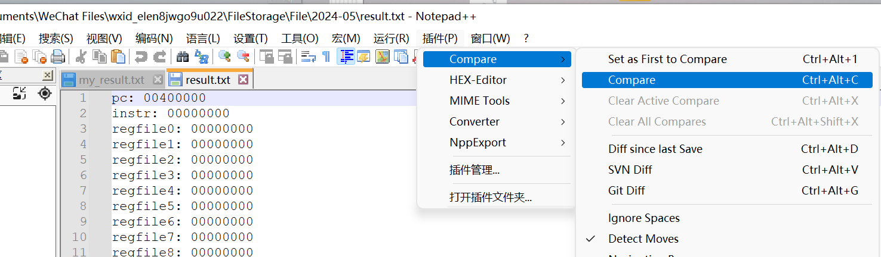

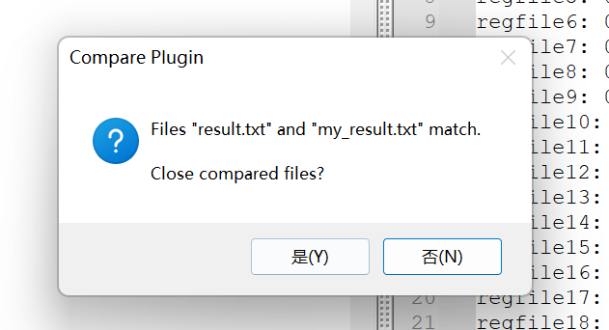

1.Addi

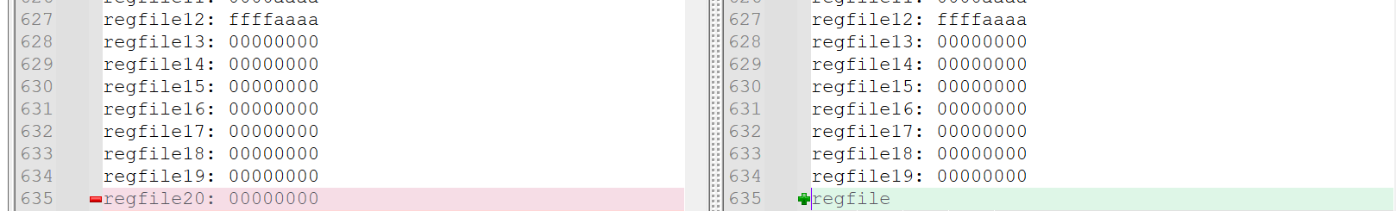

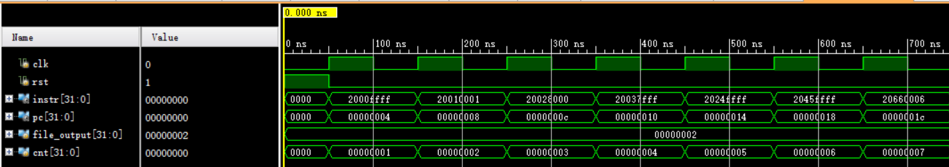

2.Addiu

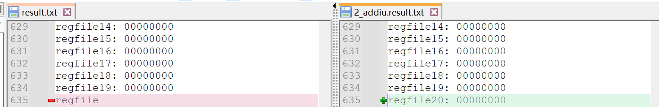

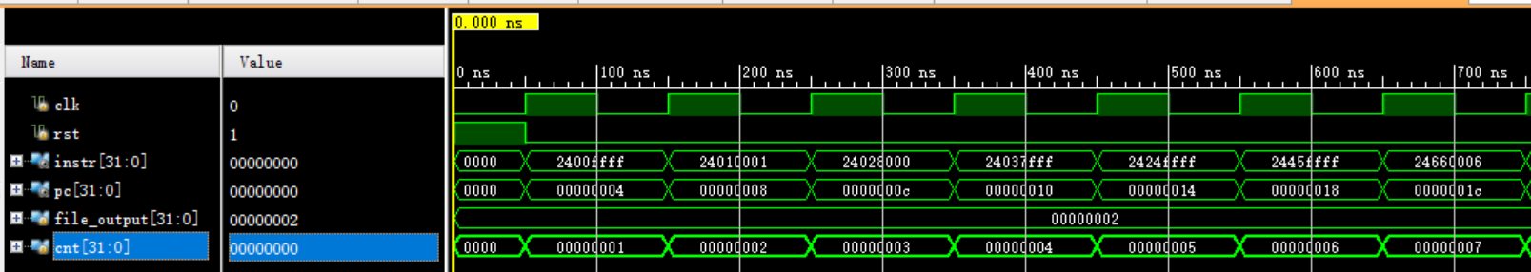

3.Andi

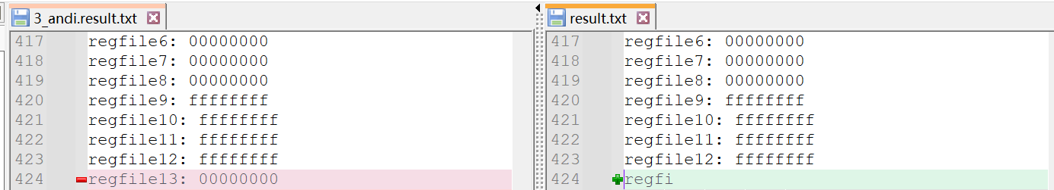

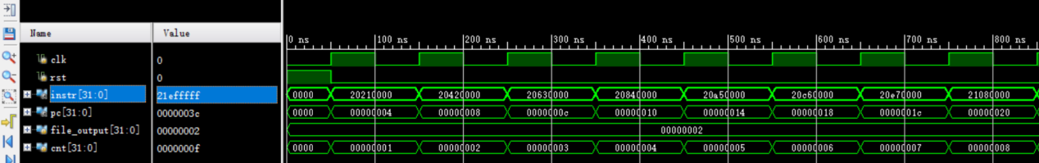

4.Ori

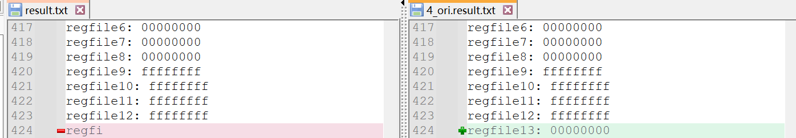

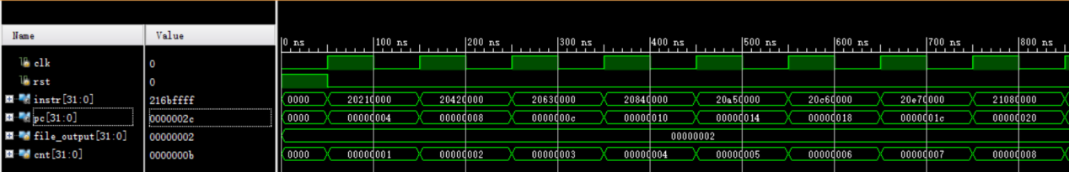

5.Sltiu

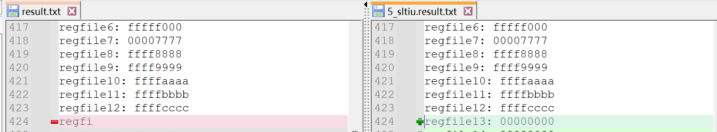

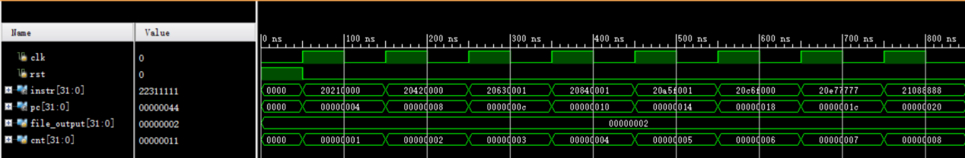

6.Lui

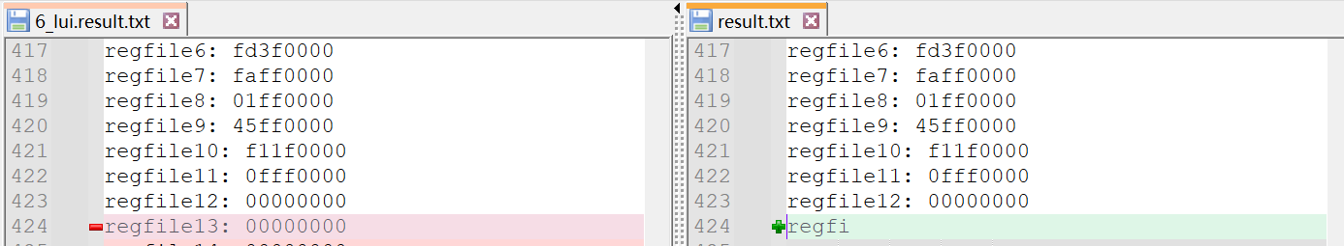

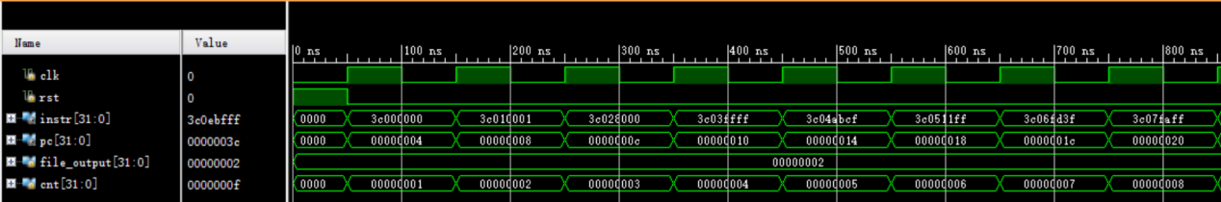

7.Xori

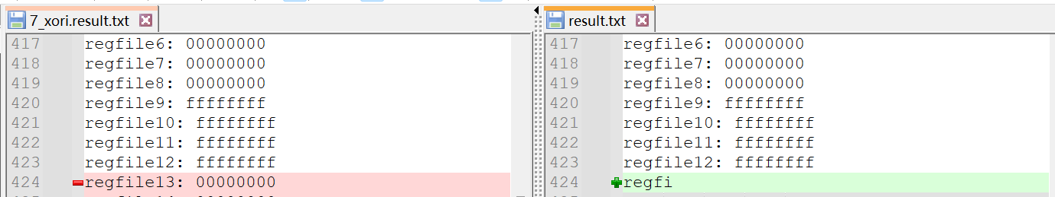

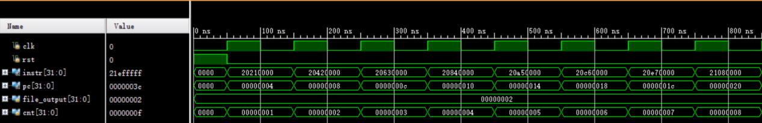

8.Slti

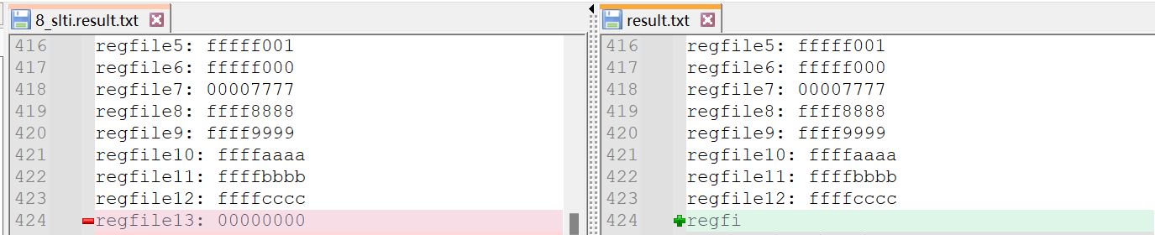

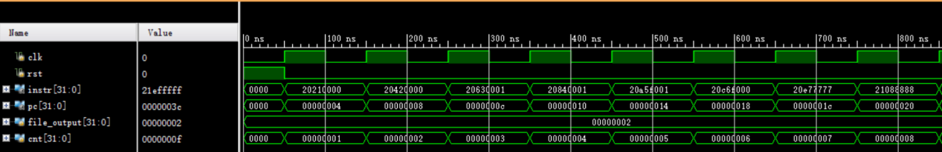

9.Addu

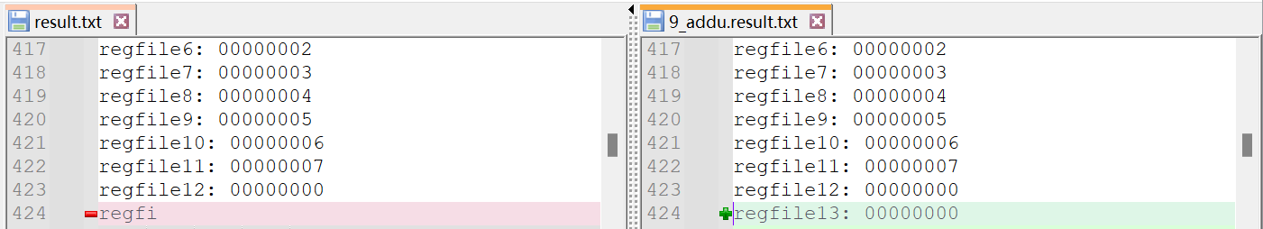

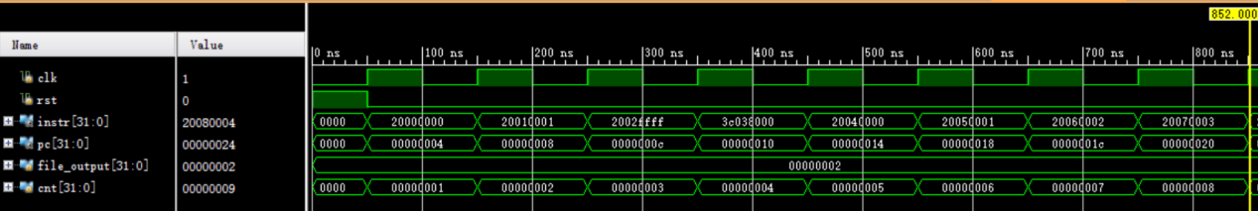

10.And

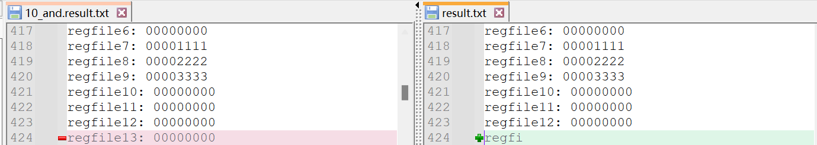

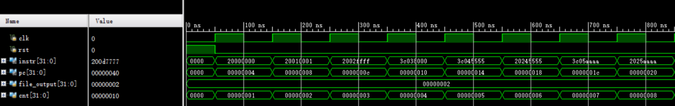

11.Beq

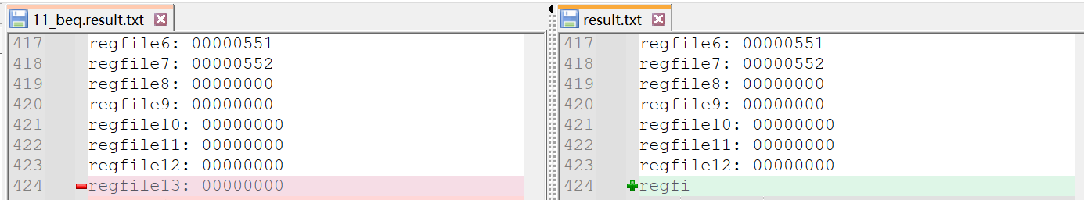

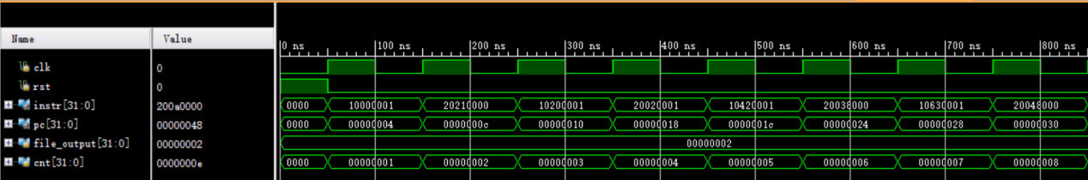

12.Bne

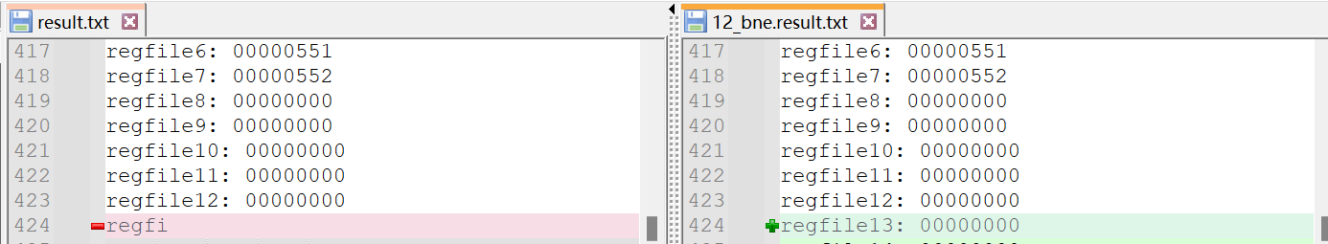

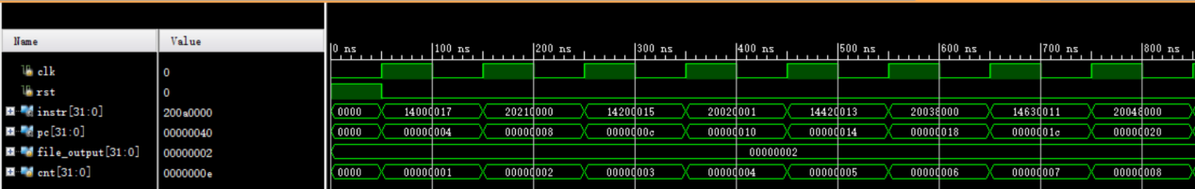

13.J

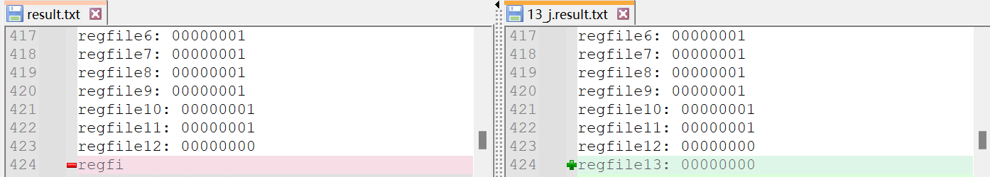

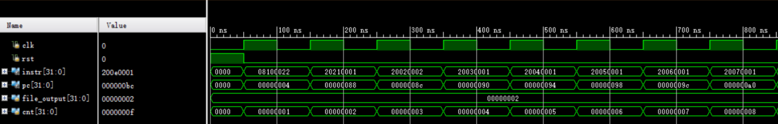

14.Jal

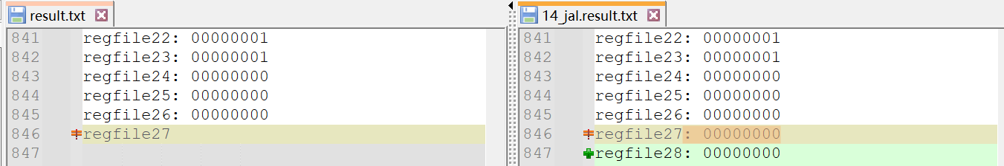

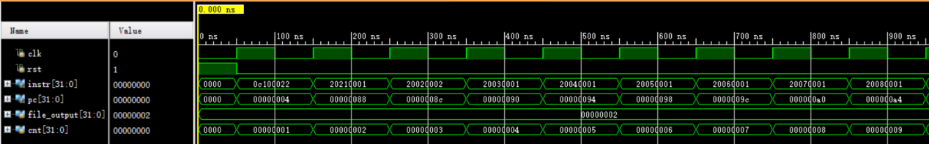

15.Jr

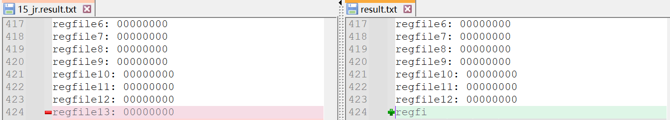

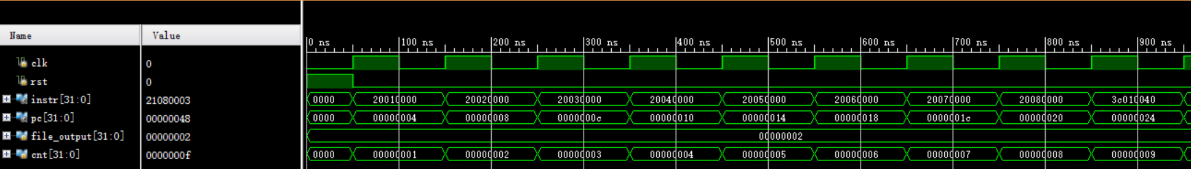

16.

LwSw

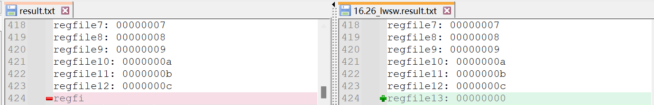

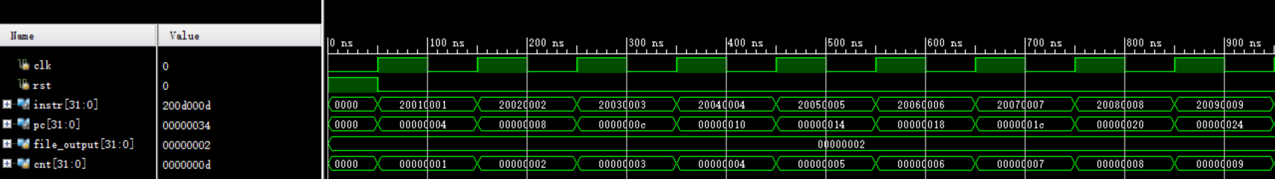

LwSw2

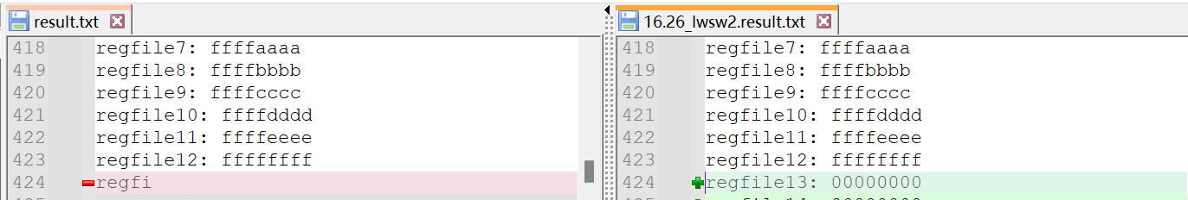

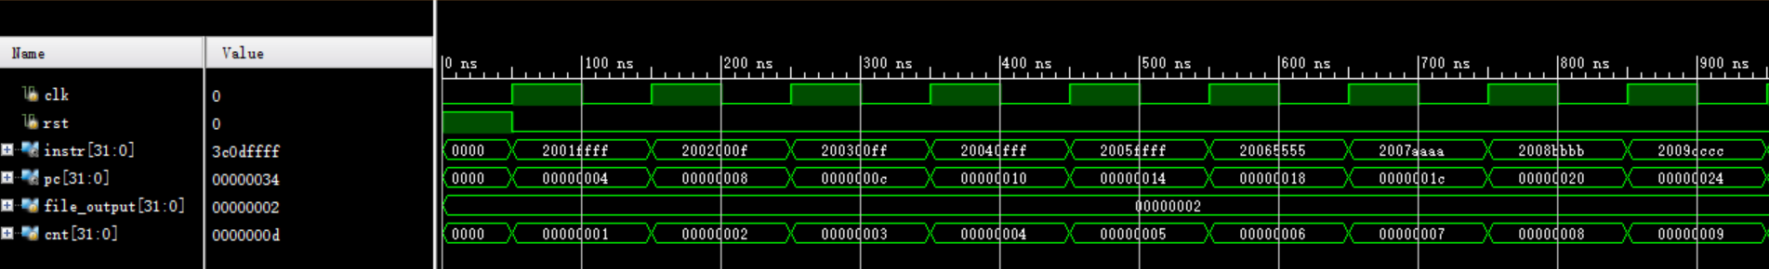

17.Xor

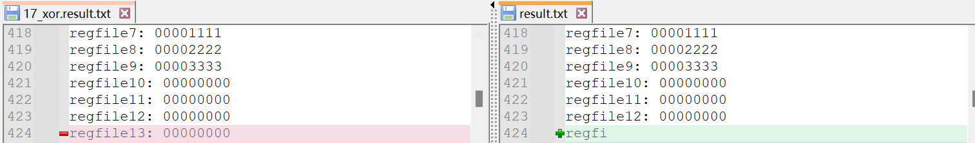

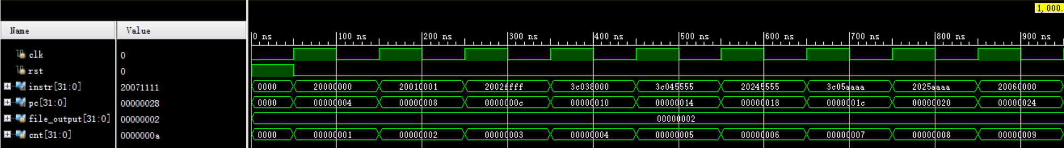

18.Nor

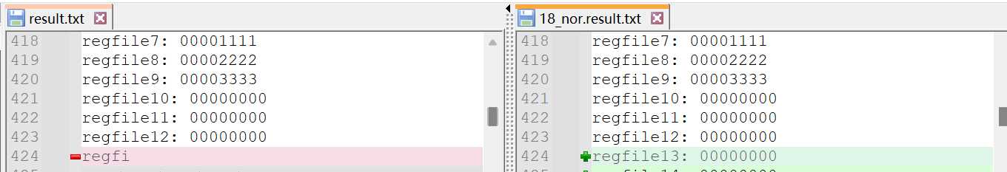

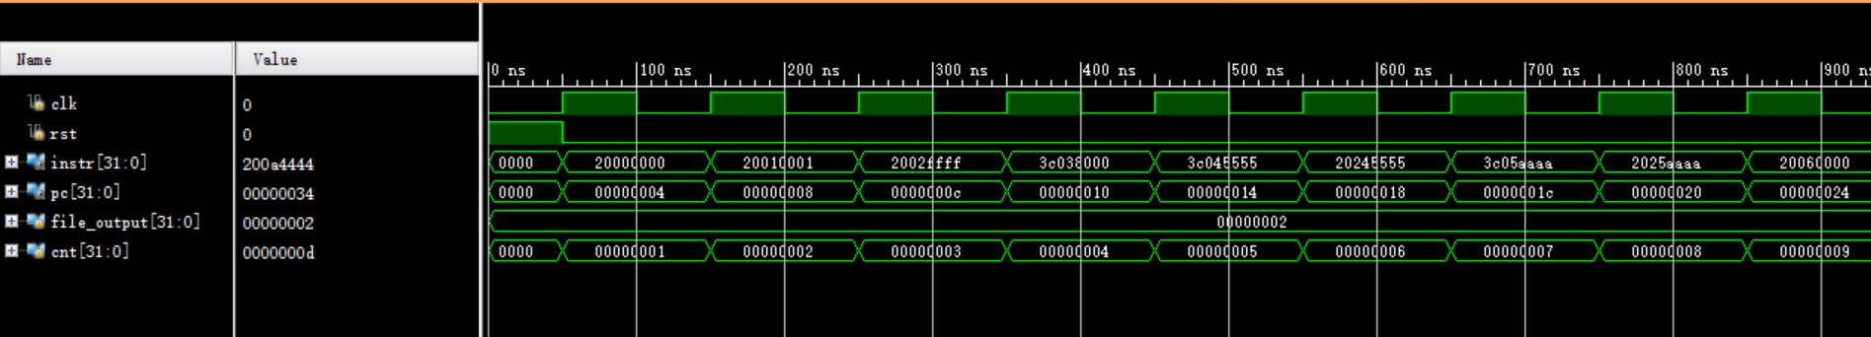

19.Or

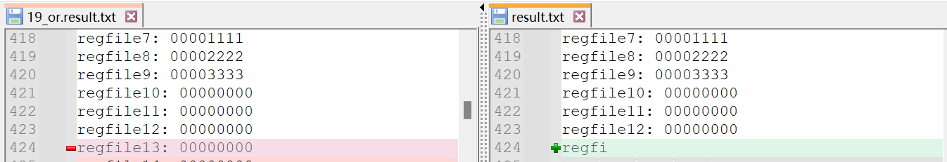

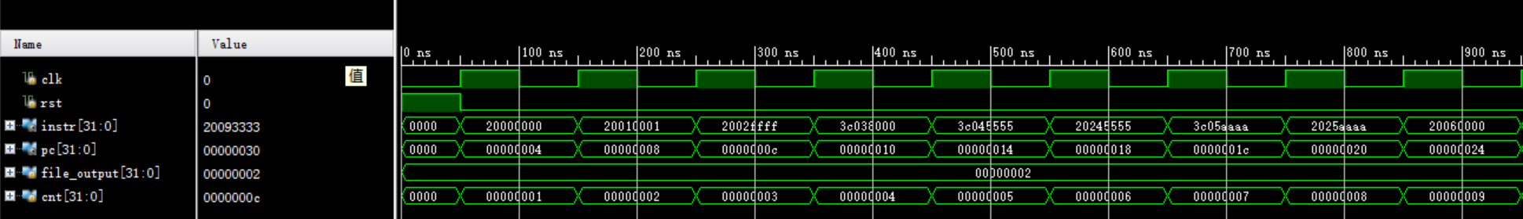

20.Sll

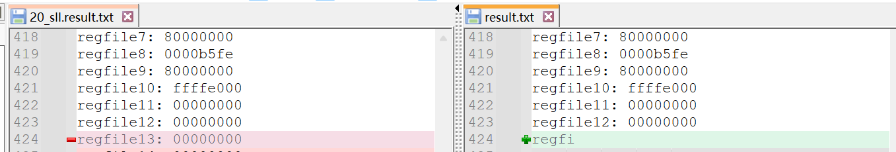

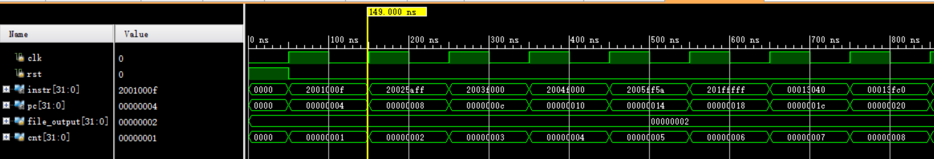

21.Sllv

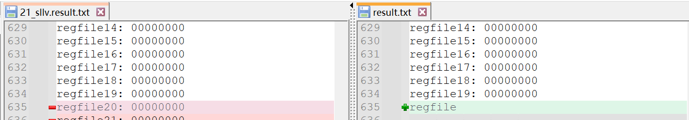

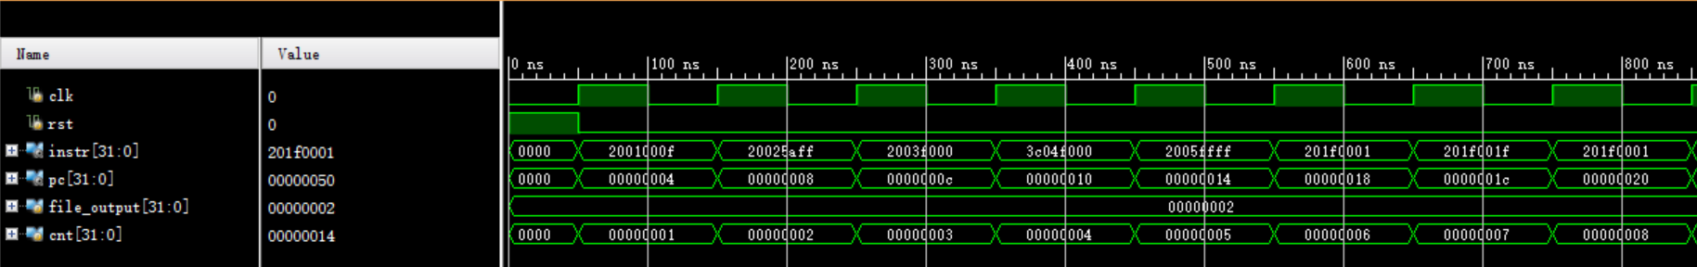

22.Sltu

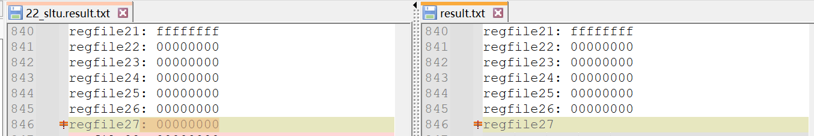

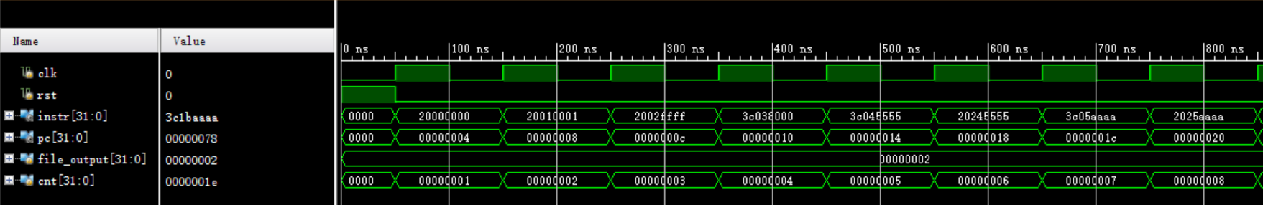

23.Sra

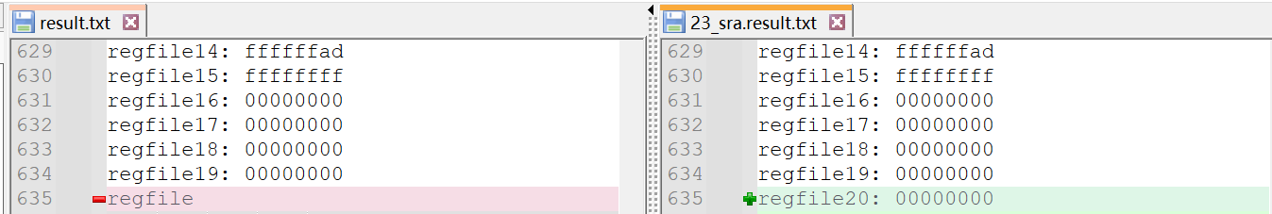

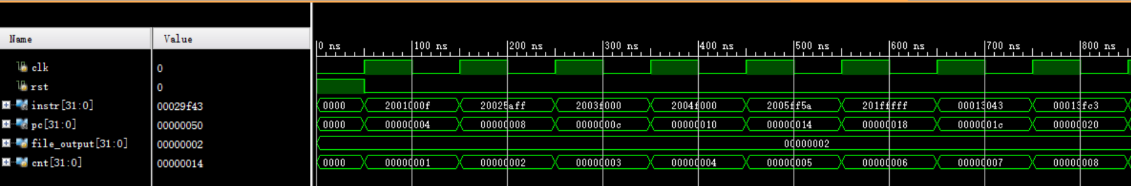

24.Srl

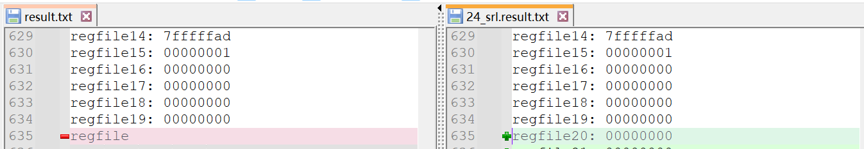

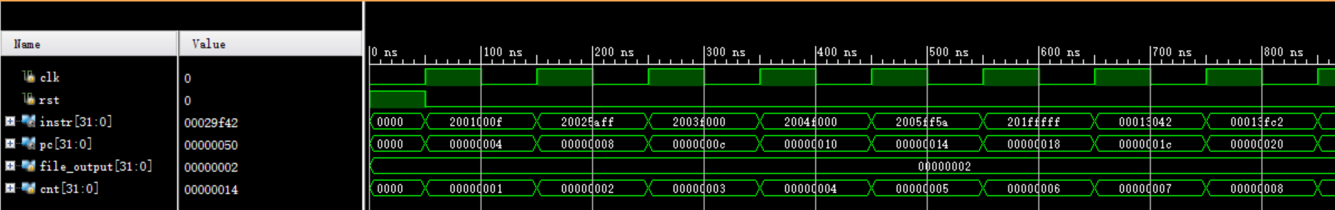

25.Subu

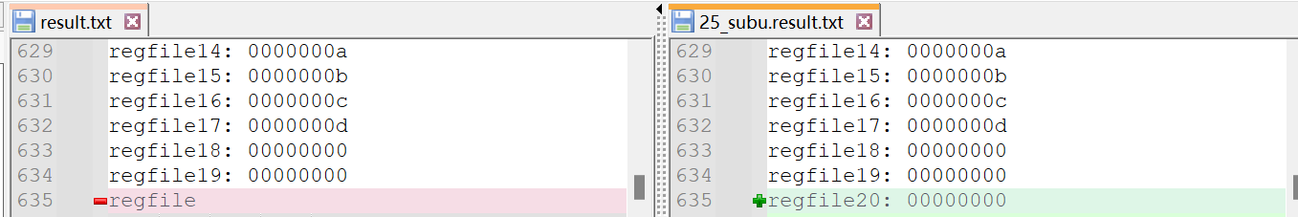

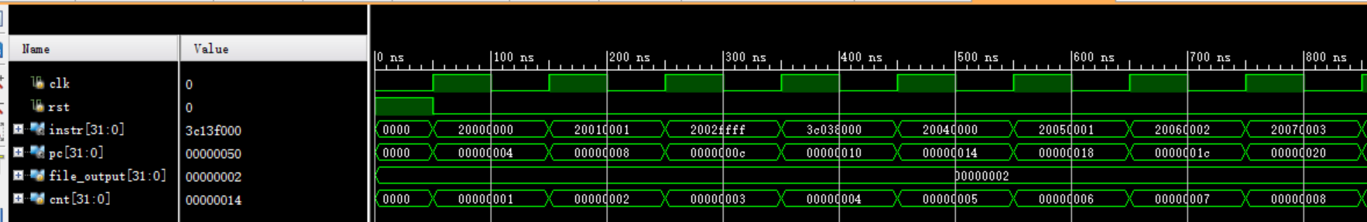

26.16已经测试

27.Add

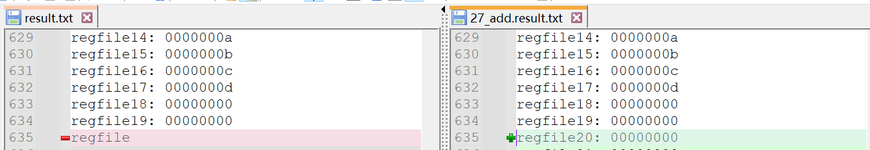

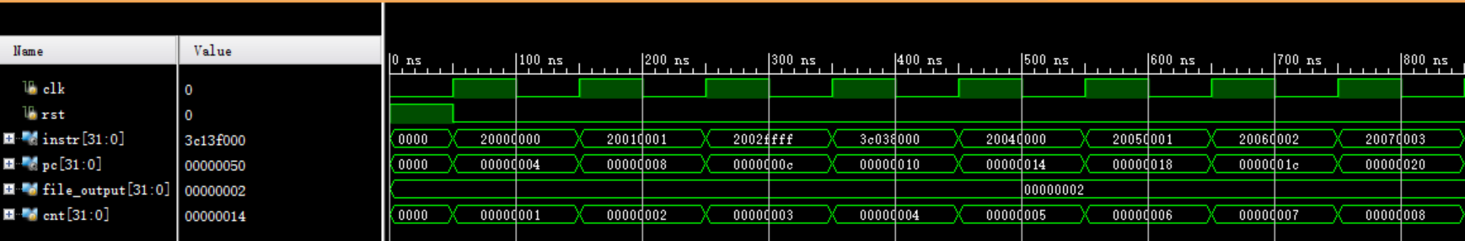

28.Sub

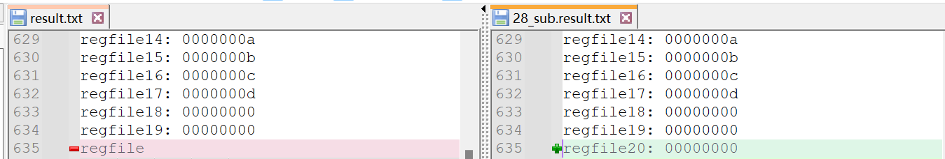

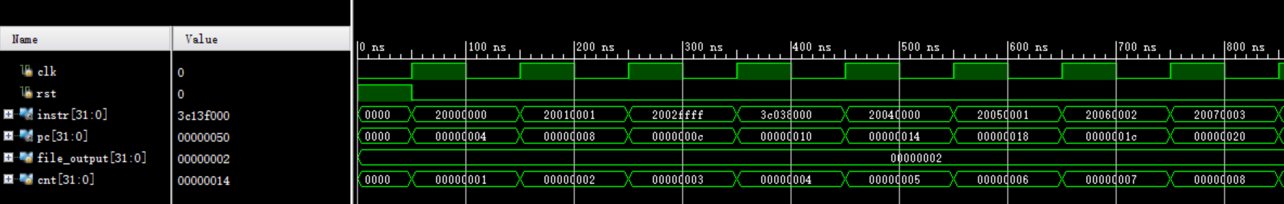

29.Slt

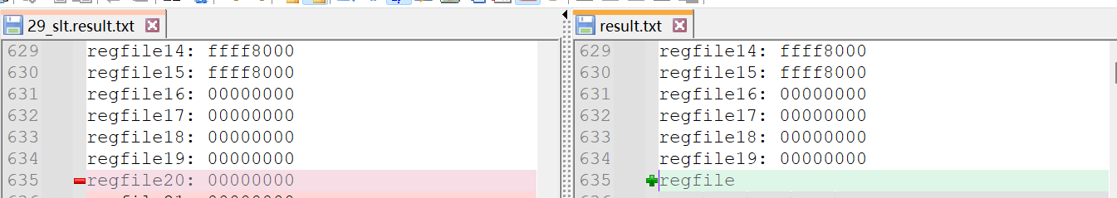

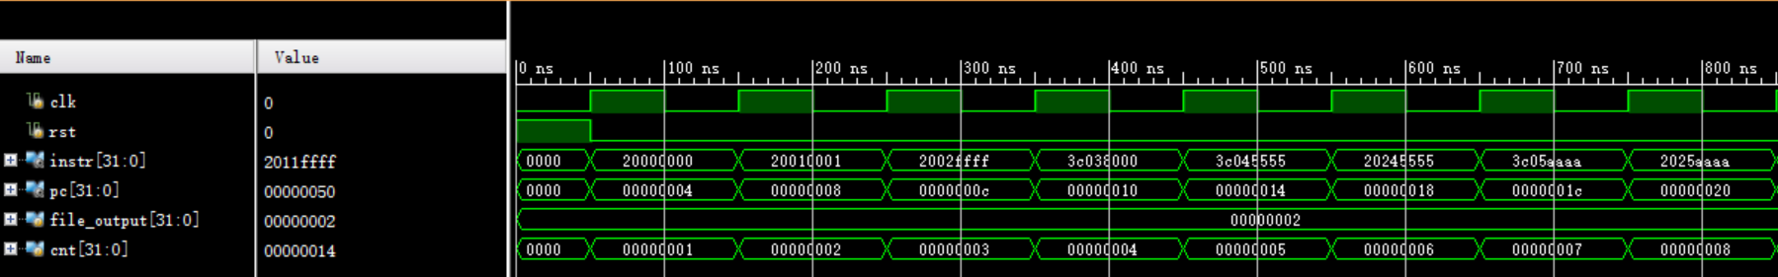

30.Srlv

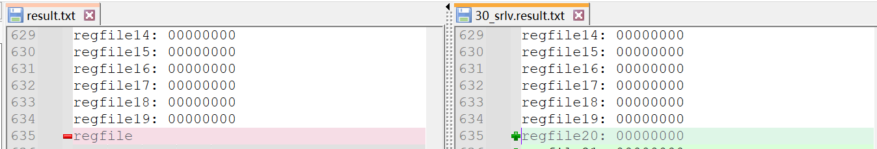

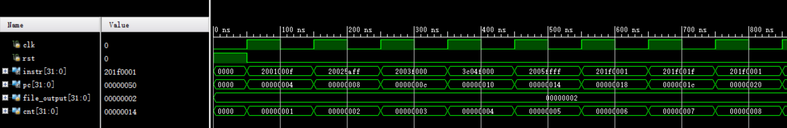

31.Srav

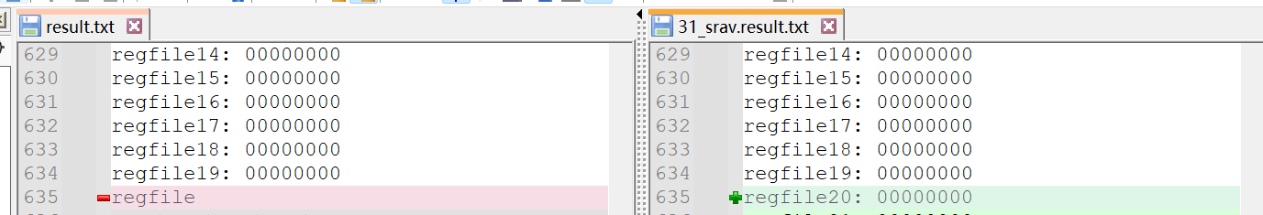

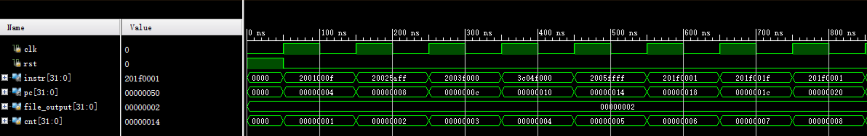

32.Clz

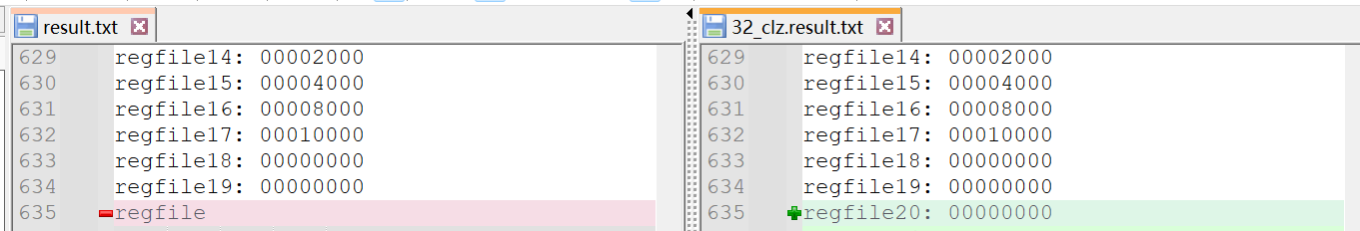

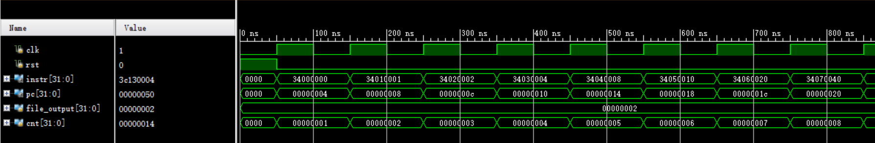

33.Divu

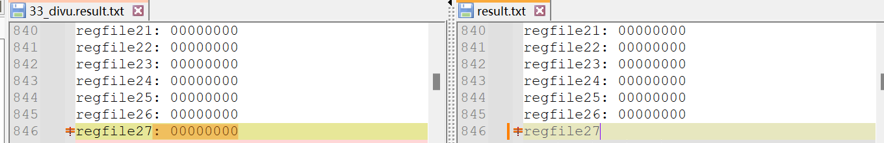

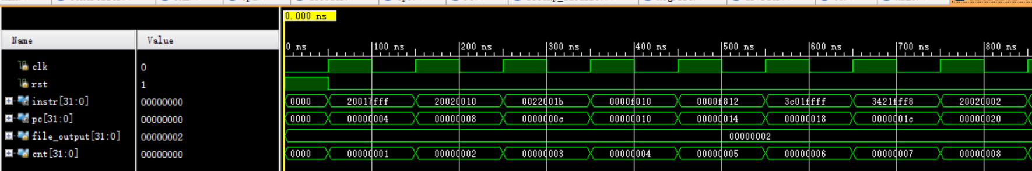

35. Jalr

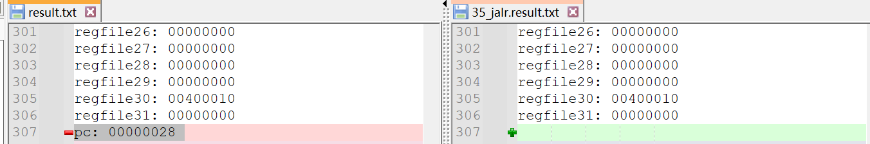

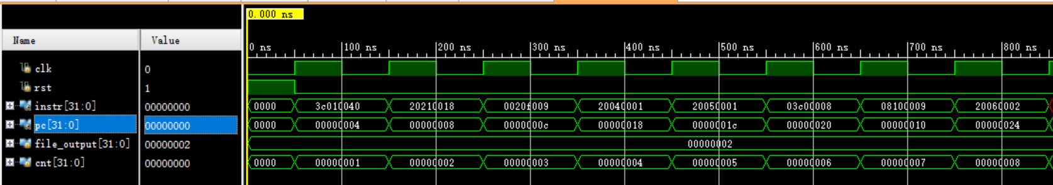

36.39 LbSb

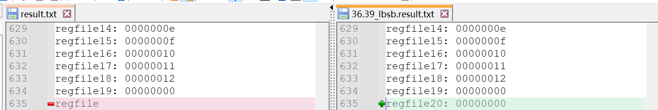

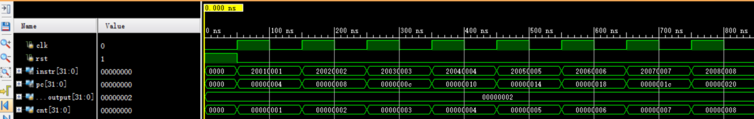

LbSb2

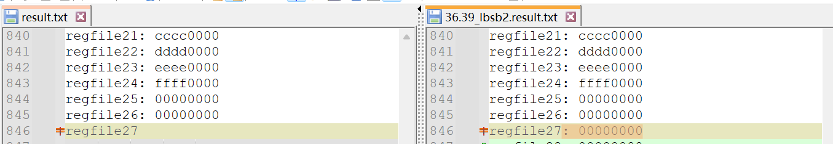

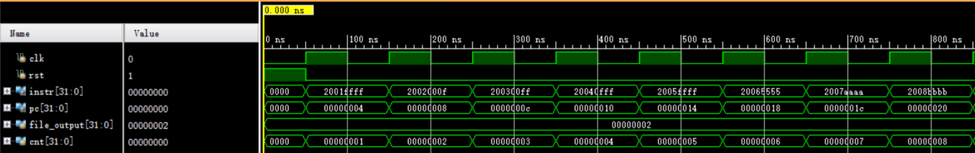

37.Lbu

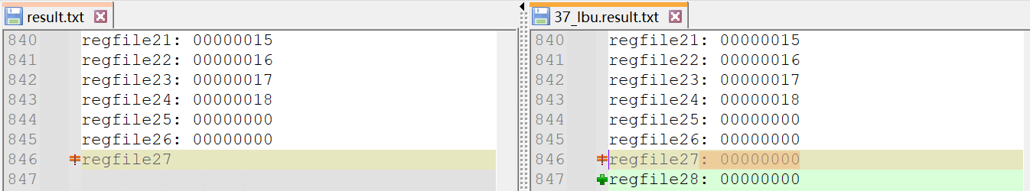

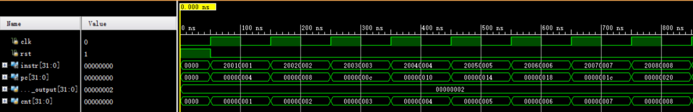

Lbu2

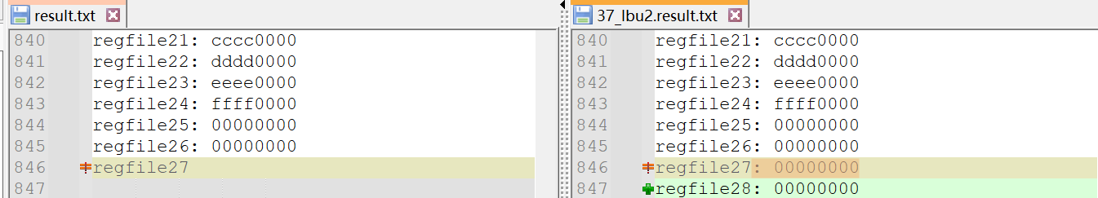

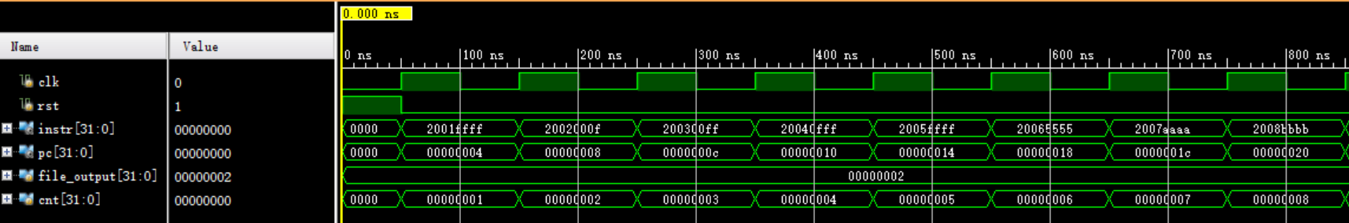

38.Lhu

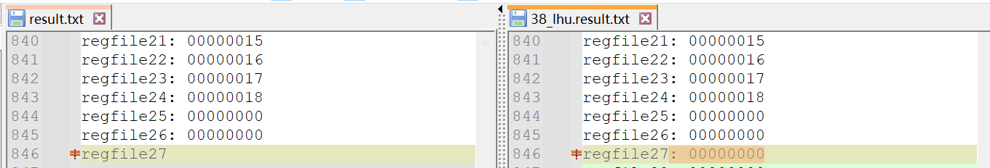

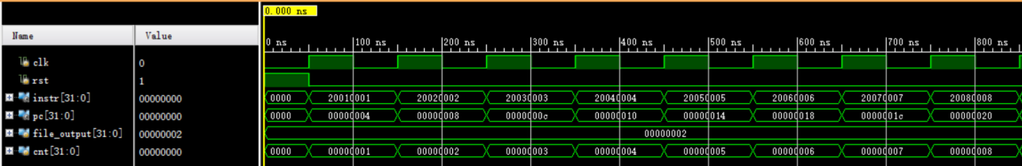

39.Lhu2

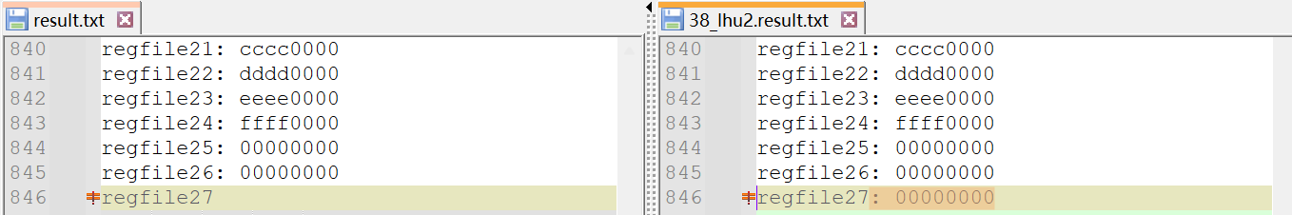

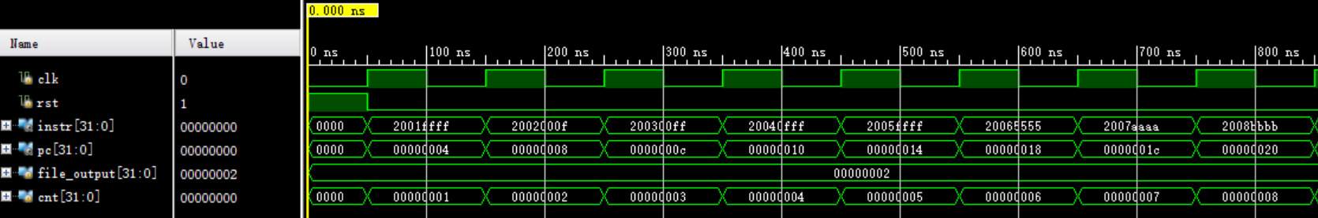

40.Lhsh

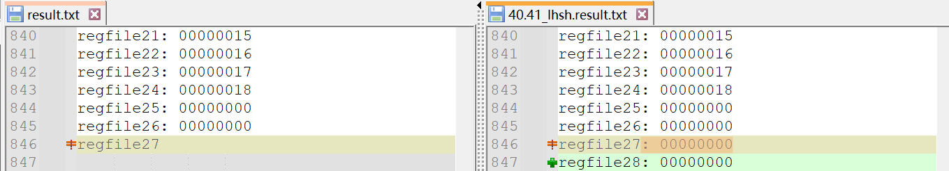

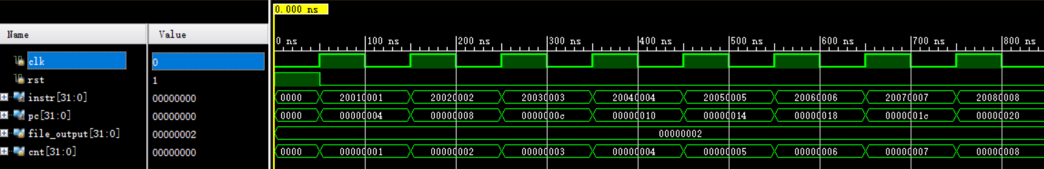

41.Lhsh2

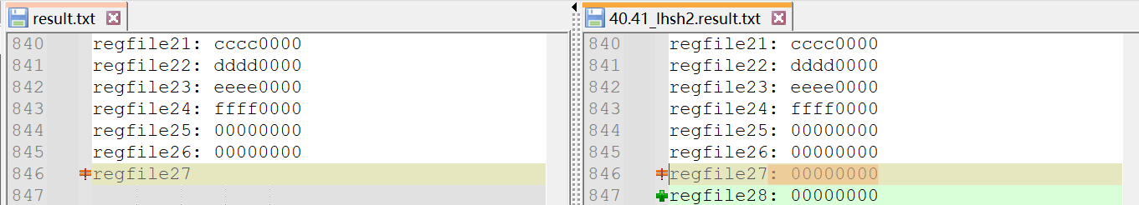

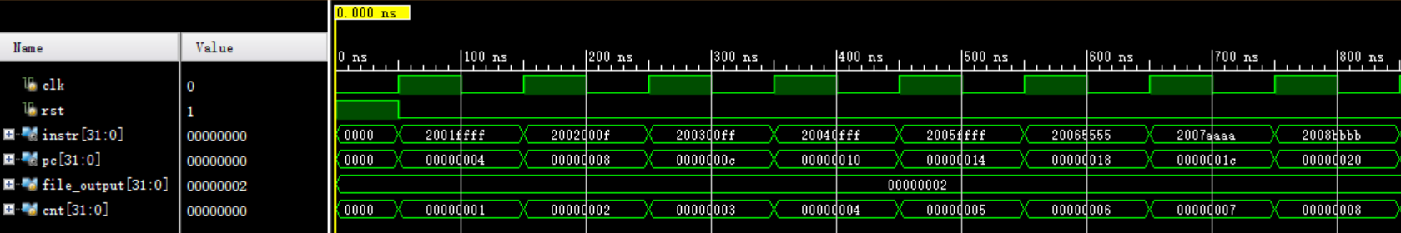

42.45 Mfc0 Mtc0

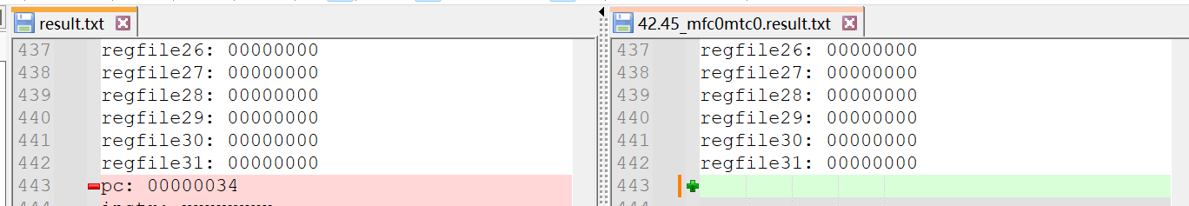

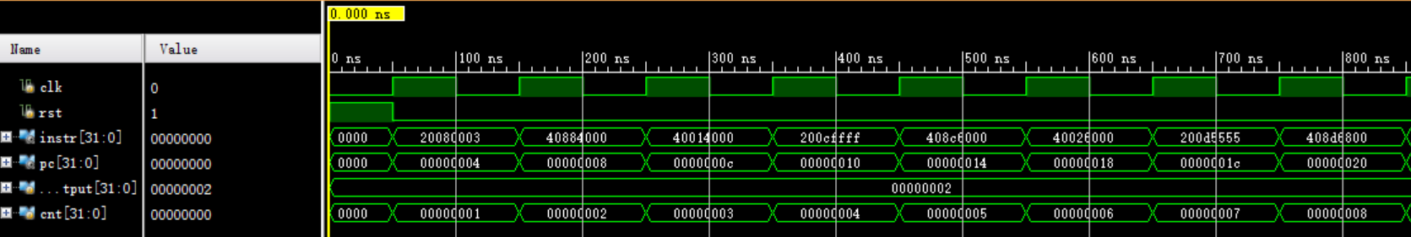

43.46 Mfhi Mthi

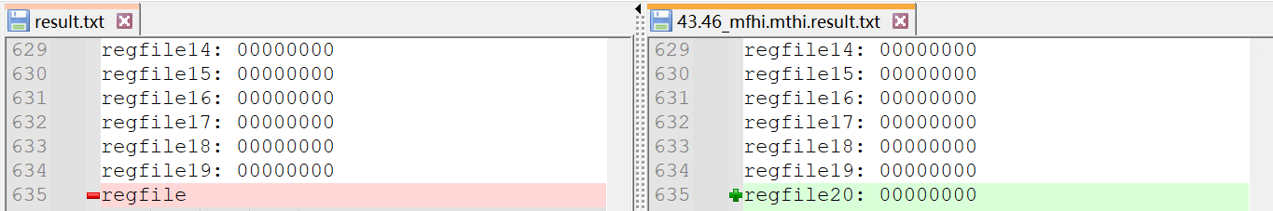

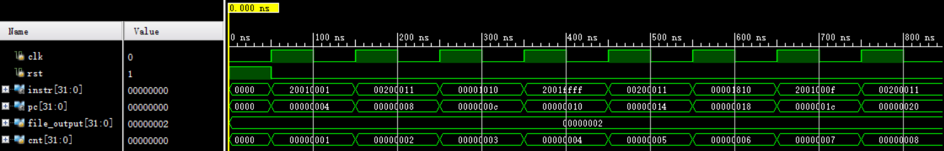

44.47 Mflo Mtlo

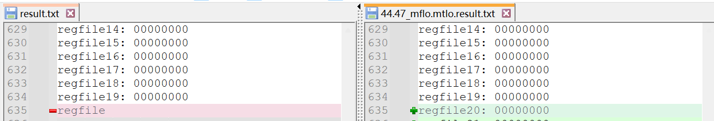

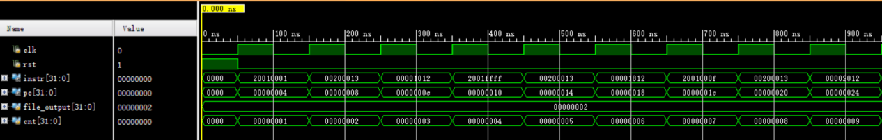

1. Mult

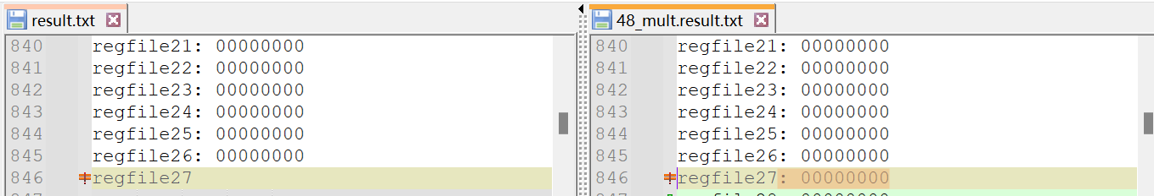

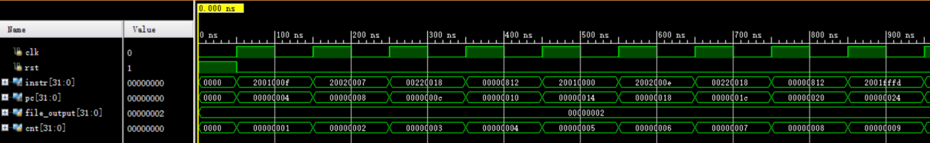

1. Multu

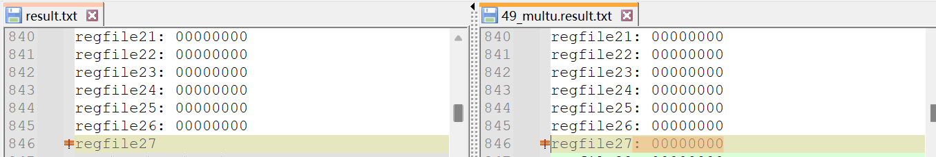

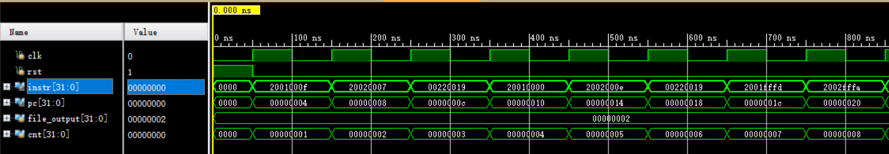

1. Bgez

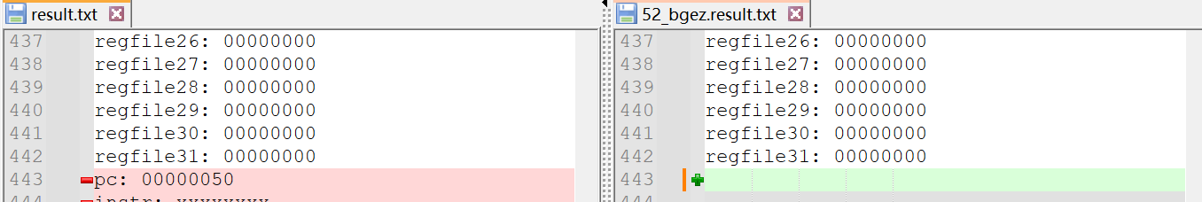

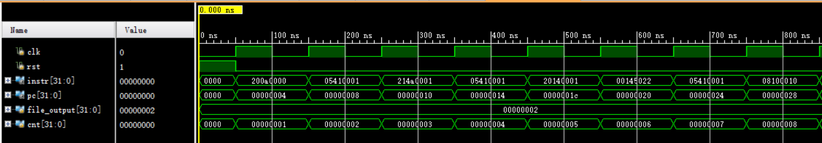

1. Div

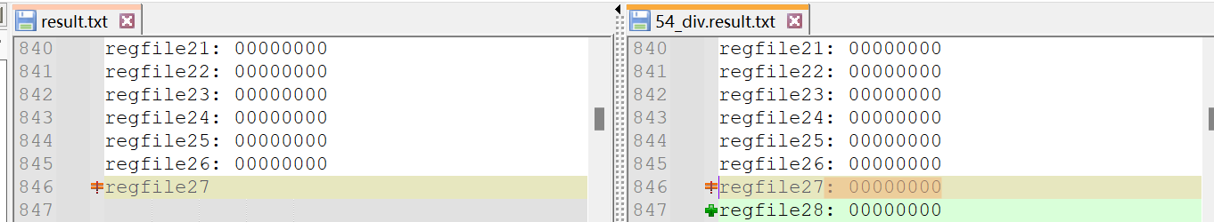

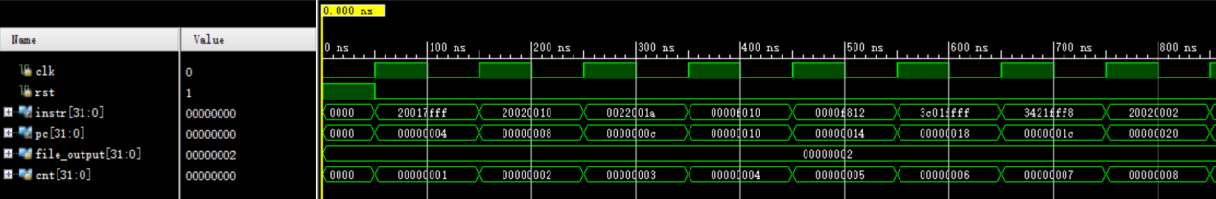

## 网站前仿真测试结果

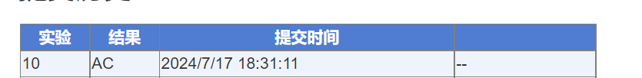

# CPU后仿真测试结果

## 后仿真测试结果及描述

完成前仿真以后，后仿真测试可以真实地模拟实际情况下存在延时的效果，从而进行更加符合真实情况的仿真测试。

配置好相关的时钟约束：时钟变量、input delay、output delay 以后，即可通过 modelsim 与 vivado链接生成后仿真波形图，经过比对可以得出结果正确：

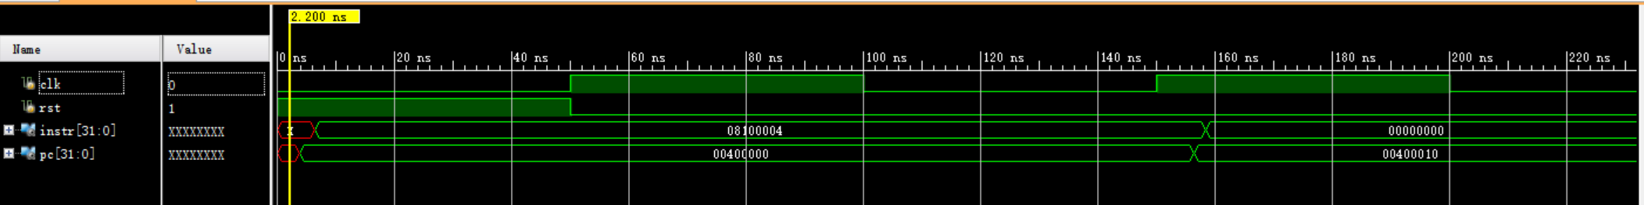

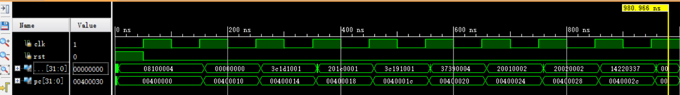

## 时序分析结果

在vivado 下进行后仿真测试，可以通过 report timing summary 生成具体的时序分析报告内容。时序报告中可以详细地查看每条路径的具体时延报告，分为 summary，source clock path，data path以及 destination path 等部分。我们通过改进逻辑布线布局，降低扇出以及减少逻辑门级数等操作可以有效地减少延迟，优化电路。

本次实验的时序分析结果如下：

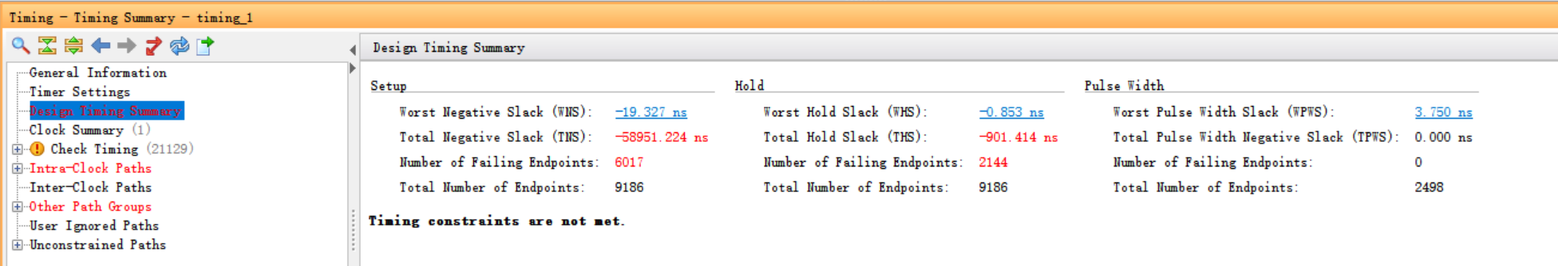

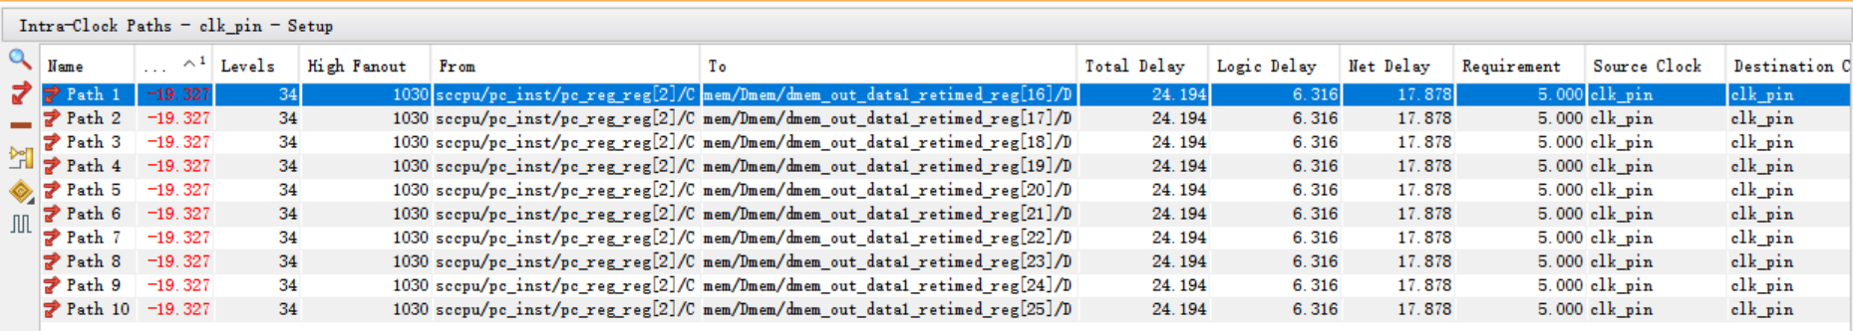

（path1详细展开）

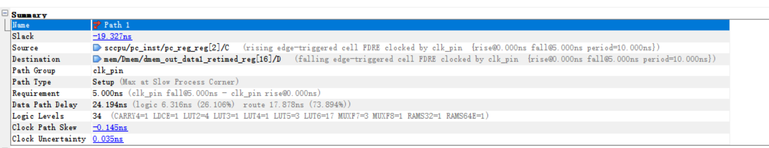

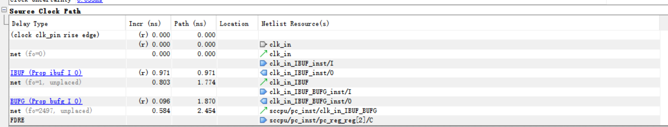

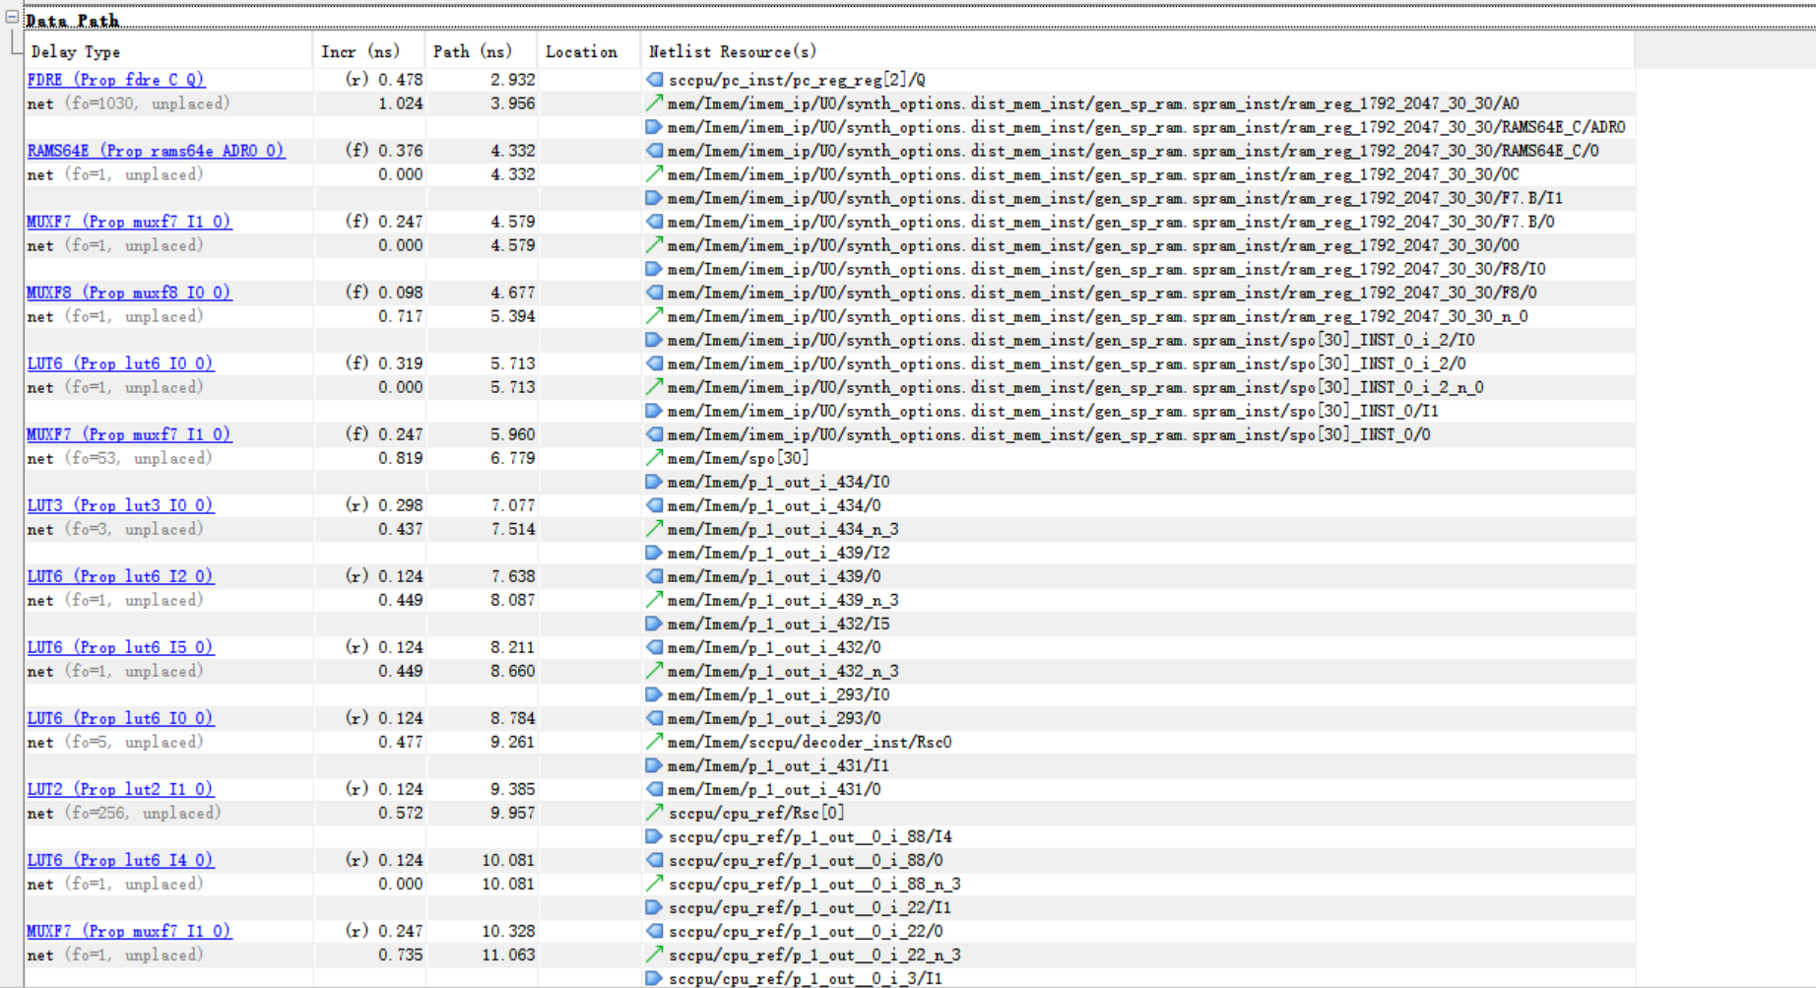

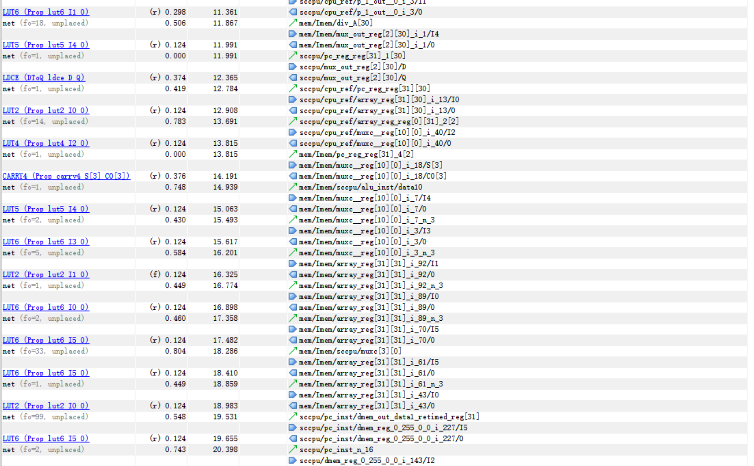

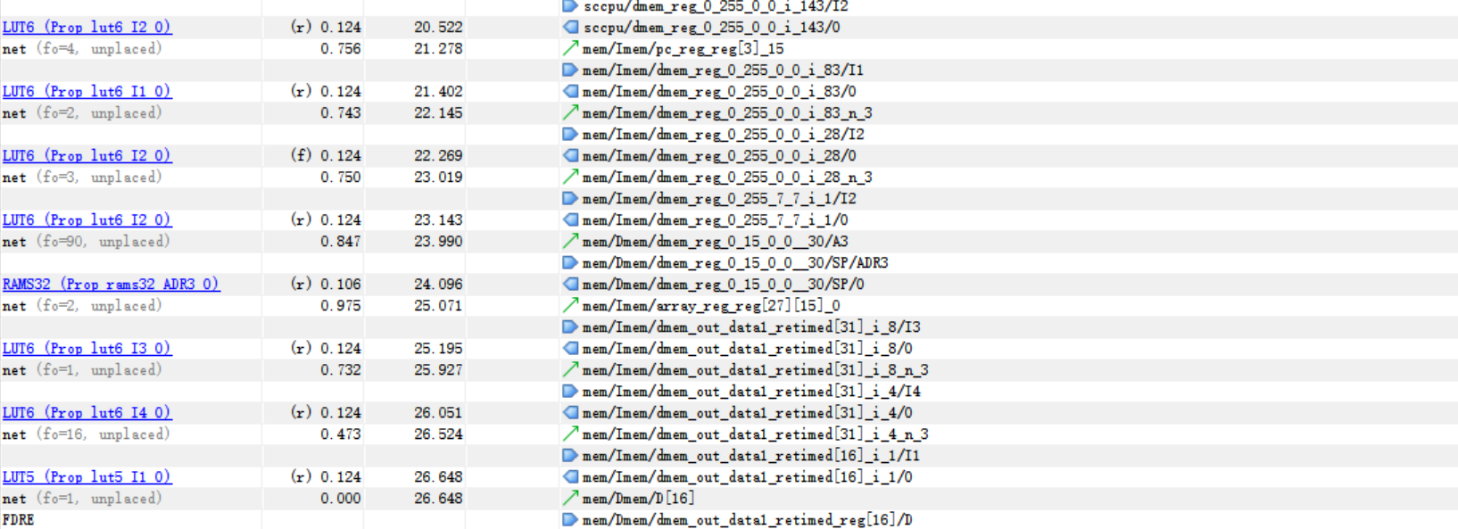

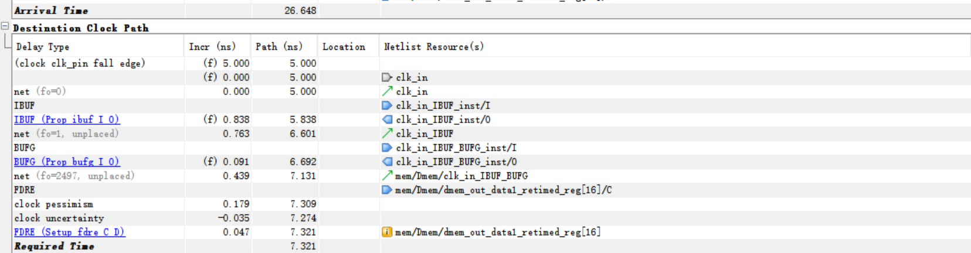

# CPU下板结果

1. **下板实验内容及结果**

下板实验的核心内容为点亮 7 段数码管，下板时可以将 PC 寄存器或通用寄存器结果输出到 7 段数码管上，通过检测寄存器值的正确性来检验所写的 cpu 程序是否正确。编写测试文件，实例化 CPU 和七段数码管模块，并进行相关的管脚约束。由于七段数码管的显示需要使得人眼肉眼可分辨，但是 CPU 执行指令的时间转瞬即逝，因此需要对时钟进行分频。

`timescale 1ns / 1ps

module show(

    input clk_in,

    input reset,

    output [7:0] o_seg,

    output [7:0] o_sel

);

    wire [31:0] clk_cpu;

    wire [31:0] pc;

    sccomp_dataflow sc(

        .clk_in(clk_cpu),

        .reset(reset),

        .inst(inst),

        .pc(pc)

    );

    seg7x16 seg(

        .clk(clk_in),

        .reset(reset),

        .cs(1'b1),

        .i_data(pc),

        .o_seg(o_seg),

        .o_sel(o_sel)

    );

    Divider #(.n(100000000)) di(

        .I_CLK(clk_in),

        .rst(reset),

        .O_CLK(clk_cpu)

    );

endmodule

module Divider#(parameter n=20)(

    input I_CLK, //输入时钟信号，上升沿有效

    input rst, //同步复位信号，高电平有效

    output O_CLK //输出时钟

);

    reg [31:0]count;

    reg clk;

    assign O_CLK=clk;

        initial

        begin

        clk<=0;count<=0;

        end

        always@(posedge I_CLK)

            begin

            if(rst)

            begin

                clk<=1'b0;count<=32'b0;

            end

            else if(count==n/2-1)

            begin

                clk<=~clk;count<=32'b0;

            end

            else

                count<=count+1;

        end//end of always

endmodule

运行.bit文件，每秒数码管上的值更新一次，显示当前PC程序计数器的值：

（1）PC=00400250:

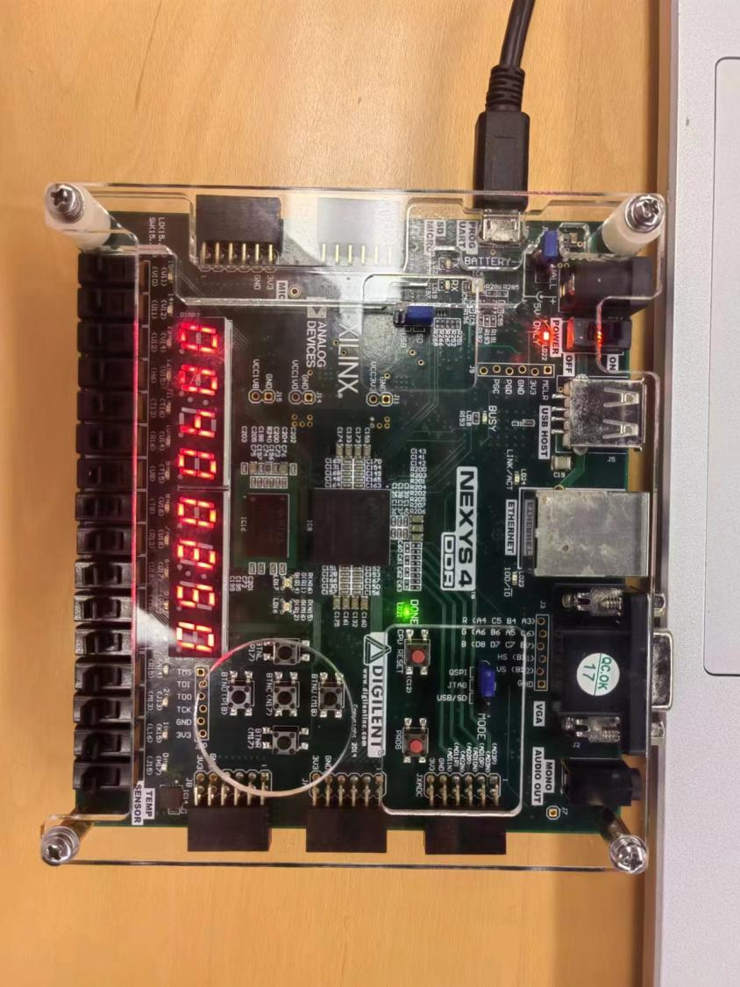

（2）PC=00400258:

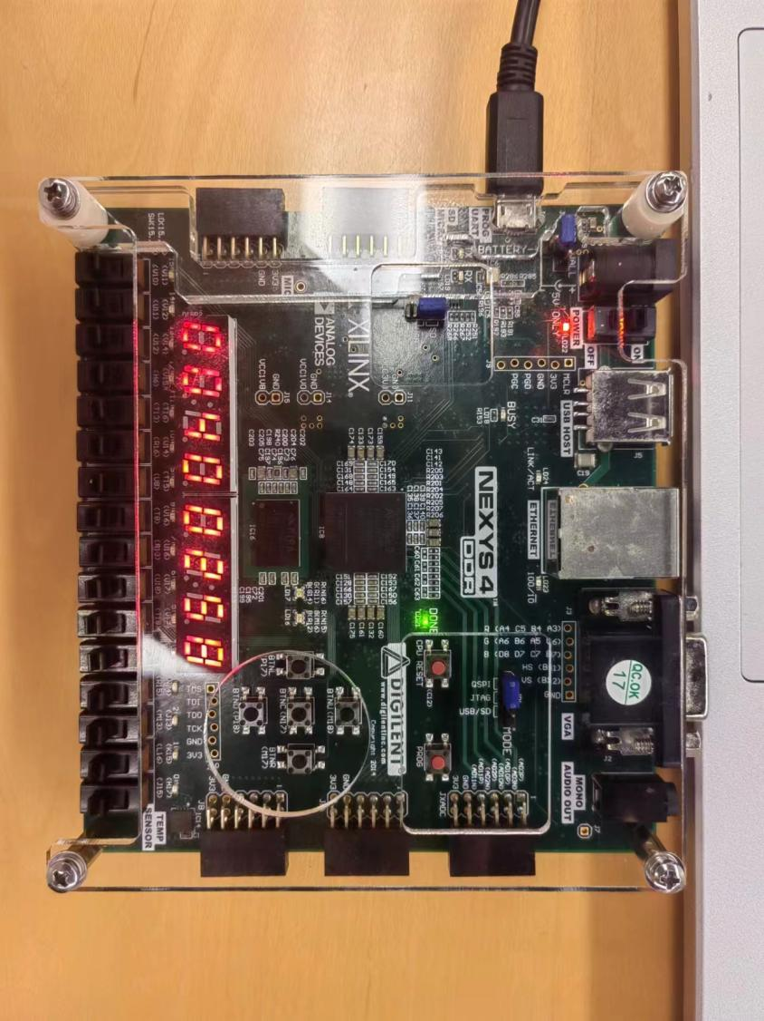

（3）PC=00400260：

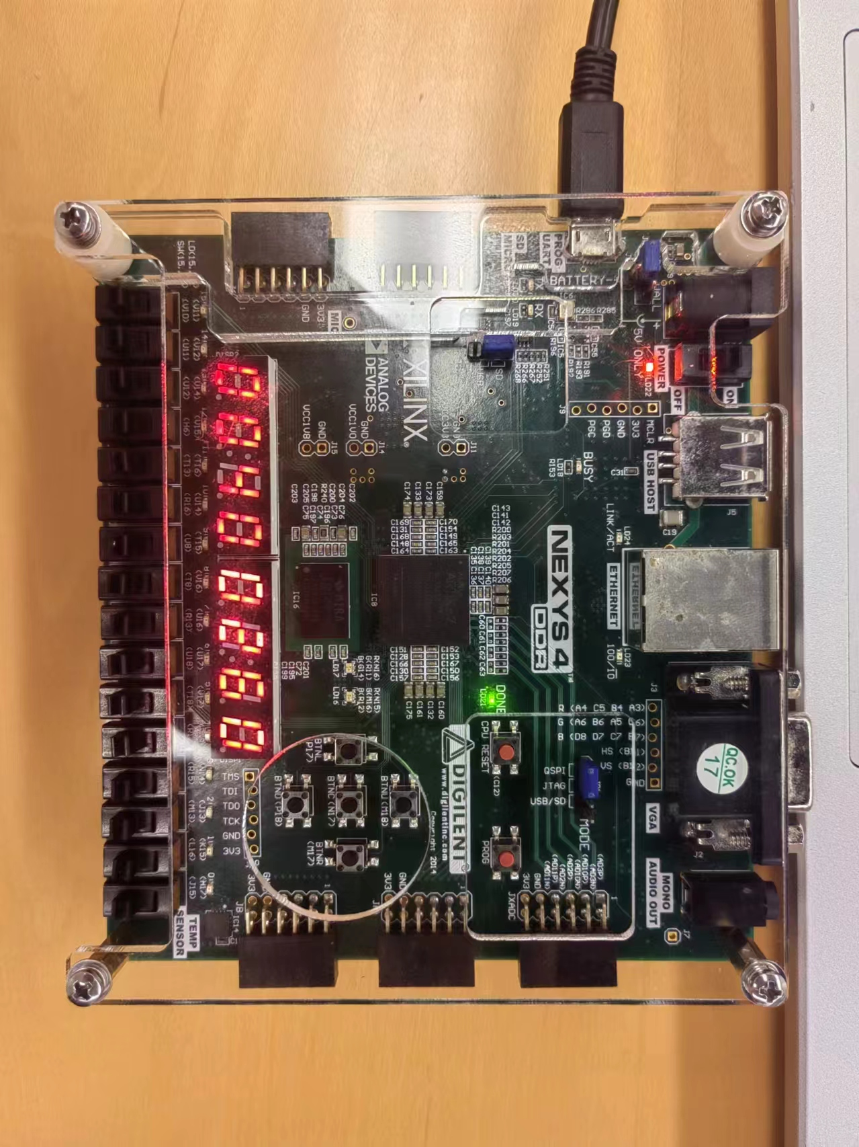

1. **实验分析与结论**

七段数码管上可以显示当前执行的程序地址（即 PC 寄存器中的值）。可以看到，显示的 PC 寄存器值从 0x00400000 开始，当执行一段时间以后，程序进入循环，会一直反复显示某几个 PC 值，这属于正常现象。

# 心得体会及建议

在本次 CPU 设计的实验中，我经历了一系列挑战和反思。尽管最终成功实现了包含 54条MIPS指令的单周期 CPU，但过程中也遭遇了一些疏忽导致的错误。在 CPU 的设计过程中，我逐步实现了 IMEM、PC、ALU 、controller、CP0等核心模块，并通过分析数据通路图，建立了各功能部件之间的逻辑联系。IMEM 和 DMEM 作为存储单元，与 CPU 紧密协作，实现了数据的读取与写入。通过顶层模块的实例化，以及 CPU 与 MEM(IMEM、DMEM)之间的协调，我成功实现了单周期 CPU 的全部功能。

通过这次实验，我对单周期 CPU 的设计有了更深刻的理解。我不仅掌握了从数据输入输出关系到指令流程再到 CPU 最终实现的全过程，还更加清晰地认识到部件之间的输入输出关系以及数据在不同部件之间的传递方式。这些实践经验不仅加深了我对课堂知识的理解，还让我对 CPU 设计过程中的优化方向有了更明确的认识。